Work/School Excuse Letter

WS NORTH FULTON HOSPITAL
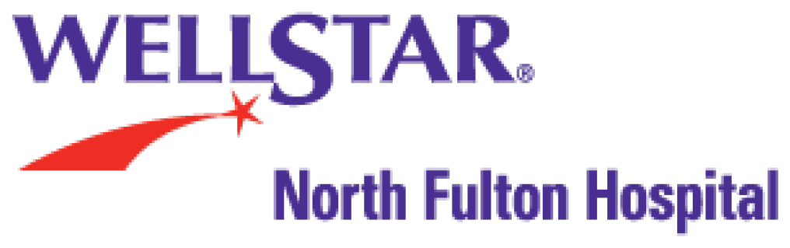
WELLSTAR NORTH FULTON HOSPITAL (NF
EMERGENCY)
3000 HOSPITAL BOULEVARD
ROSWELL, GA 30076-4915
Dept: 770-751-2505
Loc: 700-751-2500

Patient:
Date of Birth:
Date of Visit:

To Whom It May Concern:

(Name) was seen and treated in our emergency department on (date of visit). (He or She) may return to work on (date of Return).

If you have questions or concerns, please don’t hesitate to call.

The vision of WellStar Health System is to deliver world-class healthcare through our hospitals, physicians and services. Our not-for-profit health system includes WellStar Atlanta Medical Center, Atlanta Medical South, Cobb, Douglas, Kennestone Regional Medical Center, North Fulton, Paulding, Spalding Regional, Sylvan Grove, West Georgia Medical Center and Windy Hill Hospital; WellStar Medical Group; Health Parks; Urgent Care Centers; Health Place; Homecare; Hospice; Atherton Place; Paulding Nursing Center; and WellStar Foundation. For more information, call 770-956-STAR or visit wellstar.org.

