Lankeanu Medical Center
100 E Lancaster Ave, Wynnewood, PA 19096
(484) 476-2000

Beileigh Byle
10/08/19
Female
May 19, 2021

To whom it may concern,

This certifies that Beileigh Byle has came into Lankeanu medical center May 19, 2021 she was experiencing viral gastroenteritis. She was and is under our professional care. We have treated and put her on bed rest for 1 week until she is expected to return to daycare May 26,2021

If you have any questions or concerns please contact (484) 476-2000

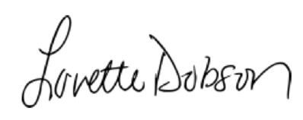

Lovette Dobson

