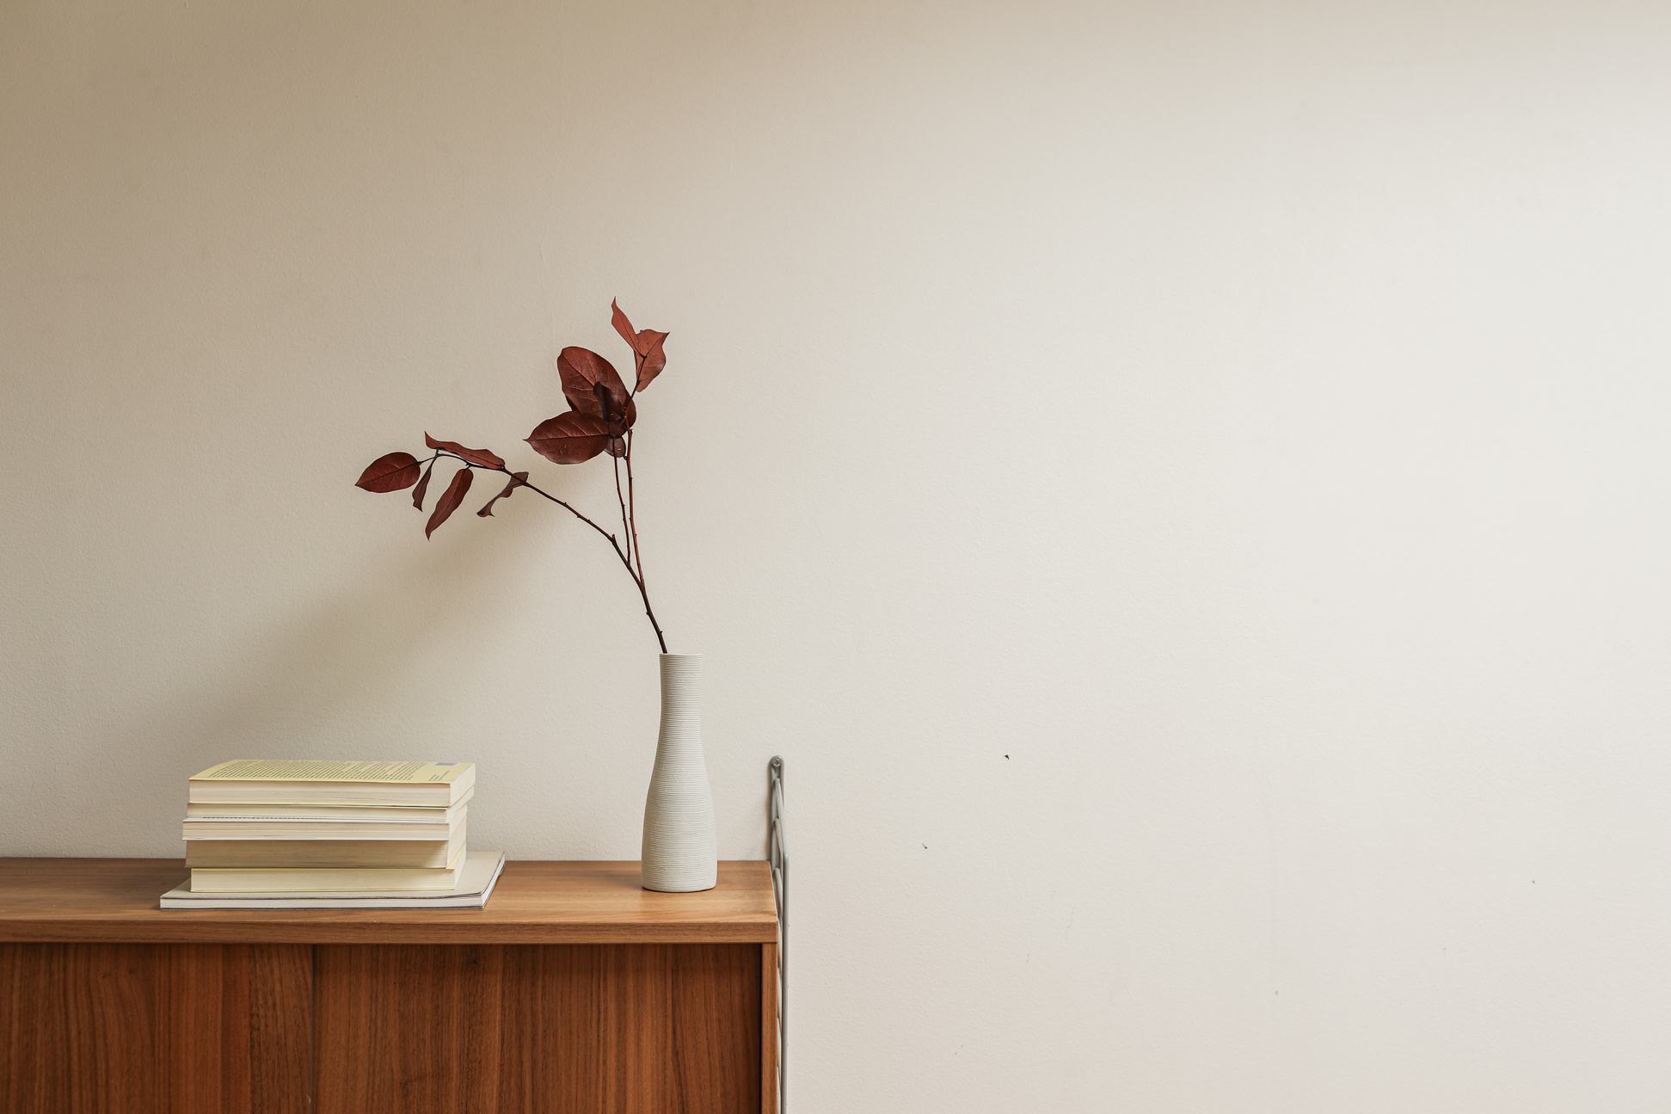

In life, is an art, the beauty moves in curves.



to



In life, is an art, the beauty moves in curves.



to