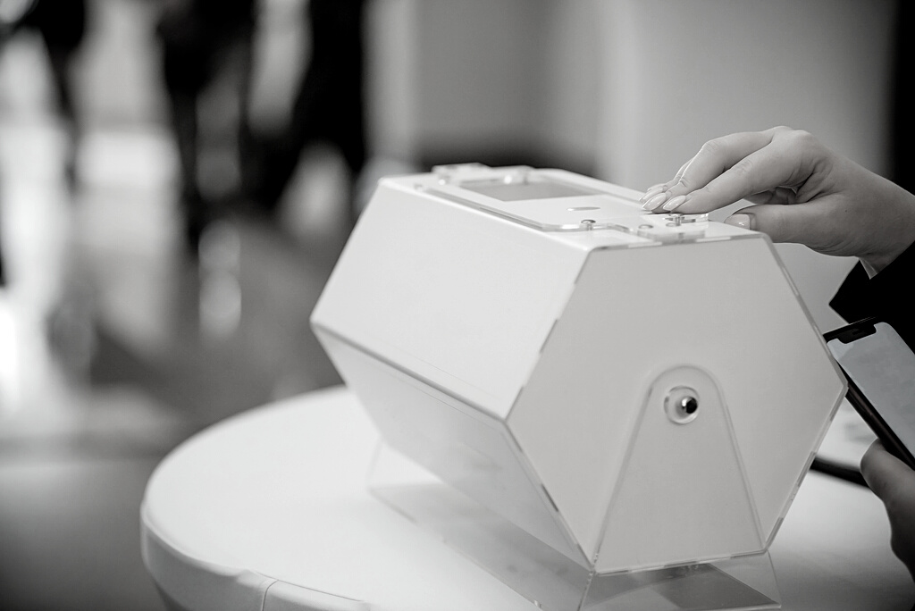

**RAFFLE TICKET**

*Your chance to win 50% of the bounty + have the other 50% support our charity*

***$5 / TICKET***

**50/50**

***NAME: __________________  
CONTACT: _______________ SIGNATURE: ______________ A***



* This ticket admits only one person.
* Tickets cannot be exchanged or transferred under any circumstances.
* Lost or damaged ticket(s) will not be entertained.

**Terms and Conditions**



**RAFFLE TICKET**

**50/50**