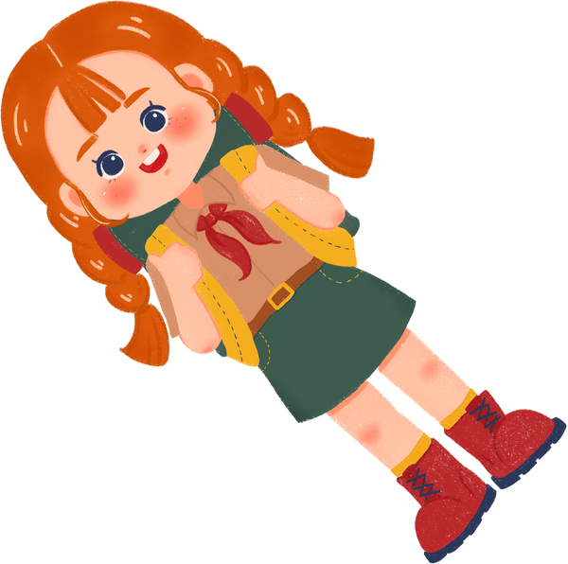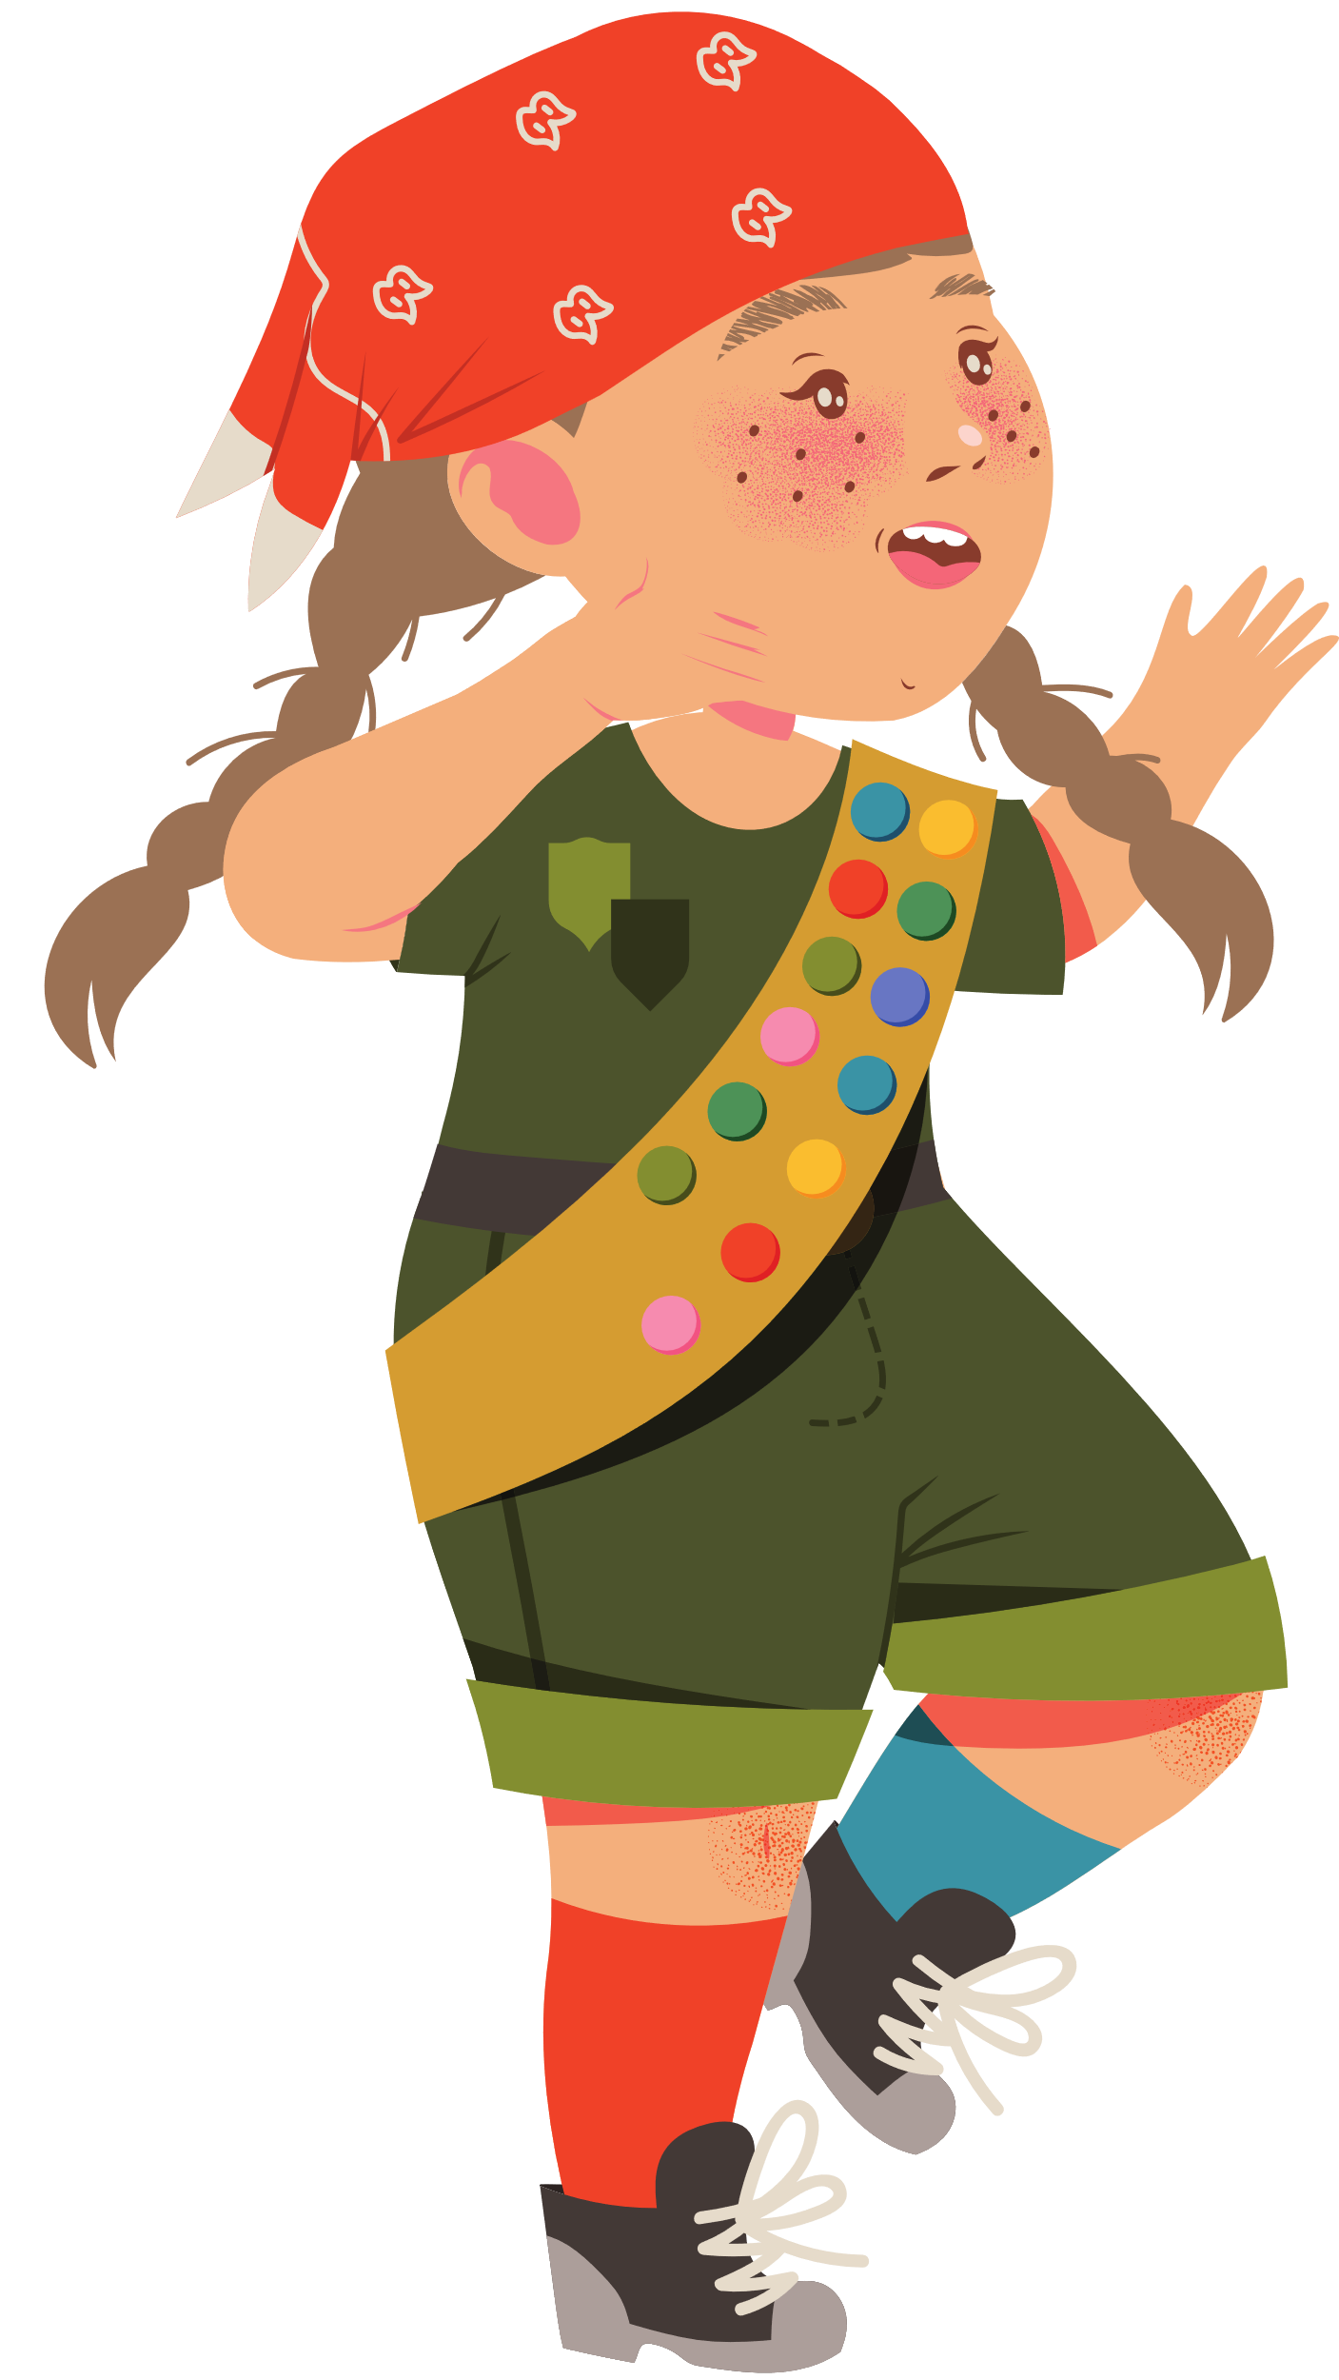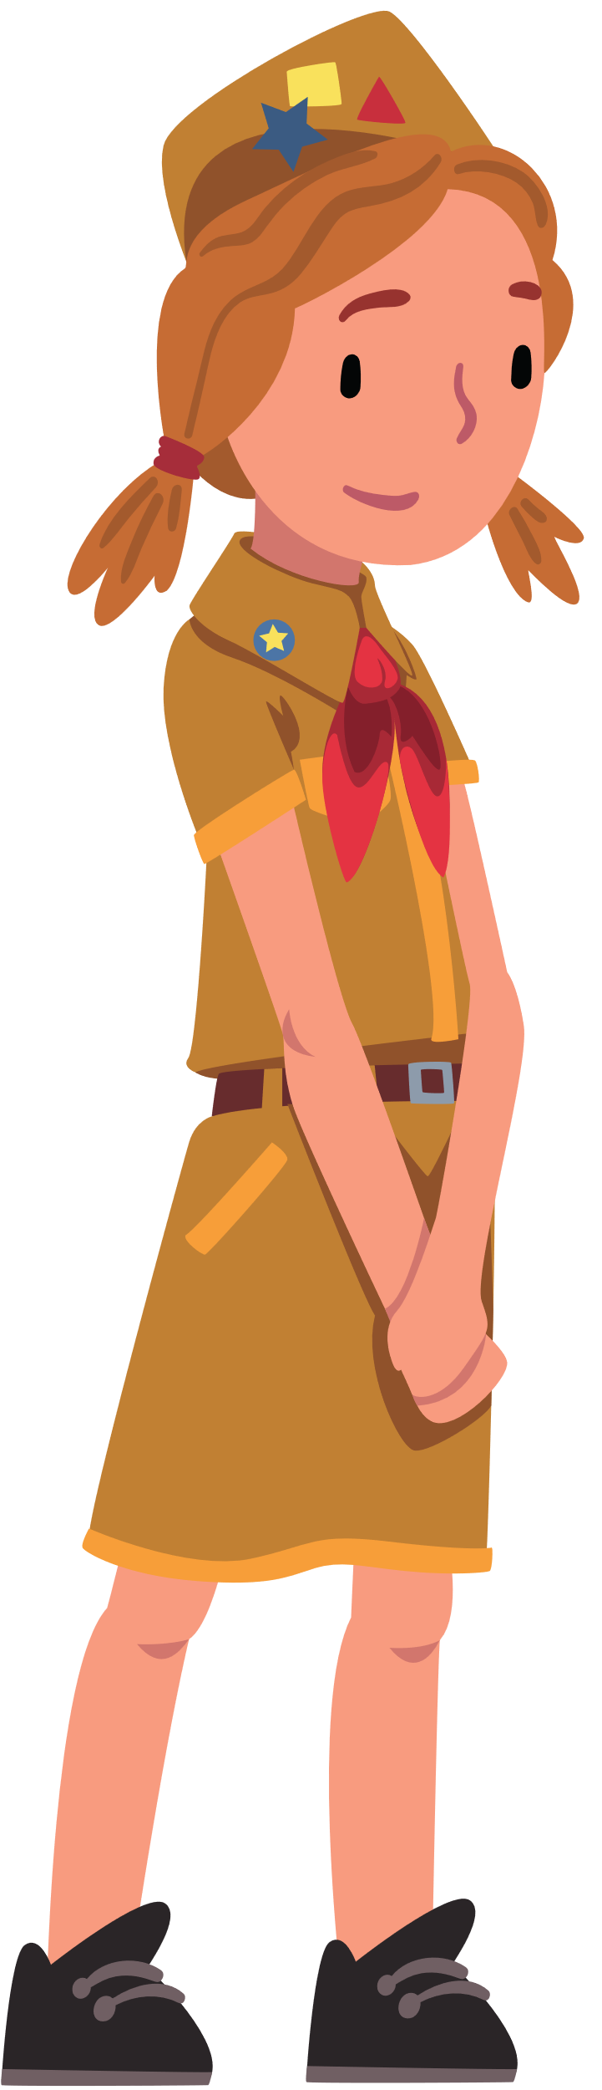

**I will do my**

**best to be**

honest and fair,

friendly and helpful, considerate and caring, courageous and strong, and responsible for

what I say and do.

**I will do my**

**best to be**

honest and fair,

friendly and helpful, considerate and caring, courageous and strong, and responsible for

what I say and do.

**I will do my**

**best to be**

honest and fair,

friendly and helpful, considerate and caring, courageous and strong, and responsible for

what I say and do.

**I will do my**

**best to be**

honest and fair,

friendly and helpful, considerate and caring, courageous and strong, and responsible for

what I say and do.

**GIRL SCOUT BOOKMARK**