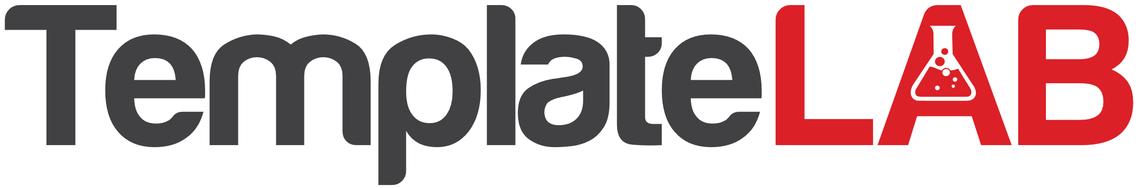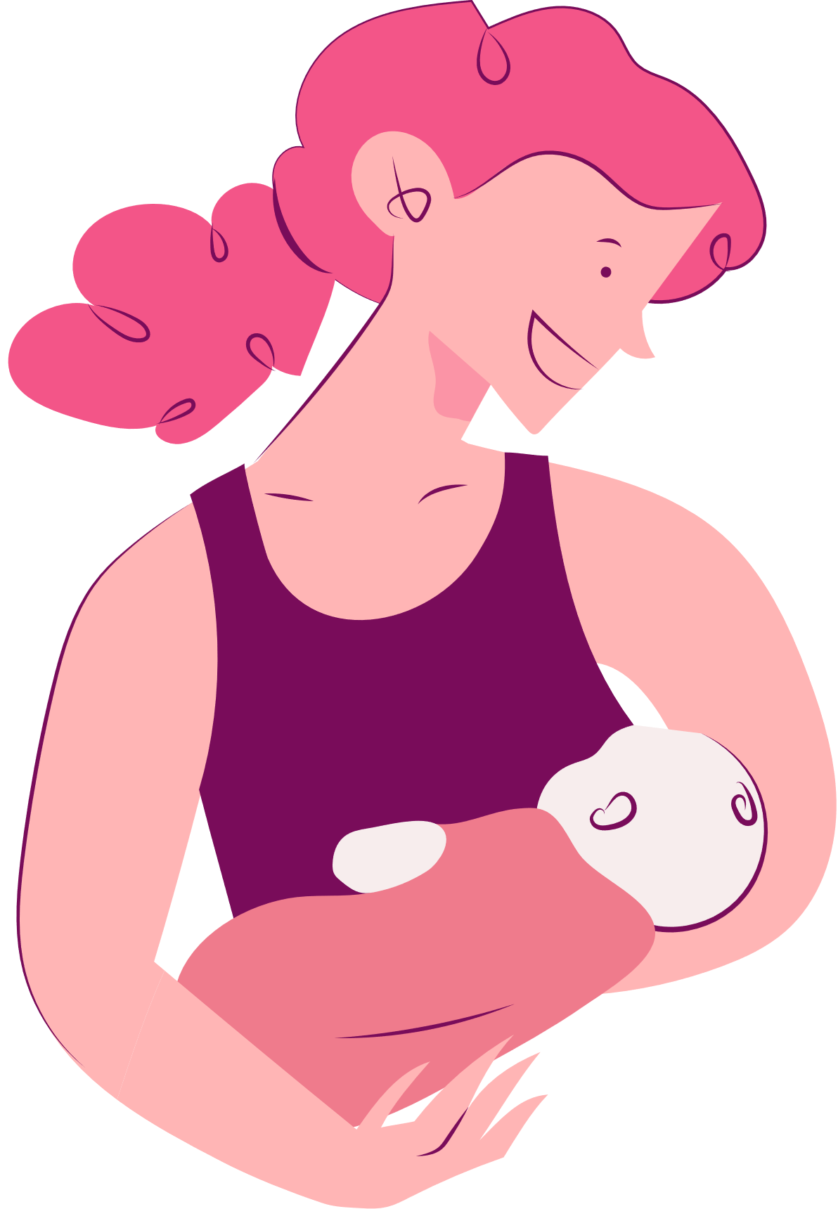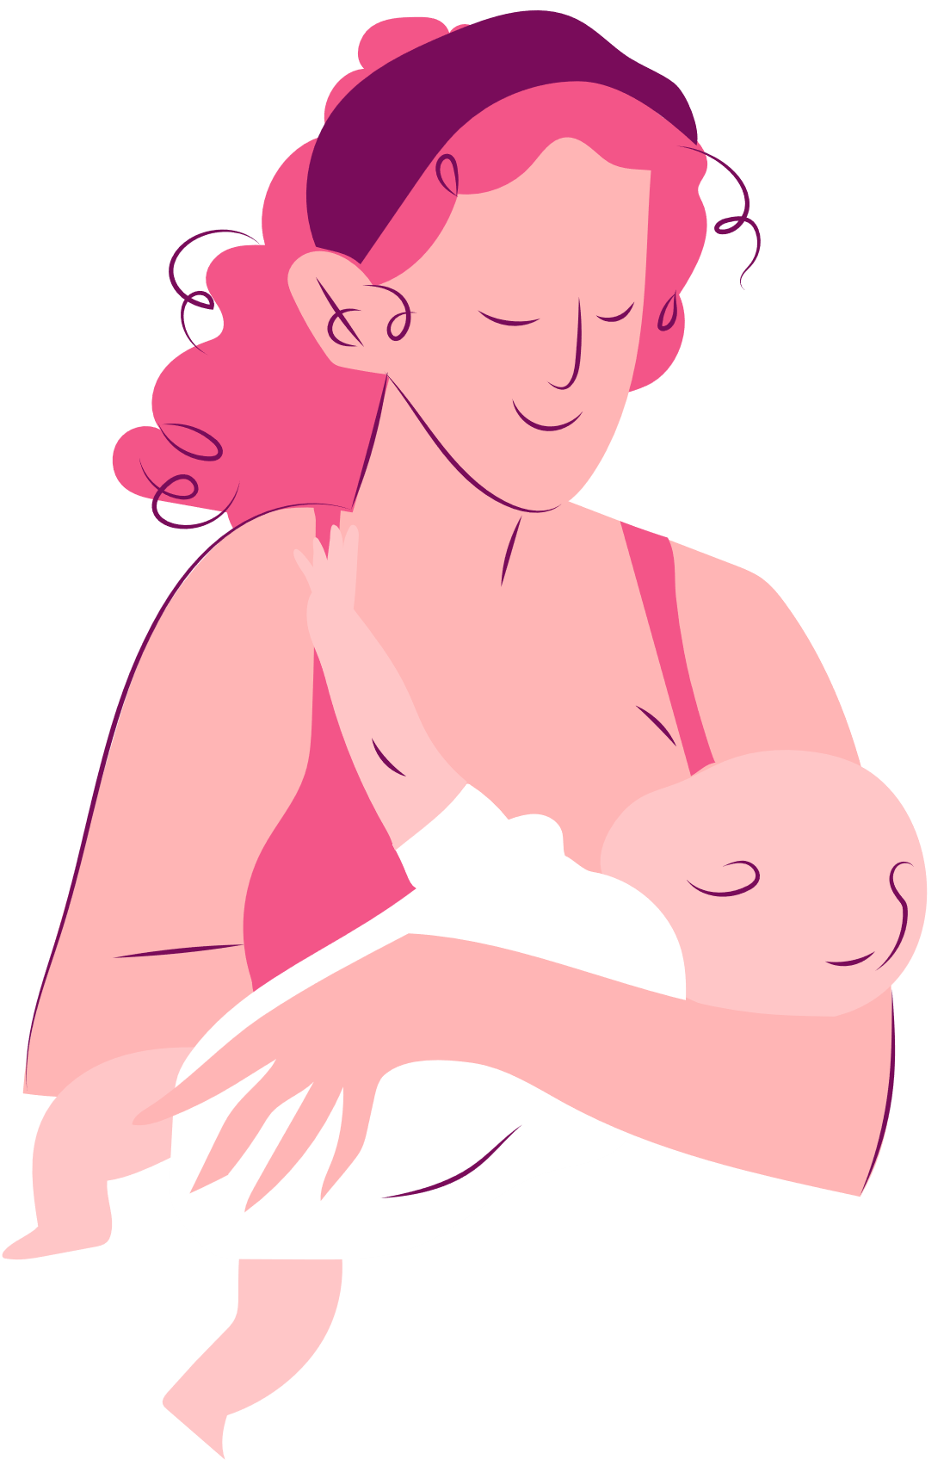

**MOTHER'S DAY BOOKMARK**

Happy

I love you,

Mom!

Thank you

for everything,

Mom!

mother's day!

You're

the best,

Mom!