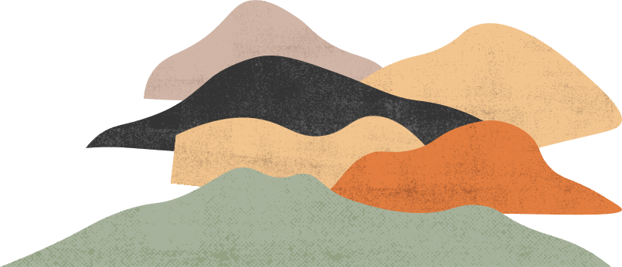

A book is a dream that you hold in your hand



love isn't like it

is in the books

