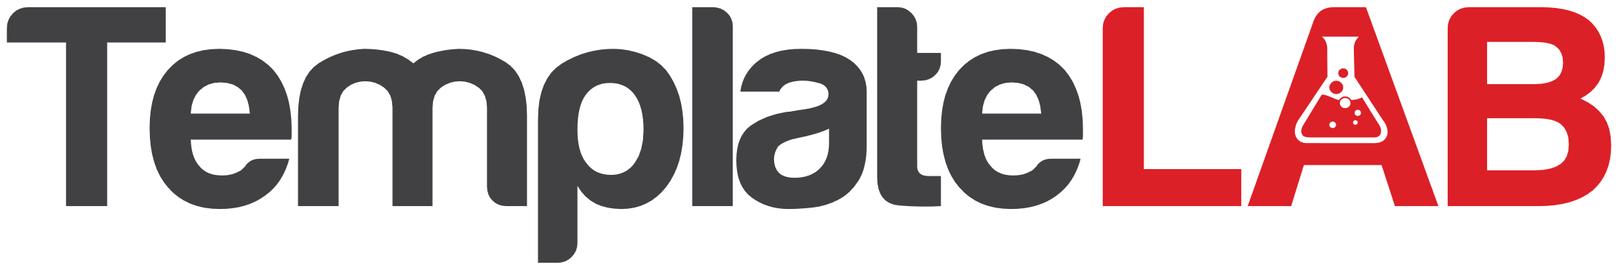

SPA COUPON

20%

WHEN SPEND OVER $50

Discount

**2022 AUG 16**

END DATE

START DATE

**2022 MAY 8**

**HAIR & NAIL**

#BEAUTY & SPA

[The Spa Name]