

**MOTHER'S DAY COUPON**

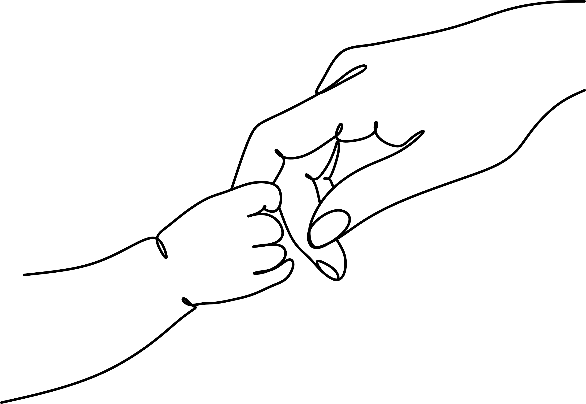

mother's day

mother's day

This coupon is good for...

**EMPTYING THE GARBAGE**



mother's day

mother's day

This coupon is good for...

**AN UNDISTURBED NAP**



mother's day

mother's day

This coupon is good for...

**A BACK RUB**



mother's day

mother's day

This coupon is good for...

**A KISS**



mother's day

mother's day

This coupon is good for...

**A BIG HUG**



mother's day

mother's day

This coupon is good for...

**WASHING UP DISHES**



mother's day

mother's day

This coupon is good for...

**BREAKFAST**

**ON BED**



mother's day

mother's day

This coupon is good for...

**ONE HOUR OF HOUSEWORK**



mother's day

mother's day

This coupon is good for...

**MAKING THE BED WITHOUT BEING ASKED**



mother's day

mother's day

This coupon is good for...

**ONE EXTRA CHORE**



mother's day

mother's day

This coupon is good for...

**A MOVIE NIGHT**



mother's day

mother's day

This coupon is good for...

**AN UNDISTURBED NAP**



mother's day

mother's day

This coupon is good for...

**COOKING WITH MOM**



mother's day

mother's day

This coupon is good for...

**ROOM**

**CLEANUP**



mother's day

mother's day

This coupon is good for...

**A NICE**

**WALKING**



mother's day

mother's day

This coupon is good for...

**PICNIC IN**

**A PARK**



mother's day

mother's day

This coupon is good for...

**PICKUP TOYS**



mother's day

mother's day

This coupon is good for...

**NO COMPLAINTS**