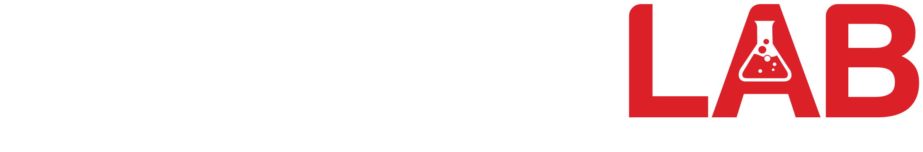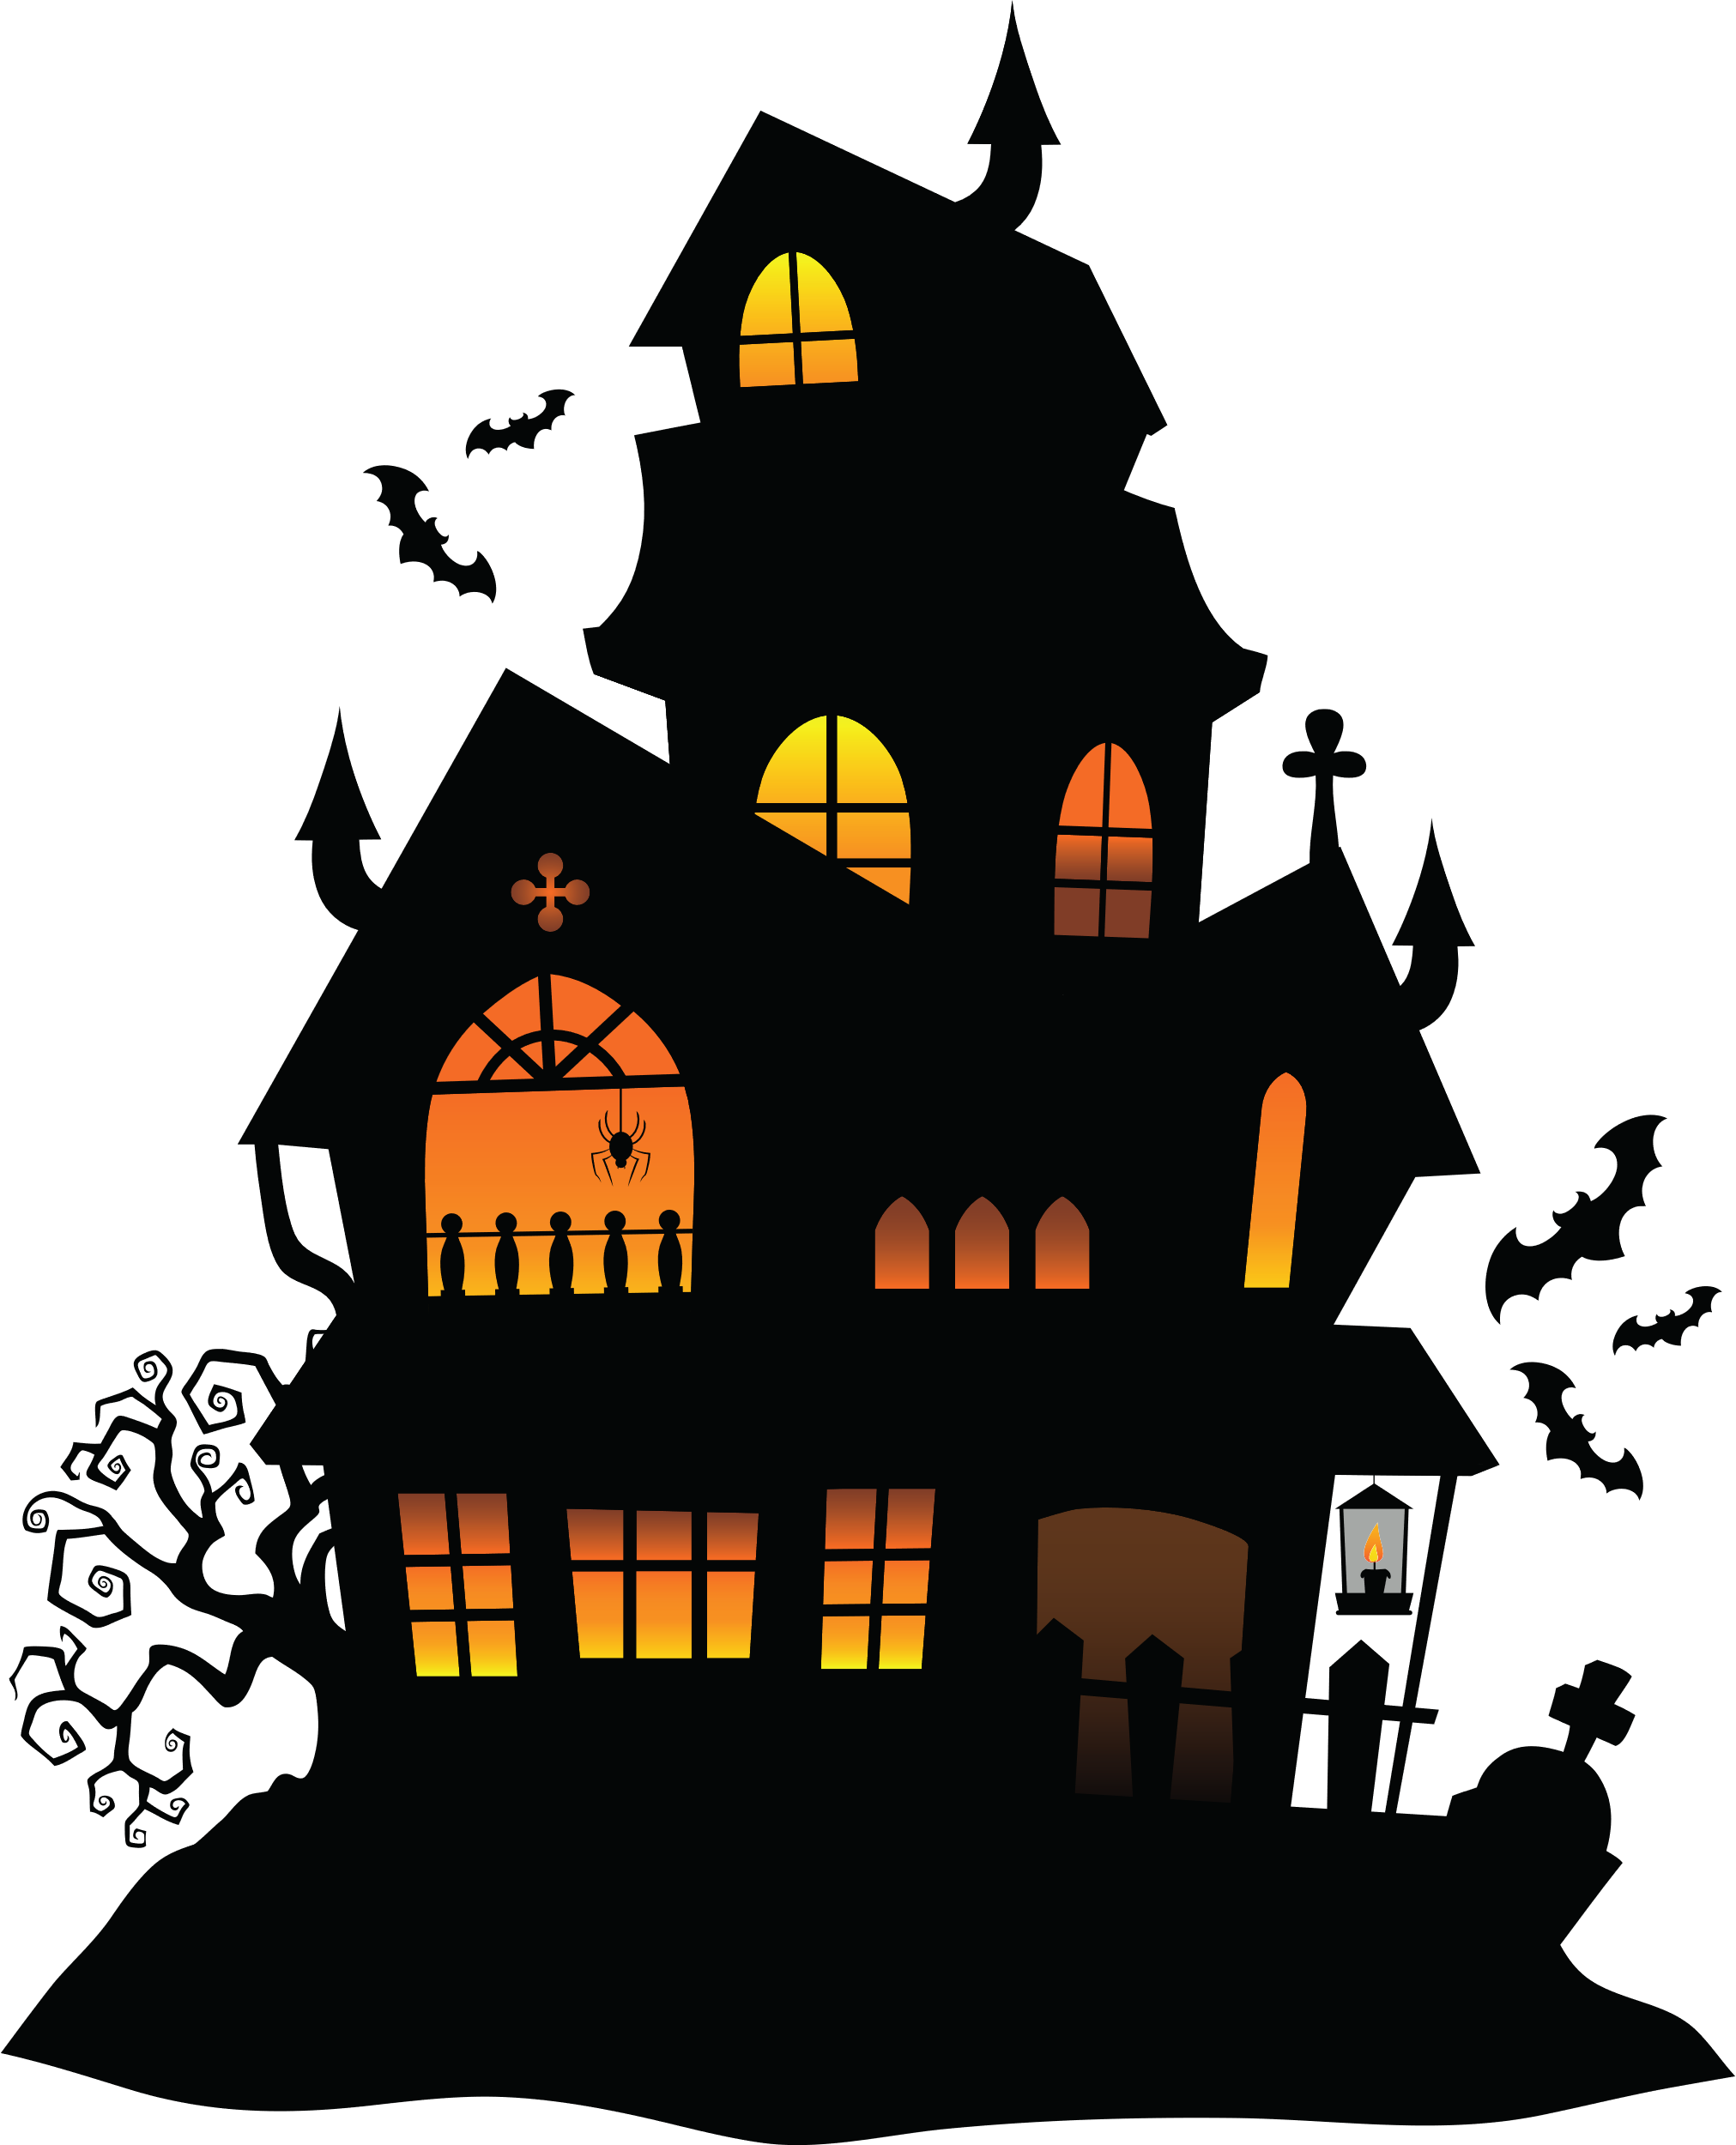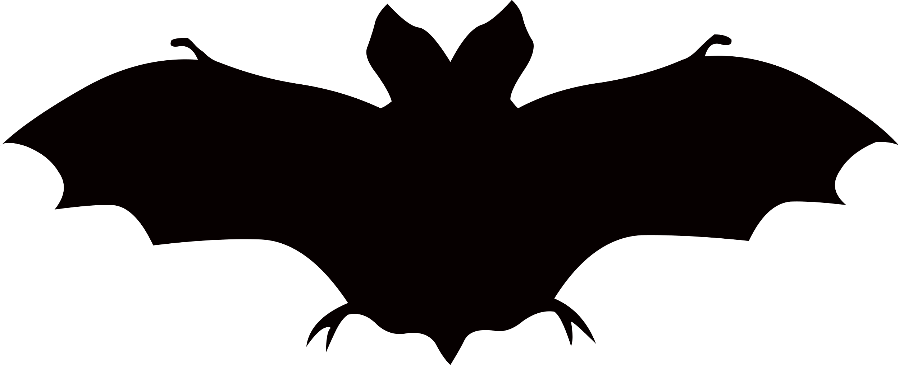

**123 Anywhere St., Any City**

**AT 10 PM**

**OCTOBER 31, 2029**

**FOR DRINKS**

**USE IN THE PARTY BEFORE 11:30PM**

Halloween

Party

Buy 2 get 1