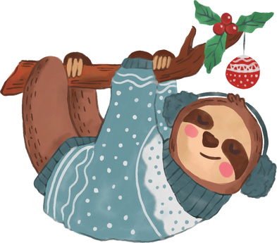

$50

TICKET CODE : 00-00-01

123 Anywhere St., Any City

123-456-7890

FOR USE IN-STORE ONLY

2025 DEC 24

END DATE

START DATE

2025 DEC 05

CHRISTMAS COUPON

The Story Name