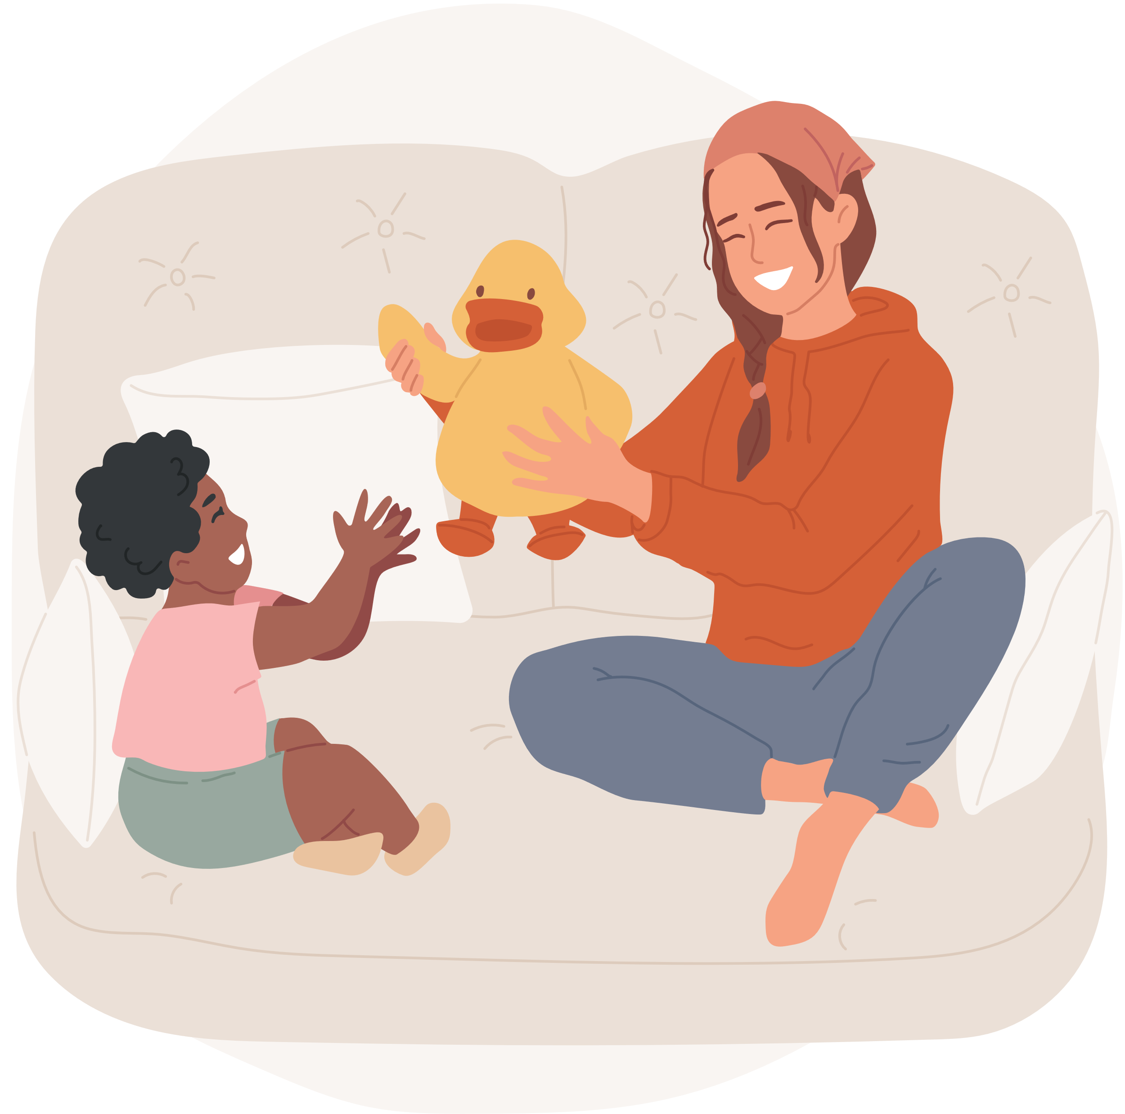

ONE NIGHT FREE OF

**BABYSITTING**

THIS COUPON HAS A VALUE OF THREE HOURS WORTH OF BABYSITTING YOUR LOVELY NUGGETS. FOR FREE.

VALID UNTIL JANUARY 09, 2022

