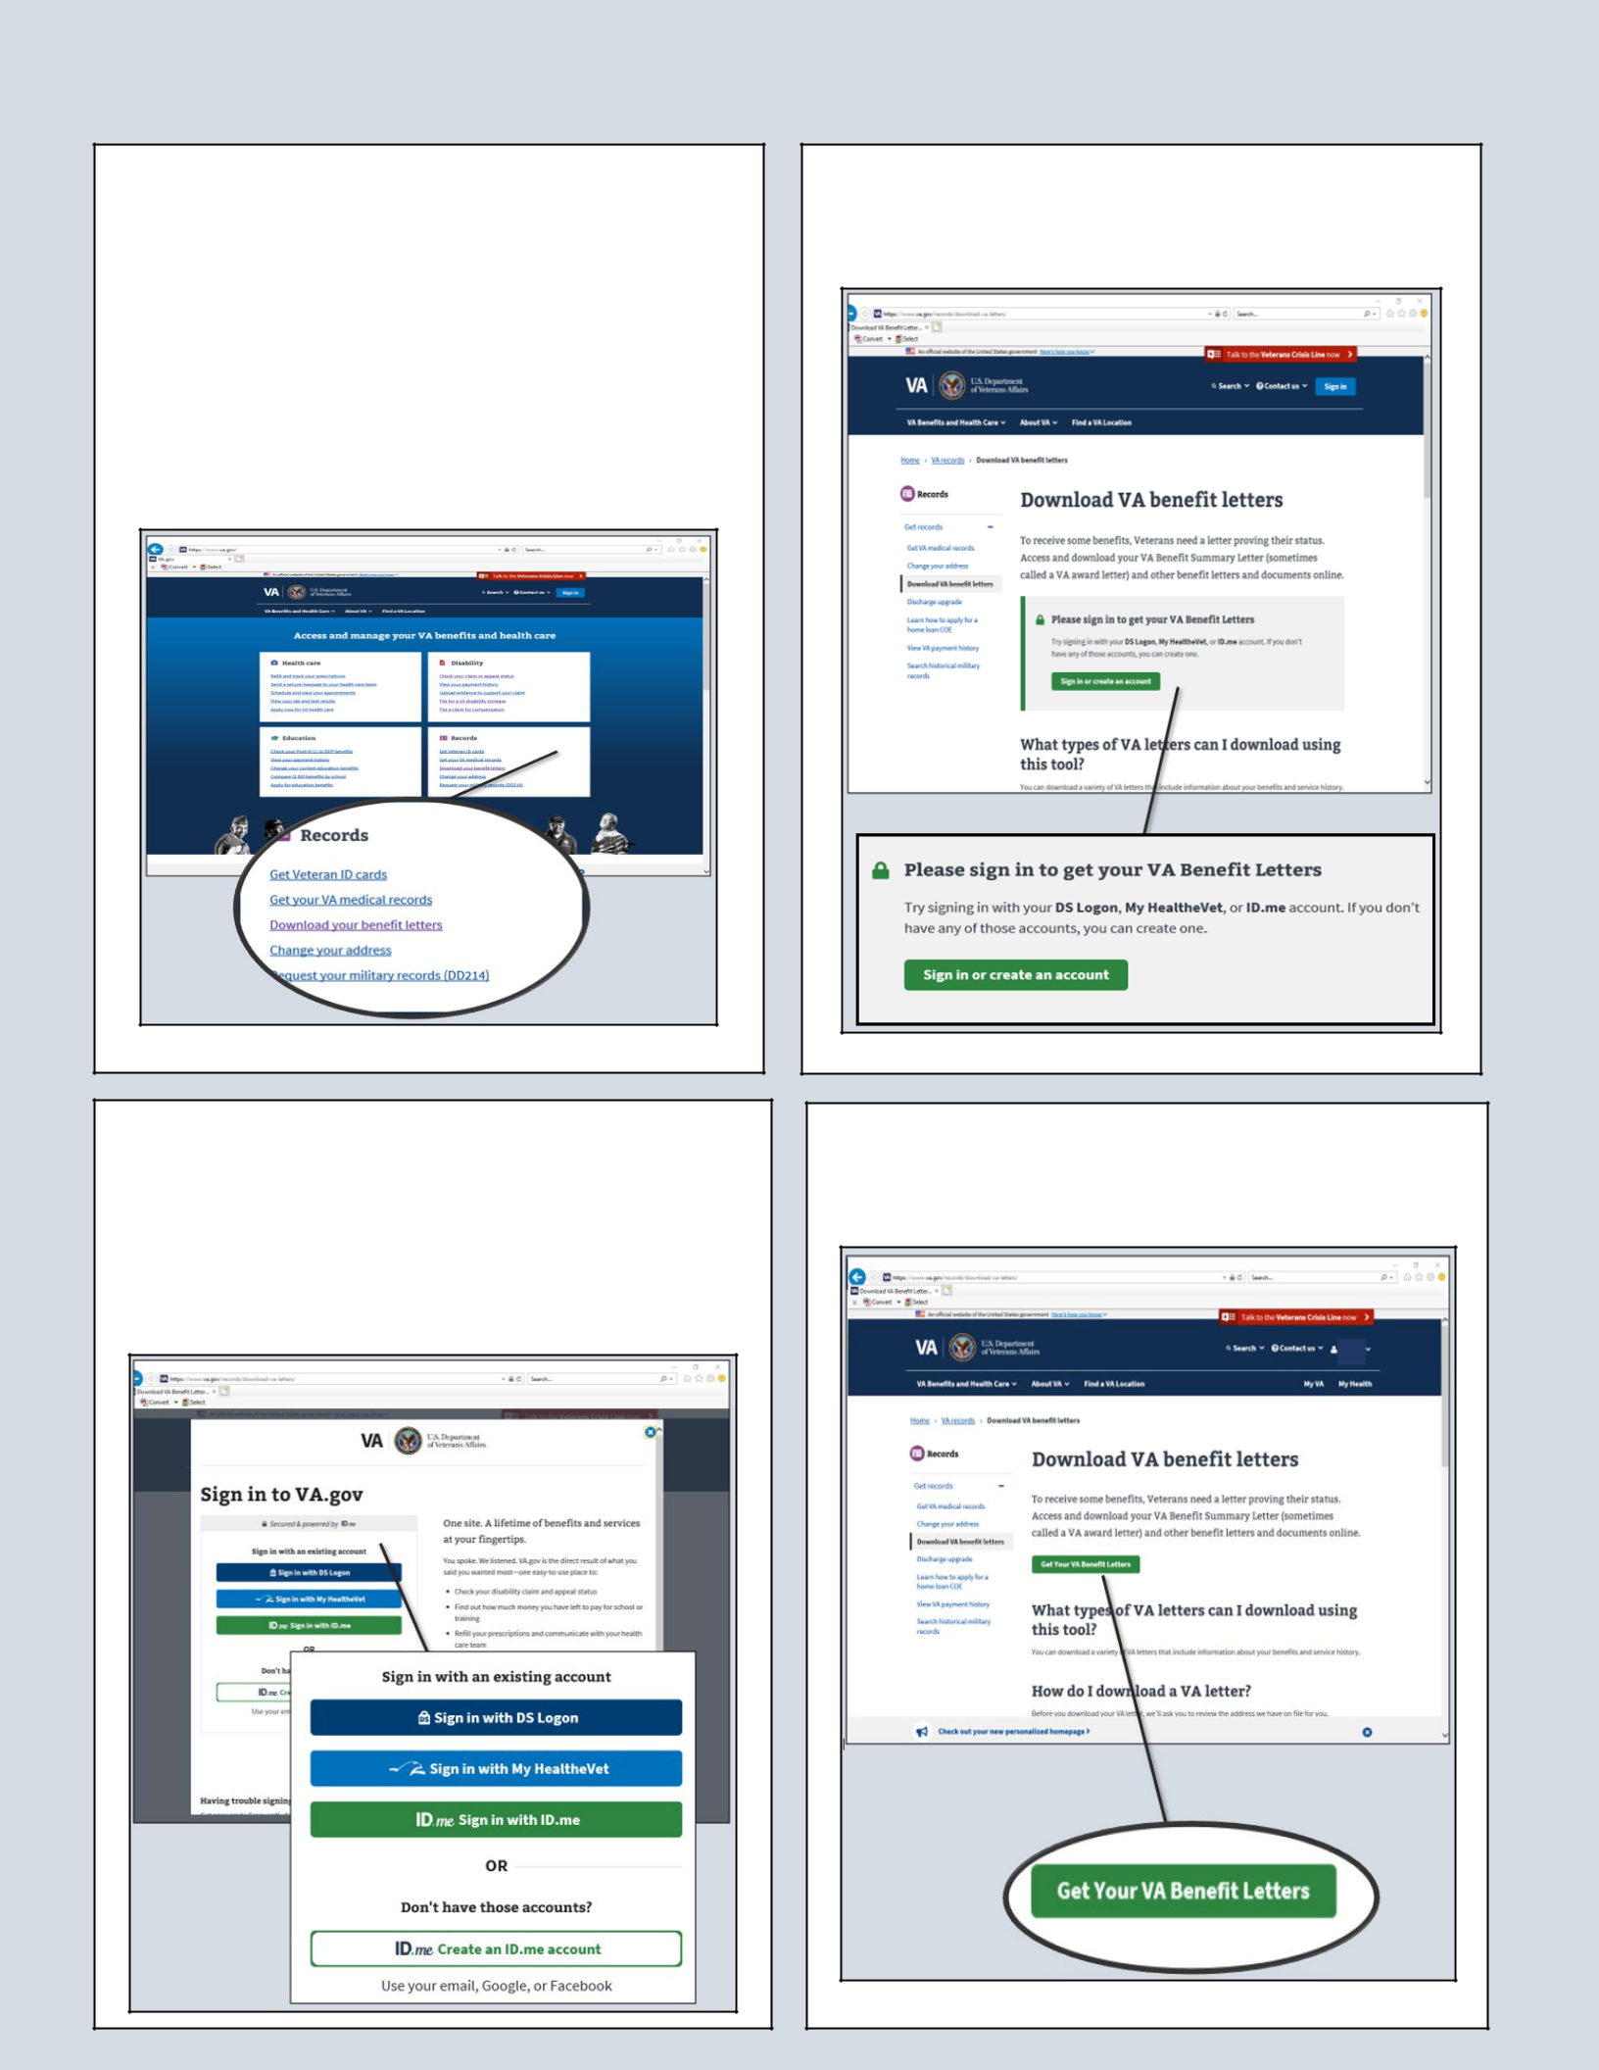
HOW TO… Retrieve Benefit Letters From VA.GOV

- Step 1. Access va.gov website via any internet browser (https://www.va.gov/).

- Step 2. Select “Download your benefit letters” from the Records section on the website.

- Step 3. Select the “Sign in or create an account” action button.

- Step 4. Choose one of the secure Sign In options. Enter User name and passwords according to sign in choice.

>>Step 5. Select the “Get Your VA Benefit Letters” action button.

- Step 6. Review your address.

- Step 7. Select “View Letters” action button.
- Step 8. Select the “+” sign next to the Benefit Summary and Service Verification Letter.
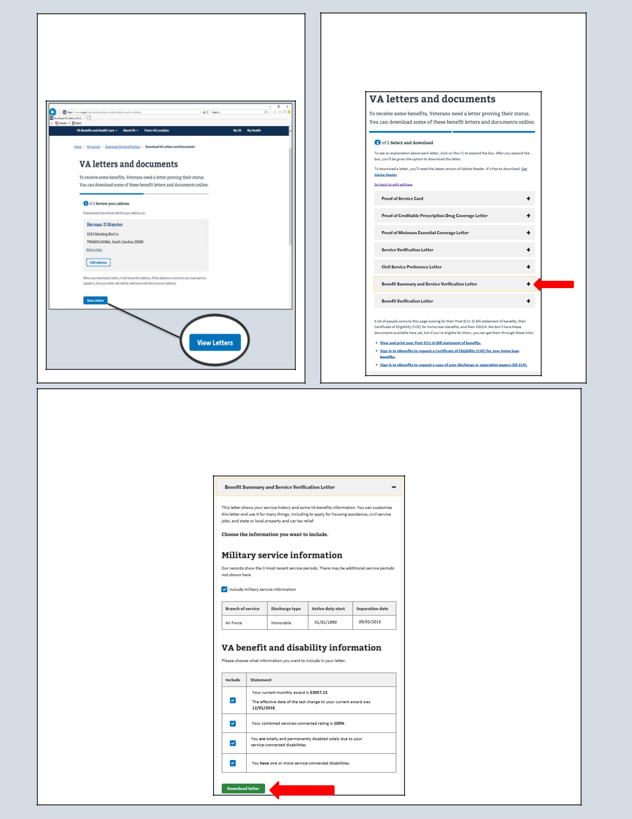

- Step 9. Check the boxes beside the sections you would like to include in the letter. (Award amount, Type of rating, Permanent and Total standing, etc.)

- Step 10. Download and Save/Print

Example Benefit Summary and Service Verification Letter
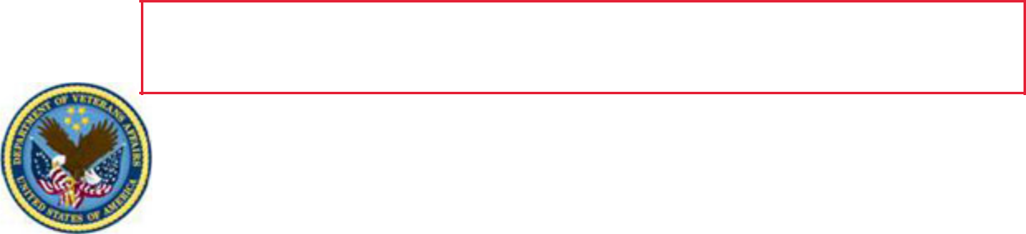
with Permanent and Total designation

DEPARTMENT OF VETERANS AFFAIRS

810 Vermont Ave NW

Washington, D.C. 20420

July 03, 2019

Herman D. Munster In Reply Refer to:
1313 Mocking Bird Lane, xxx-xx-1234

Transylvania, SC 29000 27/eBenefits

Dear Mr. Munster:

This letter is a summary of benefits you currently receive from the Department of Veterans Affairs (VA). We are providing this letter to disabled Veterans to use in applying for benefits such as state or local property or vehicle tax relief, civil service preference, to obtain housing entitlements, free or reduced state park annual memberships, or any other program or entitlement in which verification of VA benefits is required. Please safeguard this important document. This letter is considered an official record of your VA entitlement.


Our records contain the following information:

Personal Claim Information

Your VA claim number is: xxx-xx-1234

You are the Veteran.

Military Information

Your most recent, verified periods of service (up to three) include:

Branch of Service Character of Service Entered Active Duty Released/Discharged

Air Force Honorable January 01, 1990 September 03, 2015

(There may be additional periods of service not listed above.)

VA Benefit Information

You have one or more service-connected disabilities:

Your combined service-connected evaluation is:

Your current monthly award amount is:

The effective date of the last change to your current award was:

You are considered to be totally and permanently disabled due solely to your service-connected disabilities:

The effective date of when you became totally and permanently disabled due to your service-connected disabilities:

Yes

100%

$3057.13

December 01, 2018

Yes

January 01, 2016

You should contact your state or local office of Veterans' affairs for information on any tax, license, or fee-related benefits for which you may be eligible. State offices of Veterans' affairs are available at http://www.va.gov/statedva.htm.

How You Can Contact Us

If you need general information about benefits and eligibility, please visit us at https://www.ebenefits.va.gov or

