

COMMUNITY CLINICAL | GILGAL, INC.

OCTOBER 15, 2020



Track the
past, organize
the present,
design the
future.

-Ryder Carroll


What is
- Bullet Journal?

Bullet Journal:


- simplified, one-stop organizational system for daily productivity and self-reflection.


A bullet journal is a customizable productivity tool – make it yours!


Key

Components

Features

Optional

Components

- Page Numbers

- Index

- Key

- Calendars

- Habit Trackers

- Symptom Trackers

- Mood Trackers

- Sleep Diaries

- Food Diaries

- Reflections

- Project Planners
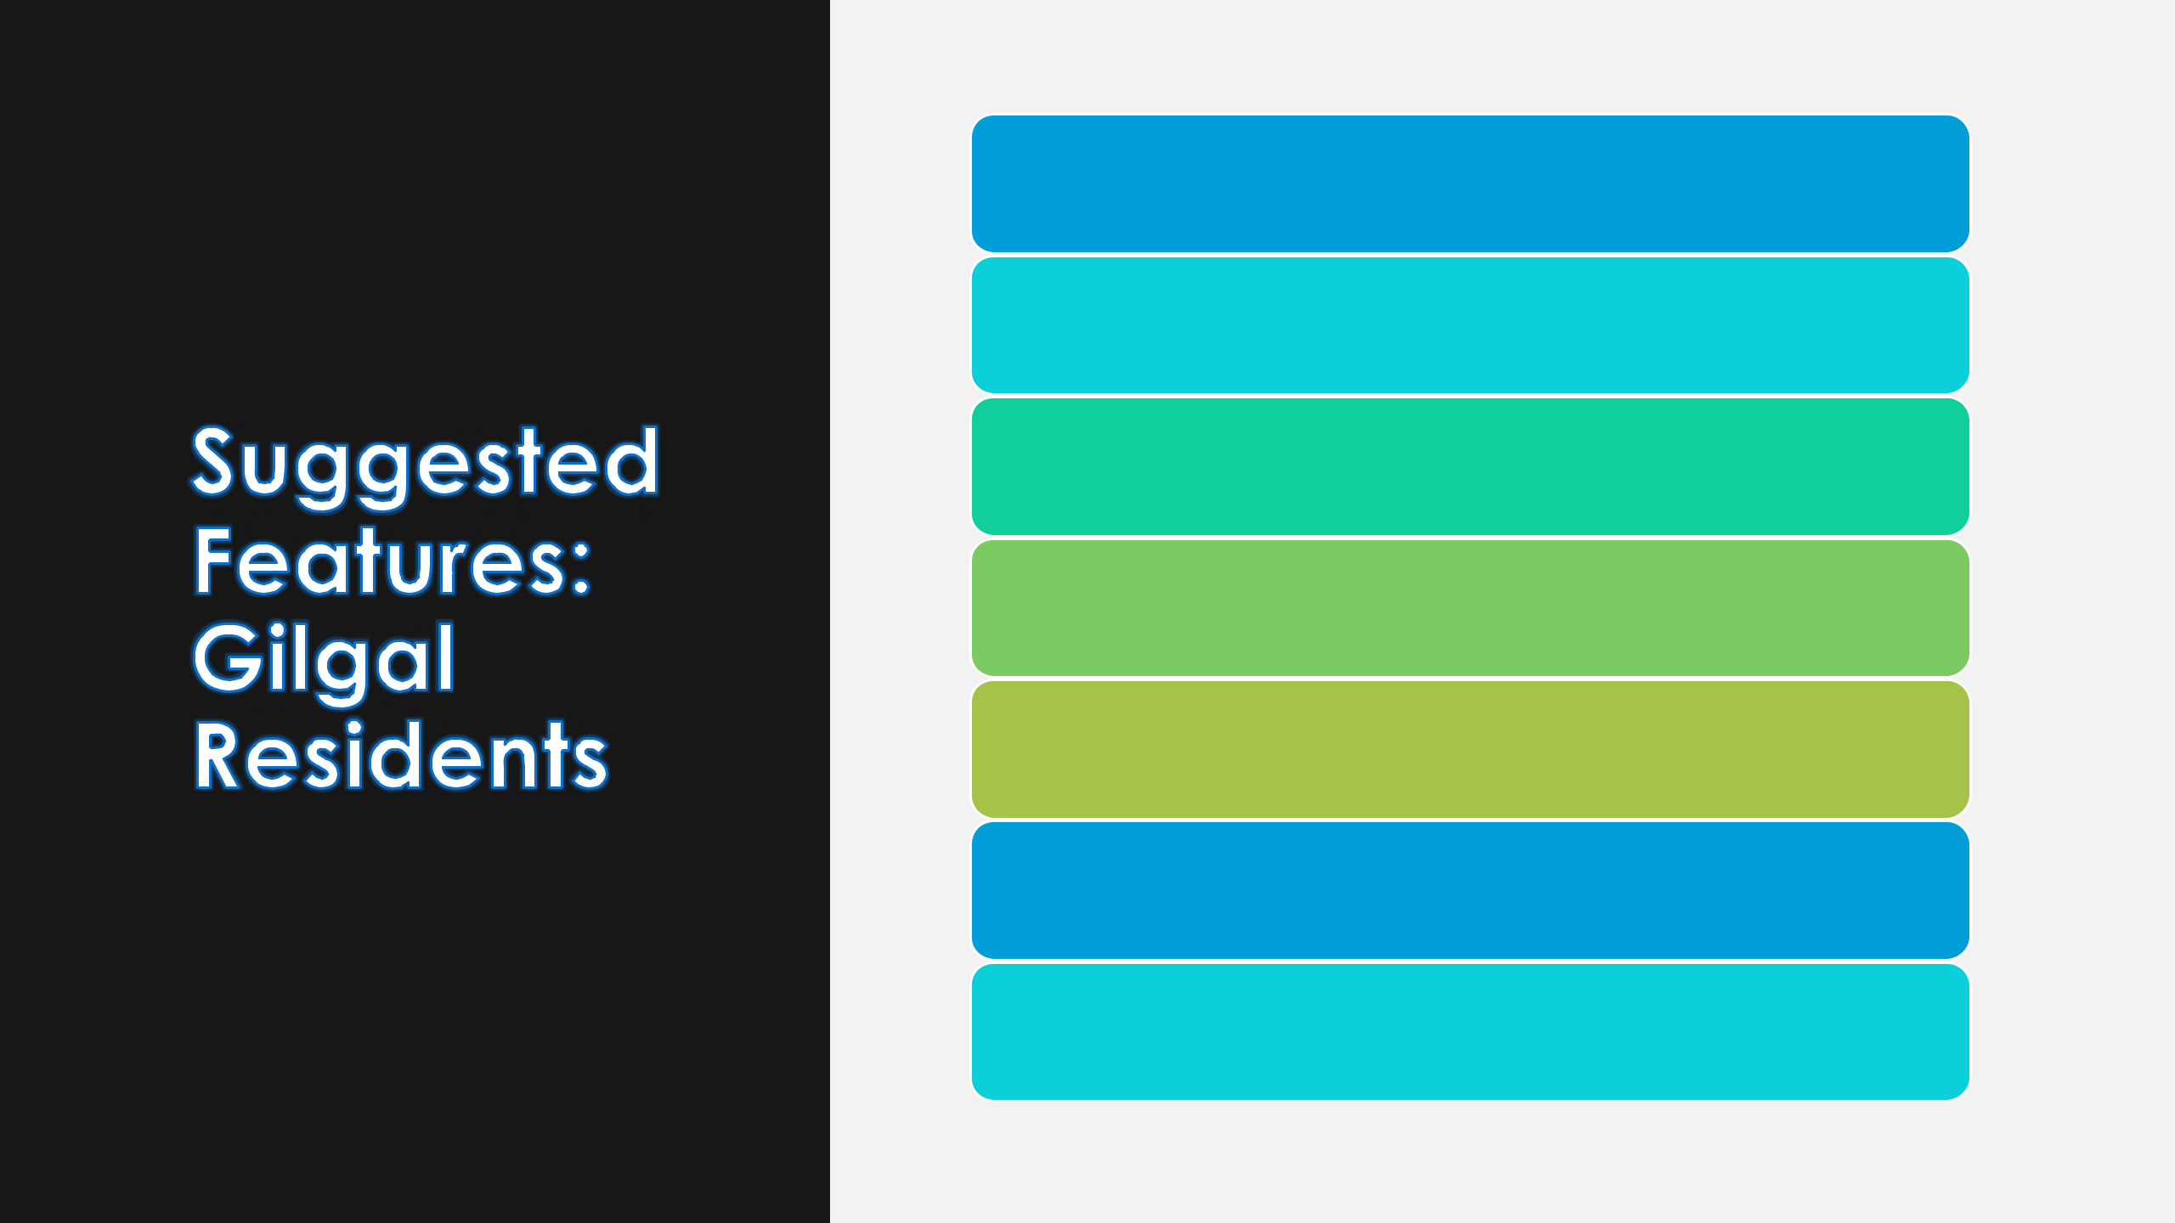
- PAGE NUMBERS

- INDEX

- KEY

- CALENDARS

- EXERCISE TRACKER

- HEALTH MANAGEMENT

- REFLECTIONS



PAGE NUMBERS



Page numbers are essential to every bullet journal - they help you find specific notes and journal entries easily!

INDEX


INDEX
The index helps you

keep track of notes

and journal entries

Each journal entry is

logged in the index

by description or
title and page

number.
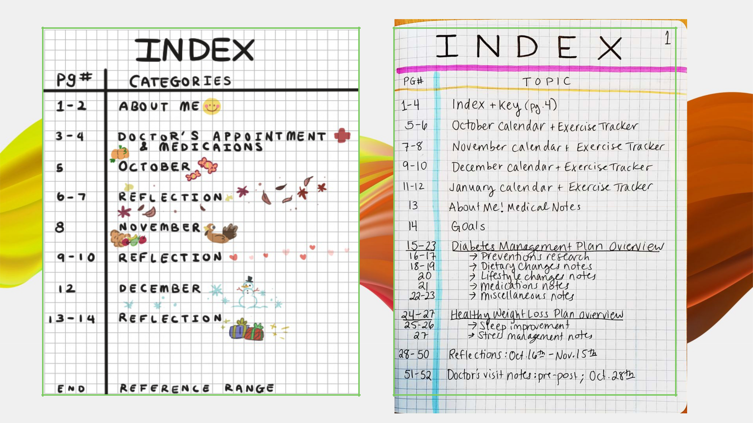

KEY

KEY
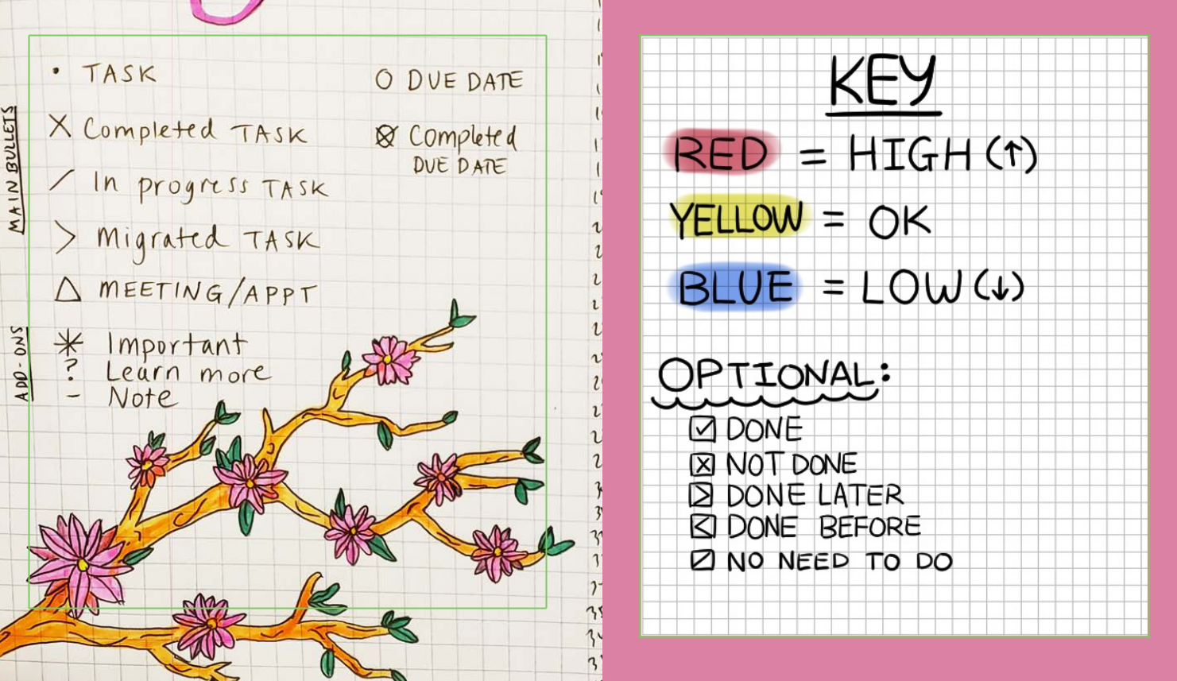

Bullet journals use symbols


to save space and keep

notes organized.

You can also use different colors to help identify important information.

Adding a key to the front of your journal helps keep track of your unique system.

CALENDARS


CALENDARS

Monthly calendars are a great way to keep track of your schedule and look ahead to the future.

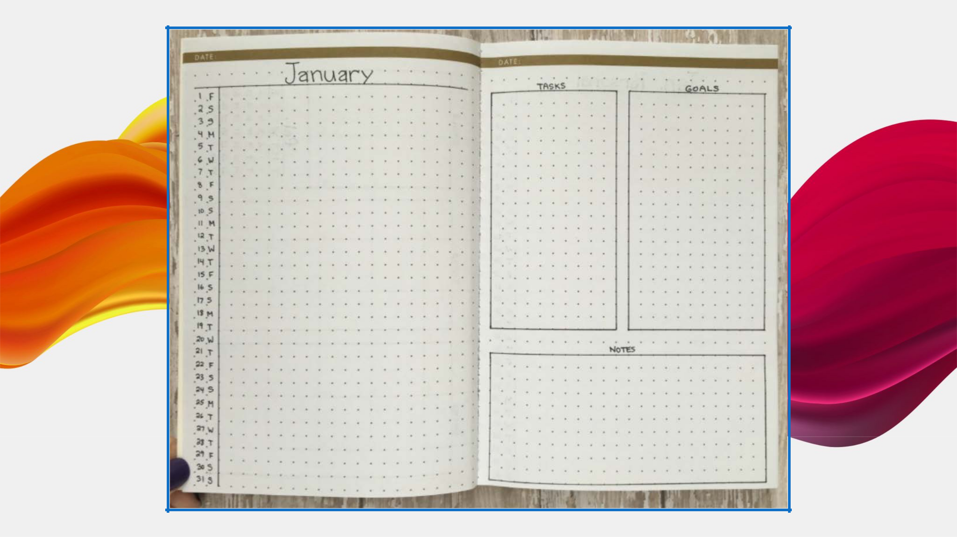
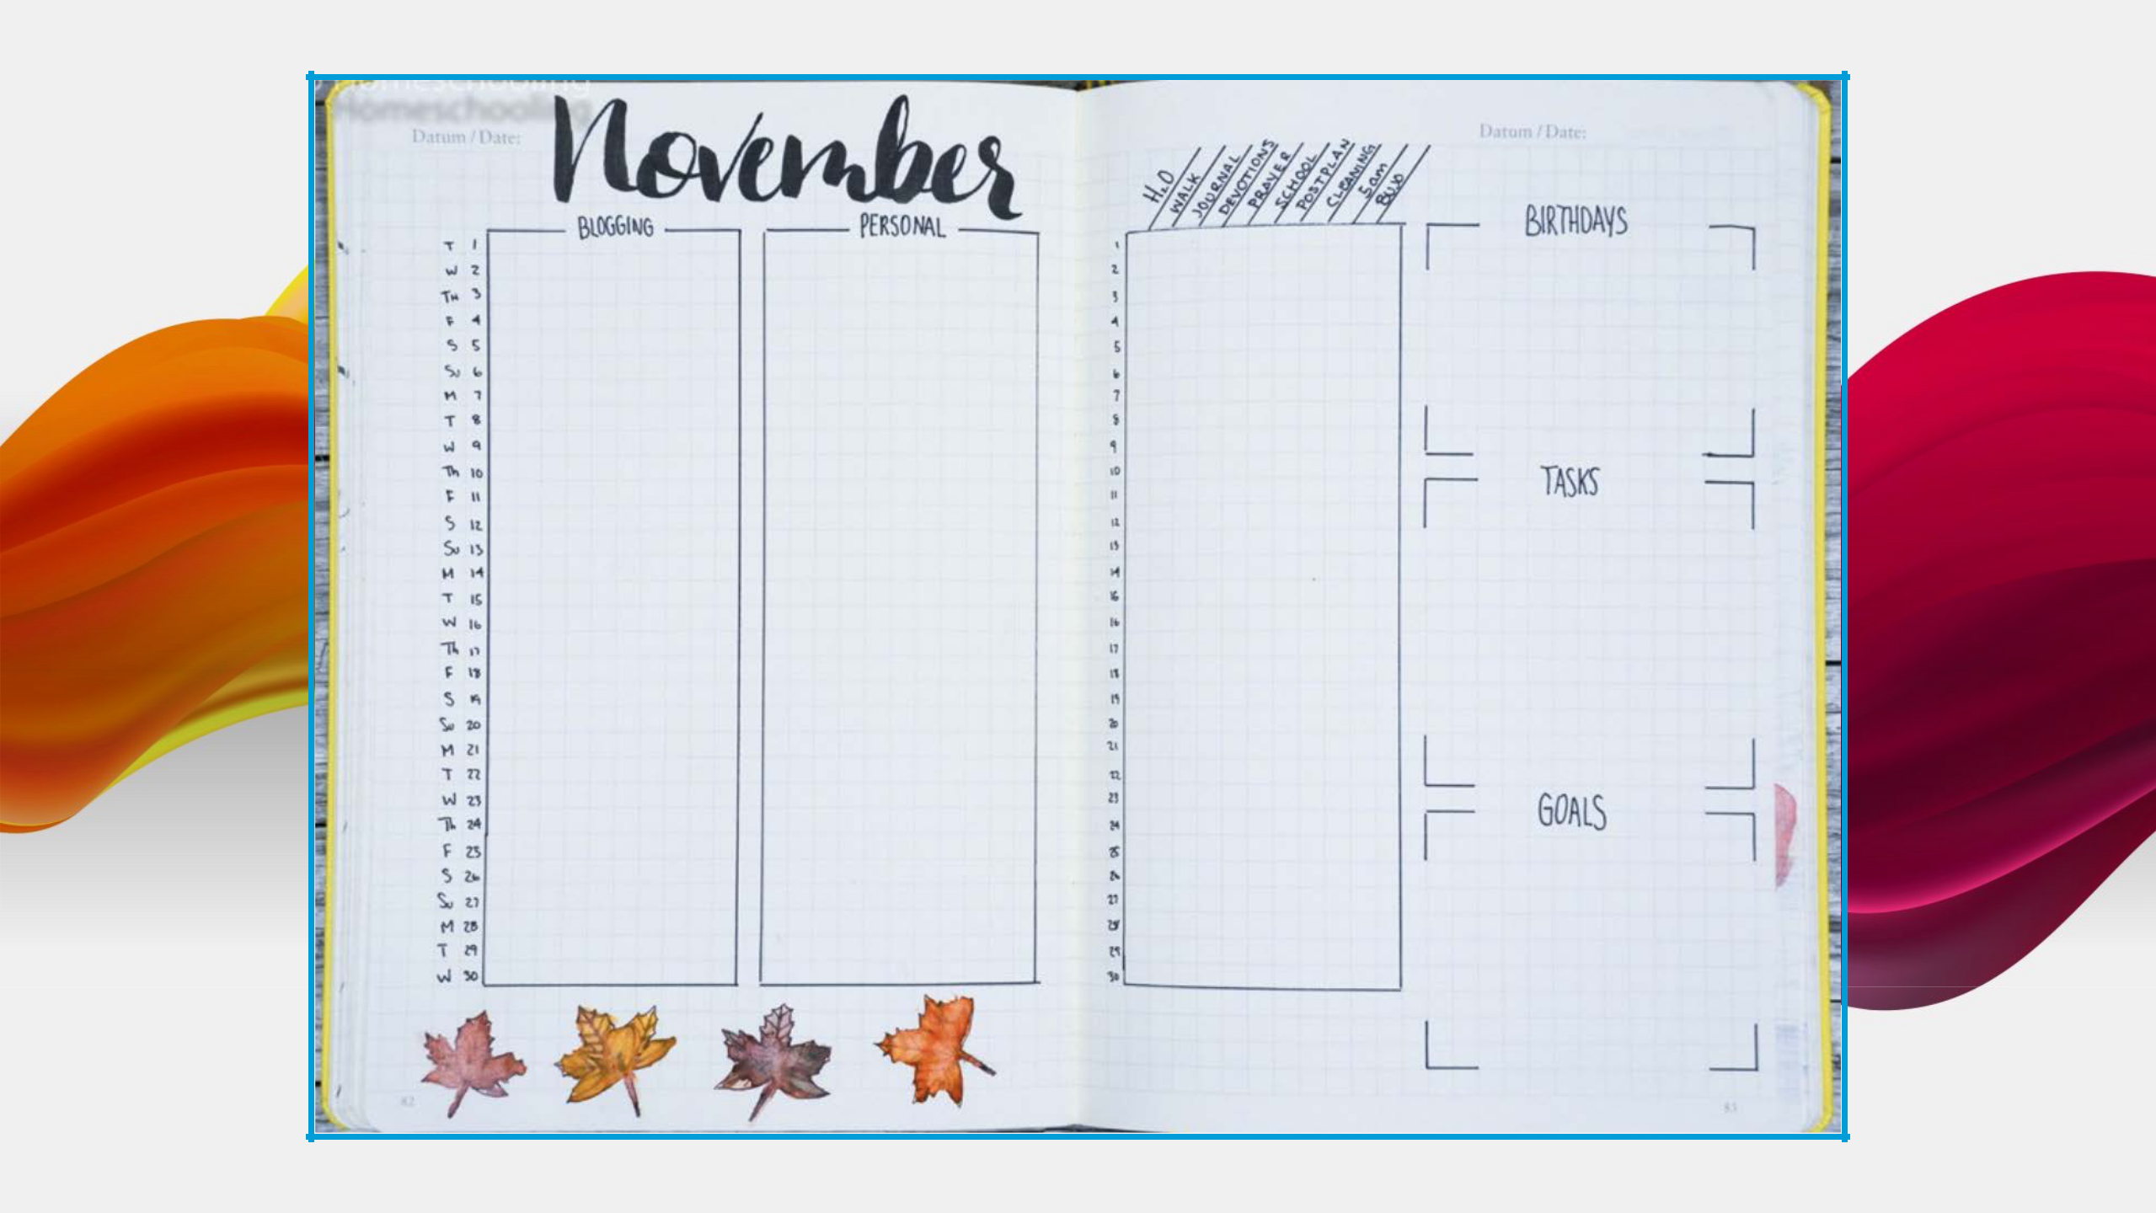
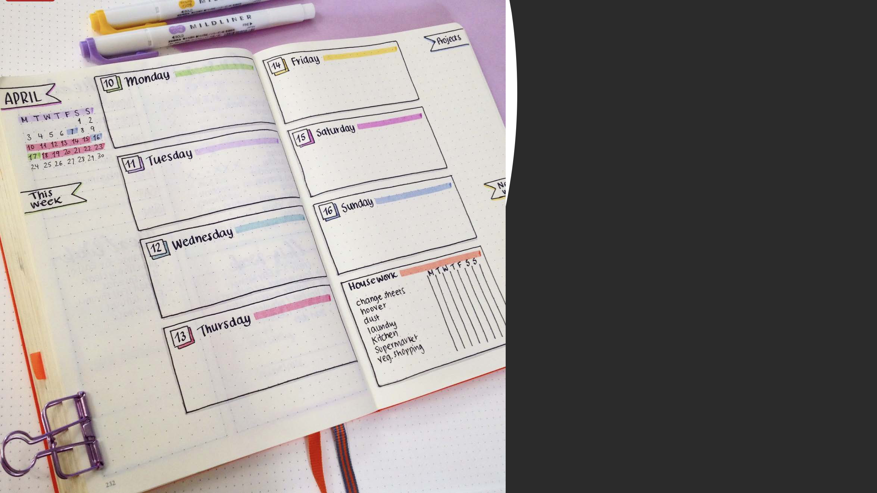

You can add

weekly
calendars to fit in more detail!

HABIT/SYMPTOM TRACKERS
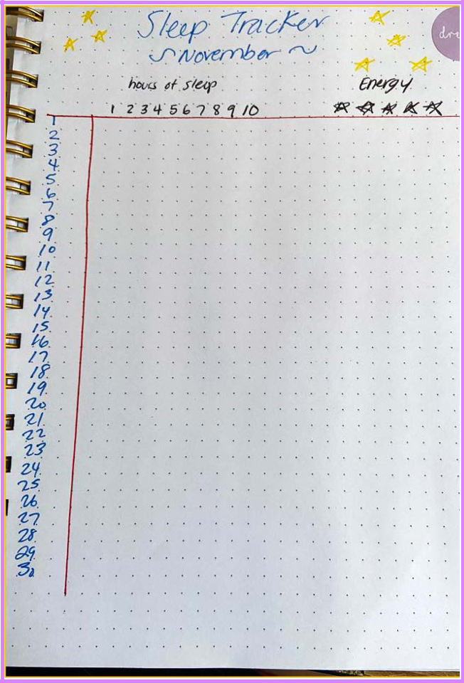
Habit/Symptom Trackers

- Adding a habit or symptom tracker to your monthly calendar can be a helpful way to build habits and manage your health.

- Habit trackers help you to stay motivated when building new habits.

- Symptom trackers can help you identify patterns in your health.

- You may even start to notice relationships between your habits and your symptoms.

- For example, when you get more hours of sleep, do you have more energy?
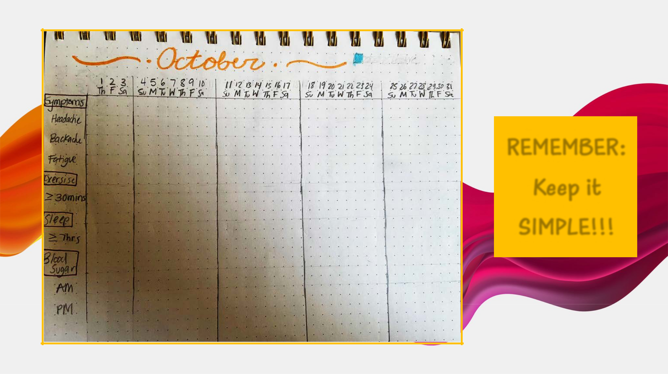

REMEMBER:

Keep it

SIMPLE!!!
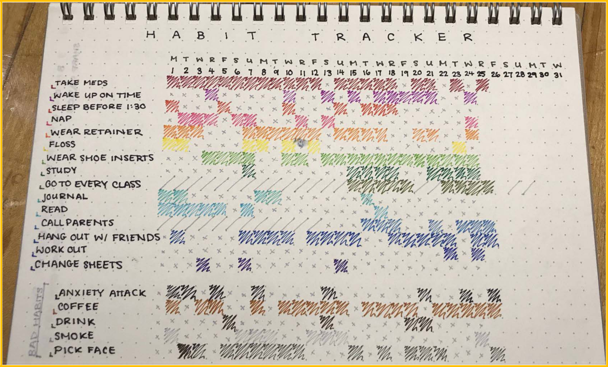

EXERCISE TRACKER

Exercise Tracker

Later in the presentation, we will be

introducing our Exercise Tracking Competition.

You are all invited to compete and earn Wal-

Mart gift cards!

If you wish to participate, you will need to

create an Exercise Tracking page in your bullet

journal. Standby for more details!
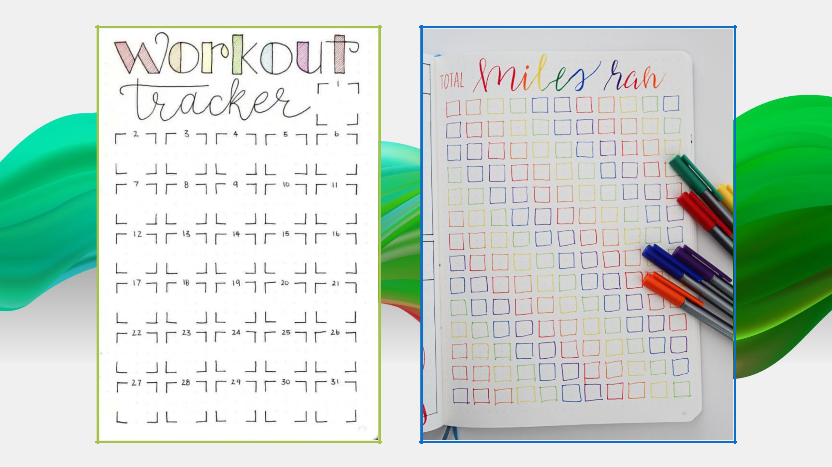

HEALTH MANAGEMENT


PART 1: About Me

PART 1: About Me

- You may have noticed that every doctor’s office asks you for the same information over and over.

- Keeping this information in one place can save you time and stress.

  - Plus it helps your medical team give you best possible care.

Info to Include:

- Name

- Allergies

- Personal Medical/Surgical History
  - Current and previous diagnoses
  - Major surgeries

- Family Medical History
  - Cancer? Diabetes? Heart Disease? Mental illnesses?

- Medication List

  - Drug name, dosage, time, and frequency

- Primary Care Provider and Specialists Information

  - Name and contact information

- Pharmacy name, address, and phone number
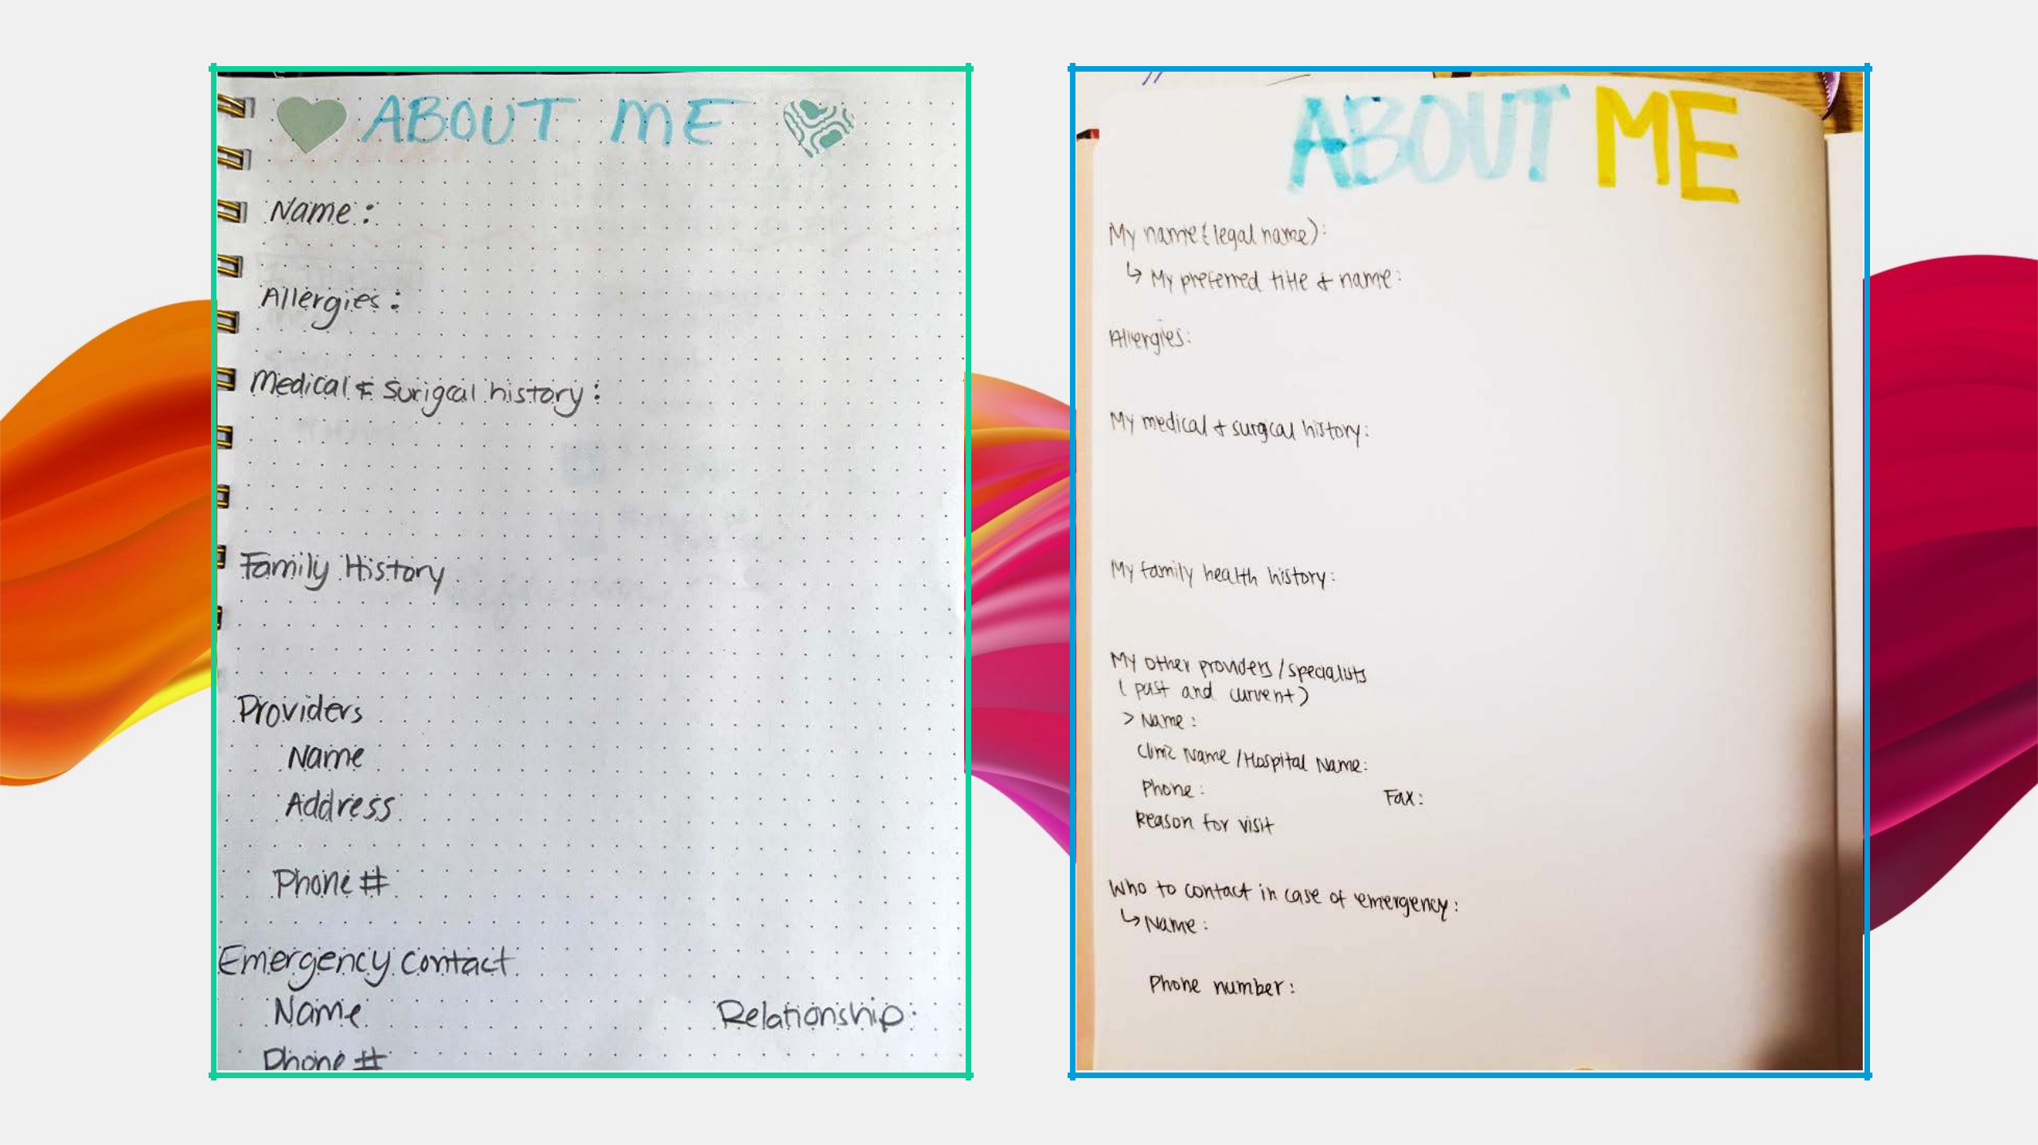

PART 2: Medical Journaling
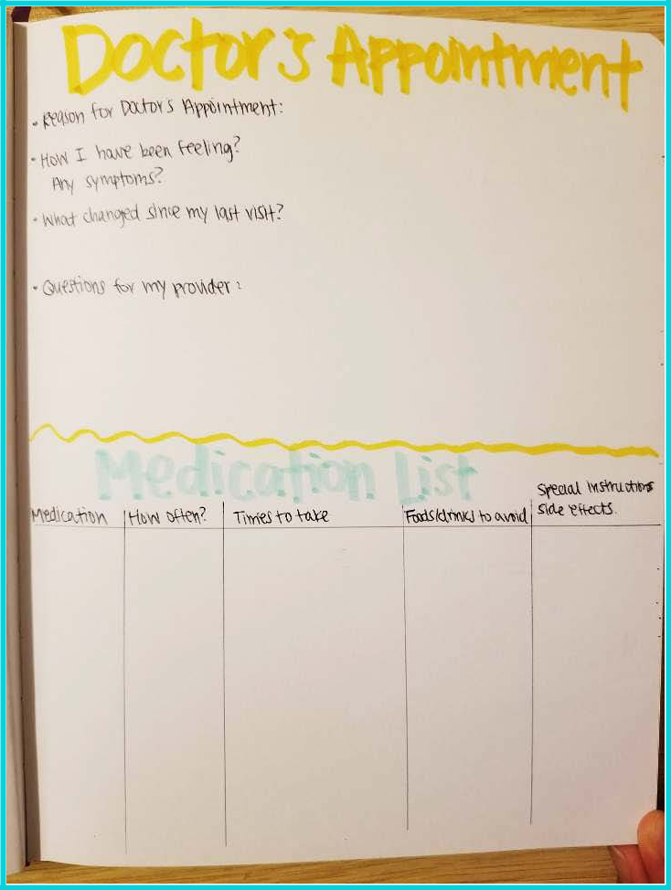
PART 2: Medical Journaling

- As we discussed previously, bringing a journal to your doctor’s appointments can be very helpful.
- Before your appointment, take notes on any symptoms, changes, or questions that you may have.

- During your appointment, use your journal to take notes on the information your doctor provides.

PART 3: Project Planners

PART 3: Project Planners

- When you are trying to tackle a large project or an intimidating goal, it can be helpful to break it down into small steps.

- Project Planners are a great way to accomplish this.

- They help you visualize and track your progress
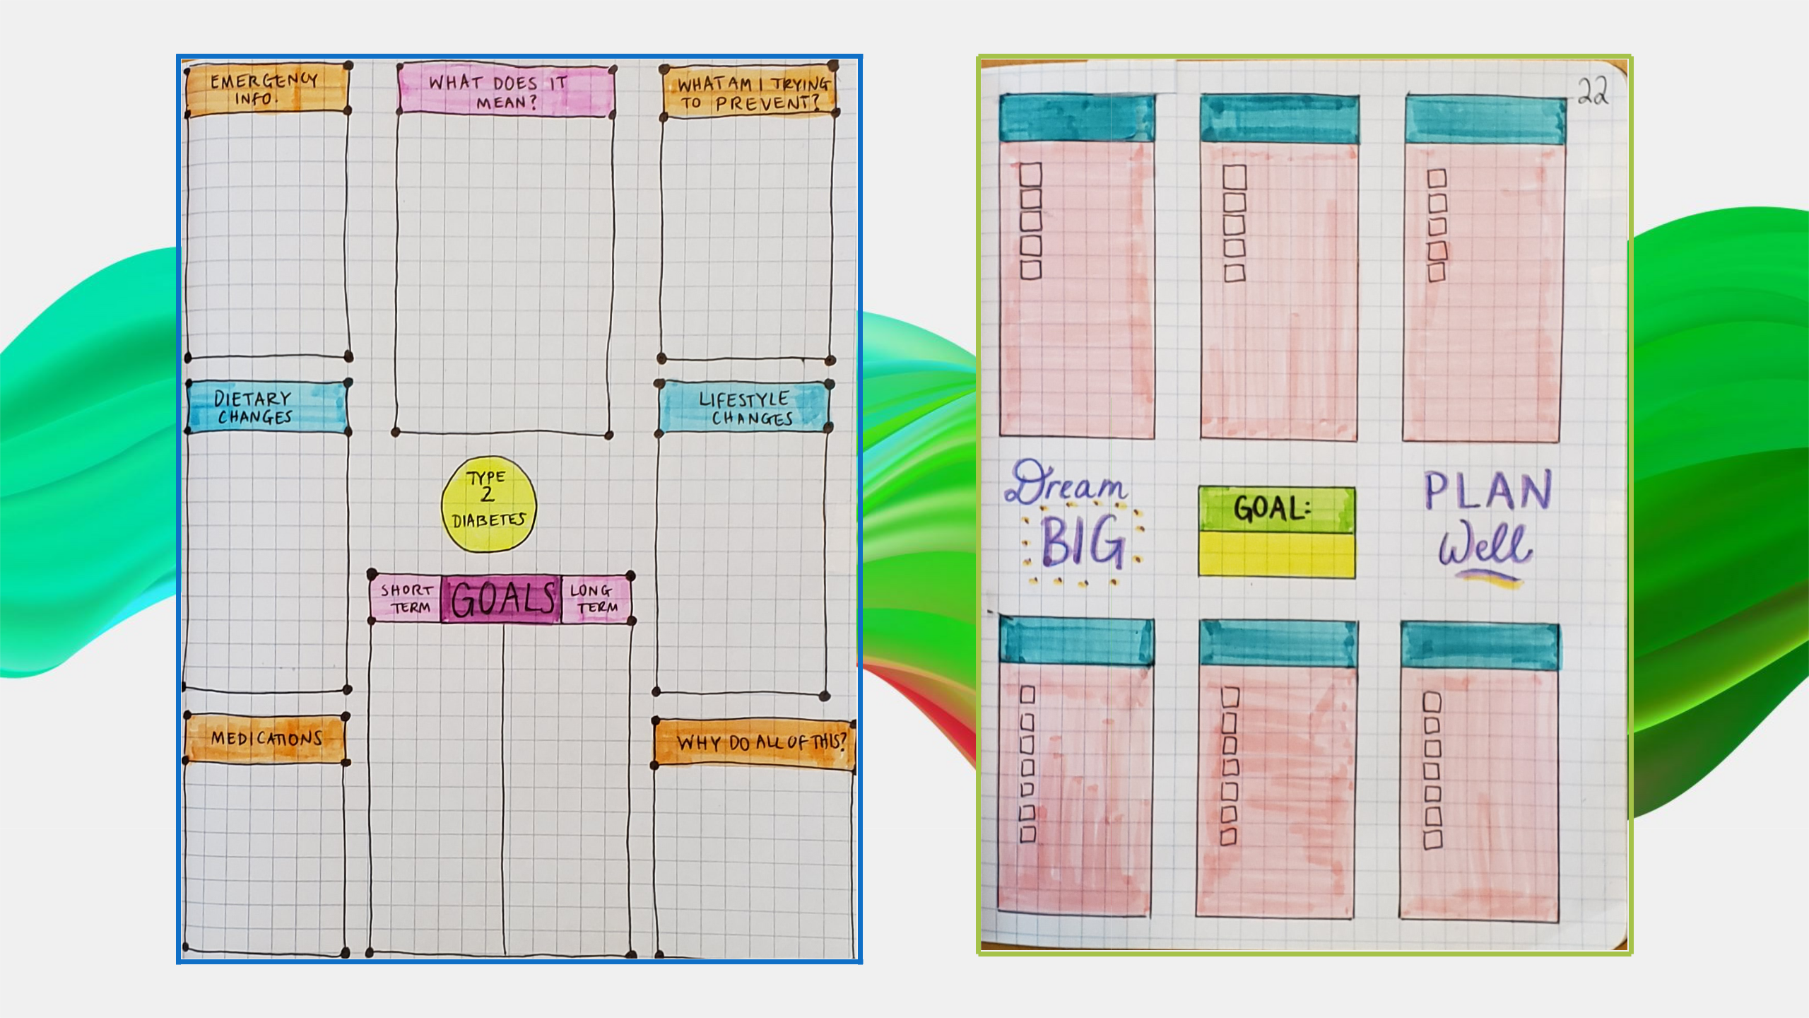

REFLECTIONS


EXERCISE TRACKING COMPETITION

EXERCISE TRACKING

COMPETITION

When: October 15 – November 14, 2020

How to Win:

- Track the total number of minutes/hours that you exercise each day. Any exercise counts! It doesn’t have to be done all at once!
- Once you have logged 14 hours, present your Exercise Tracking Page to a Gilgal administrator. You will be presented with your own $5 Wal-Mart gift card! Go at your own pace – there is one for everyone

- The GRAND Prizes: the top two women that log the most exercise will receive ANOTHER $5 Wal-Mart gift card!
  - Winners will be announced on November 14th!


Let’s get creative!

