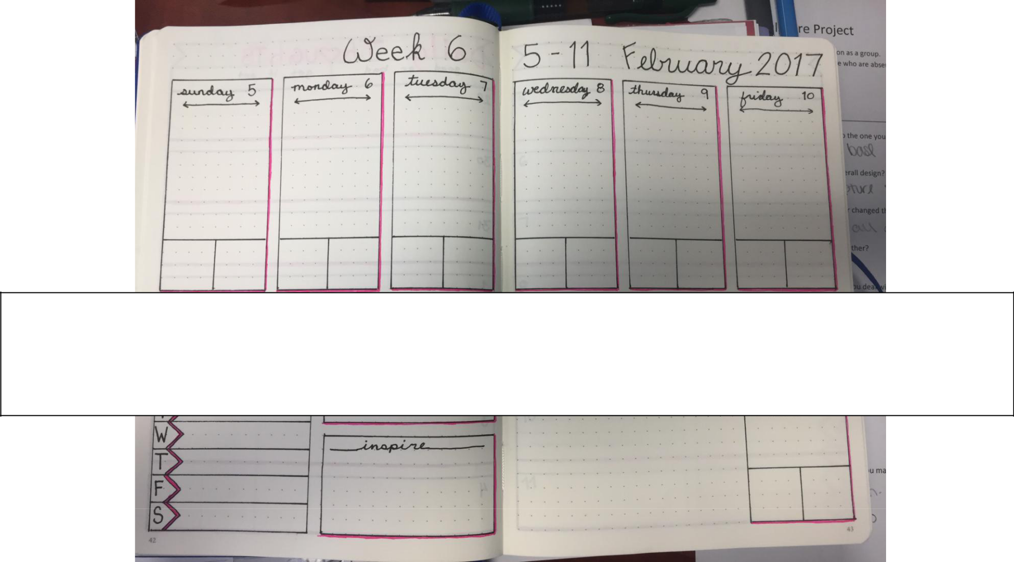

Bullet Journal Weekly Layout
Printable

Printable Bullet Journal Weekly Layout Template © juliedkohl.com Printable Bullet Journal Weekly Layout Template © juliedkohl.com

For best results, print this template onto cardstock

and use a craft knive to carefully cut out the boxes.

Template is designed to fit the pages of a

Leuchtturm 1917 notebook.

Please do not sell or redistribute this template

without permission.

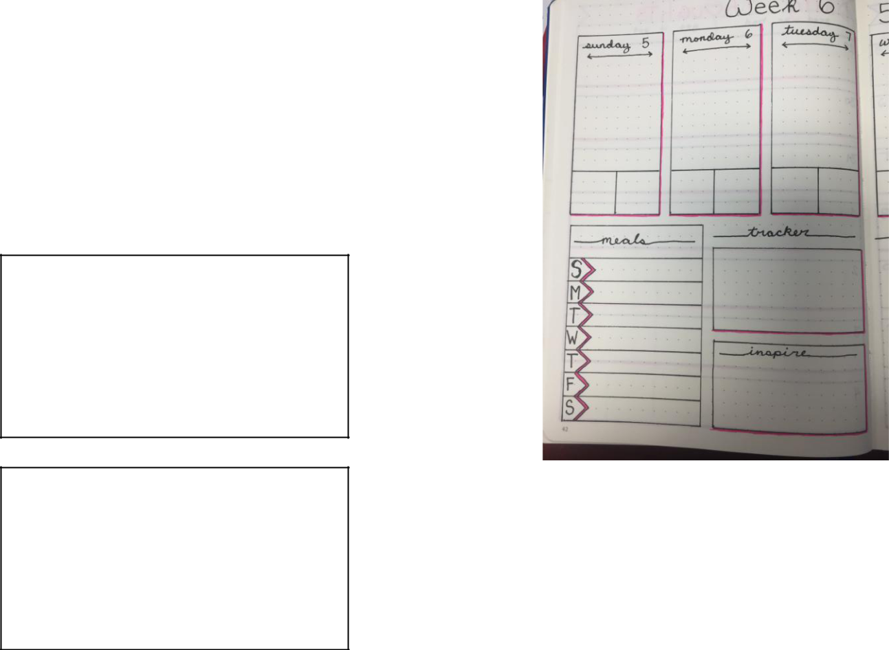

Please check out JulieDKohl.com for more bullet journaling,

recipes, crafts and travel content.


Printable Bullet Journal Weekly Layout Template © juliedkohl.com Printable Bullet Journal Weekly Layout Template © juliedkohl.com


For best results, print this template onto cardstock

and use a craft knive to carefully cut out the boxes.

Template is designed to fit the pages of a

Leuchtturm 1917 notebook.

Please do not sell or redistribute this template

without permission.

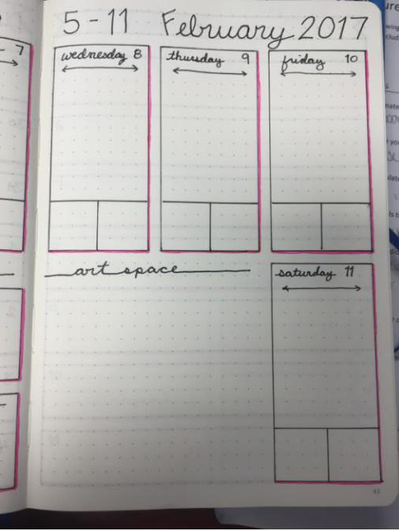

Please check out JulieDKohl.com for more bullet journaling,

recipes, crafts and travel content.

