Move In Checklist

TWO MONTHS BEFORE

Start investigating moving company options.

Sort through the contents of closets, drawers, and cupboards to weed out what you don’t want or need. Hold a yard sale, or donate unwanted items to charity.

Go to your children’s school and arrange for their records to be transferred to their new school district.

Budget for moving expenses.

SIX WEEKS BEFORE

Obtain copies of medical and dental records for each family member and arrange to have veterinarian records transferred.

Gather copies of legal and financial records.

Contact health clubs, organization, and groups to cancel or transfer memberships.

ONE MONTH BEFORE

Select a moving company and get written confirmation of your moving date, costs, and other details.

Clearly label and number each box with its contents and the room it’s destined for. This will help you to keep an inventory of your belongings. Pack and label “essentials” boxes of items you’ll need right away.

Go to your local post office and fill out a change-of-address form, or do it online at usps.gov.

Alert utility companies to disconnect services the day after you move and to have new service activated several days before you arrive at your new house. Contact the chamber of commerce in your new town for information on utility services.

Electric

Water

Gas

Telephone

Cell phone

Cable/Satellite and Internet

Sewer

Trash Collection

Start packing the things that you use most infrequently, such as the waffle iron and croquet set. While packing, note items of special value that might require additional insurance from your moving company. Make sure to declare, in writing, any items valued over $100 per pound, such as a computer.

eahomes.com

Move In Checklist

TWO WEEKS BEFORE

Notify these services/accounts of your move: | Notify these government offices of your move:
Auto Finance Company | City/County Tax Assessor
Bank/Credit Union/Finance Companies | State Vehicle Registration
Credit Card Companies | Social Security Administration
Exterminator | State/Federal Tax Bureau (IRS)
Health Club | Veterans Administration
Health Insurance
Home care service providers (lawn, | Call your moving company and reconfirm your
exterminator, snow removal etc.) | arrangements.
Laundry service
Magazines
Monthly memberships (Netflix, book of
the month, etc.)
Newsletters
Newspapers
Pharmacy
Store/Gas Charge Accounts
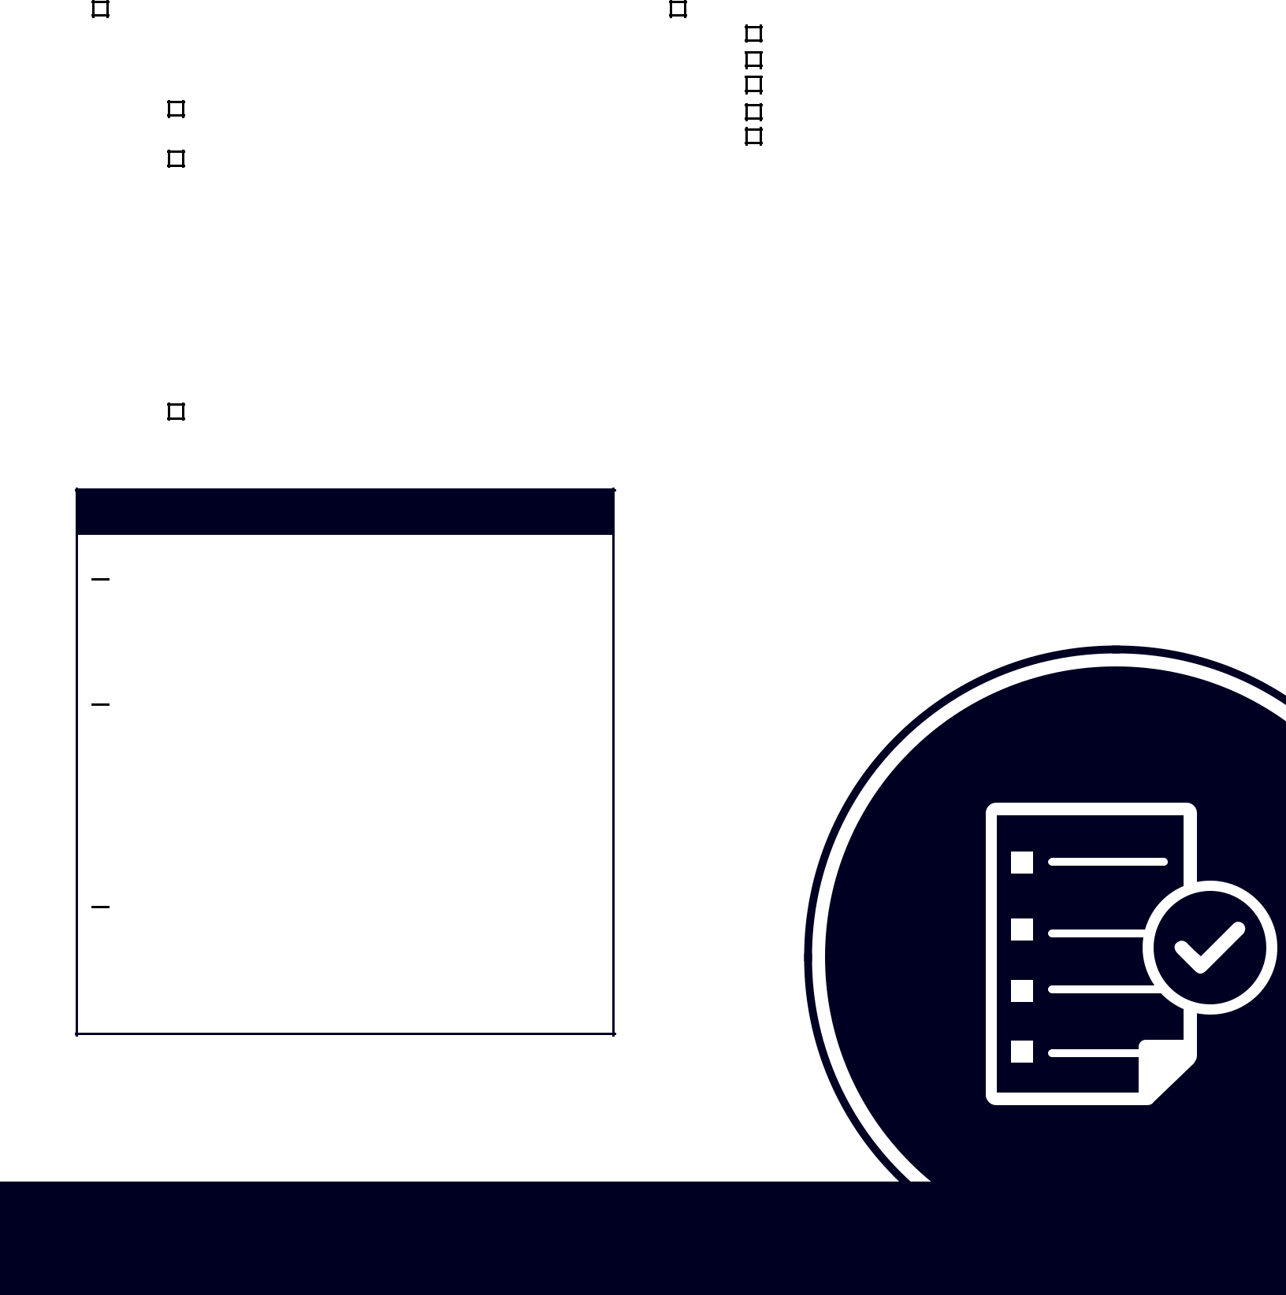

ONE WEEK BEFORE

Pack your suitcases: Aim to finish your general

packing a few days before your moving date.

Then pack suitcases for everyone in the family

with enough clothes to wear for a few days.

Notify your employers (new and old) of your

new contact information as well as notifying

your friends and family of your new address

and phone number.

Print two copies of your bill of lading (BOL) to

keep in your move file.

Pack an essentials box to keep with you during

the move.

Drain gas and oil from lawn equipment, gas

grills, heaters, etc.

eahomes.com

Move In Checklist

A FEW DAYS BEFORE

Defrost the freezer: If your refrigerator is moving Plan for payment: If you haven’t already

with you, make sure to empty, clean, and defrost arranged to pay your mover with a credit card,

it at least 24 hours before moving day. get a money order, cashier’s check, or cash for

payment and tip. If the staff has done a good

Double-check the details: Reconfirm the moving job, 10 to 15 percent of the total fee is a good

company’s arrival time and other specifics and tip. If your move was especially difficult, you

make sure you have prepared exact, written might tip each mover up to $100. Don’t forget

directions to your new home for the staff. that refreshments are always appreciated.

Include contact information, such as your

cell phone number.

MOVING DAY

Pack your first-night box.

Accompany the mover as he or she inventories your possessions and makes condition reports.

Load goods in a pre-designated order, saving "last load" items for the rear of your shipment.

Before the movers leave, sign the bill of lading (ensure that the address and phone number are correct) and inventory, and keep your copies in a safe place.

Take a family photo in your old home before you leave.

AFTER THE MOVE

Keep all the receipts and documents in your move file and store it in an easy-to-remember location.

Get a new driver’s license and automobile tags, register to vote, etc.

Enjoy your new Edward Andrews home!

eahomes.com

