MOVE-IN CHECKLIST

☐ | ☐
☐ | ☐
☐ | ☐
☐ | ☐
☐ | ☐
☐ | ☐
☐ | ☐
☐ | ☐
 | ☐
 | ☐
☐
☐ | ☐
 | ☐
☐ | ☐
☐ | ☐
☐ | ☐
☐ | ☐
☐
 | ☐
☐ | ☐
☐ | ☐
☐ | ☐
☐ | ☐
☐ | ☐
☐ | ☐
☐ | ☐
☐ | ☐
☐
☐
☐ | ☐
☐ | ☐
 | ☐
 | ☐
☐ | ☐
☐ | ☐
☐
☐
☐
☐
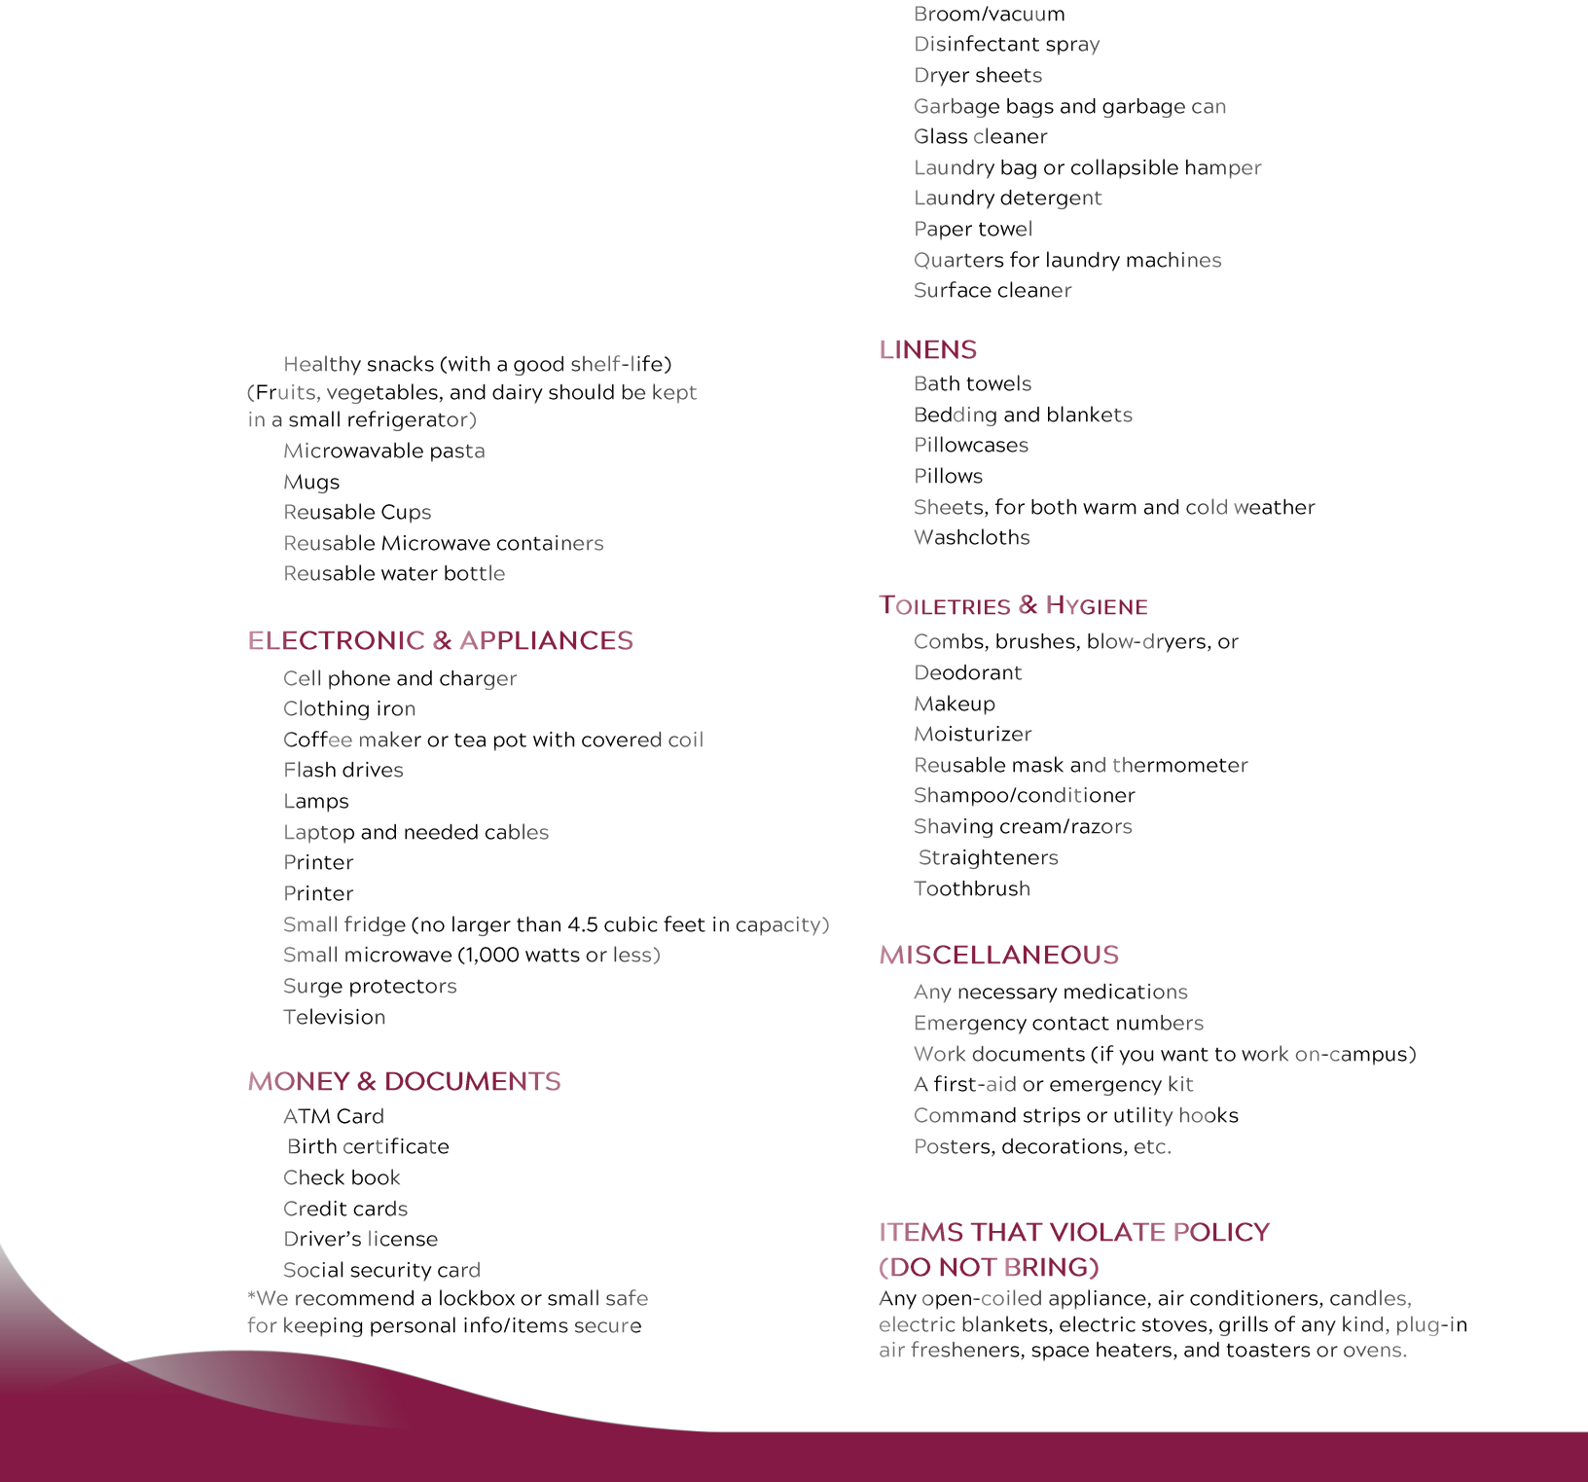

CHECKLIST FOR A SUSTAINABLE MOVE-IN

DITCH THE CARDBOARD & REUSE

WAIT ON BIG PURCHASES

RECYCLABLE PACKAGING

DRYING RACK FOR CLOTHING

CFL OR LED BULBS FOR LAMPS
