 |  |  | Move In Checklist
General Condition: Indicate YES | Living | Dining | Bathroom | Bathroom | Kitchen | Bedroom | Bedroom | Bedroom | Bedroom
or NO in the box for each item | Room | Room | 1 | 2 |  | 1 | 2 | 3 | 4
All ceilings and woodwork clean.
No cracks or holes. No dust or
cobwebs.
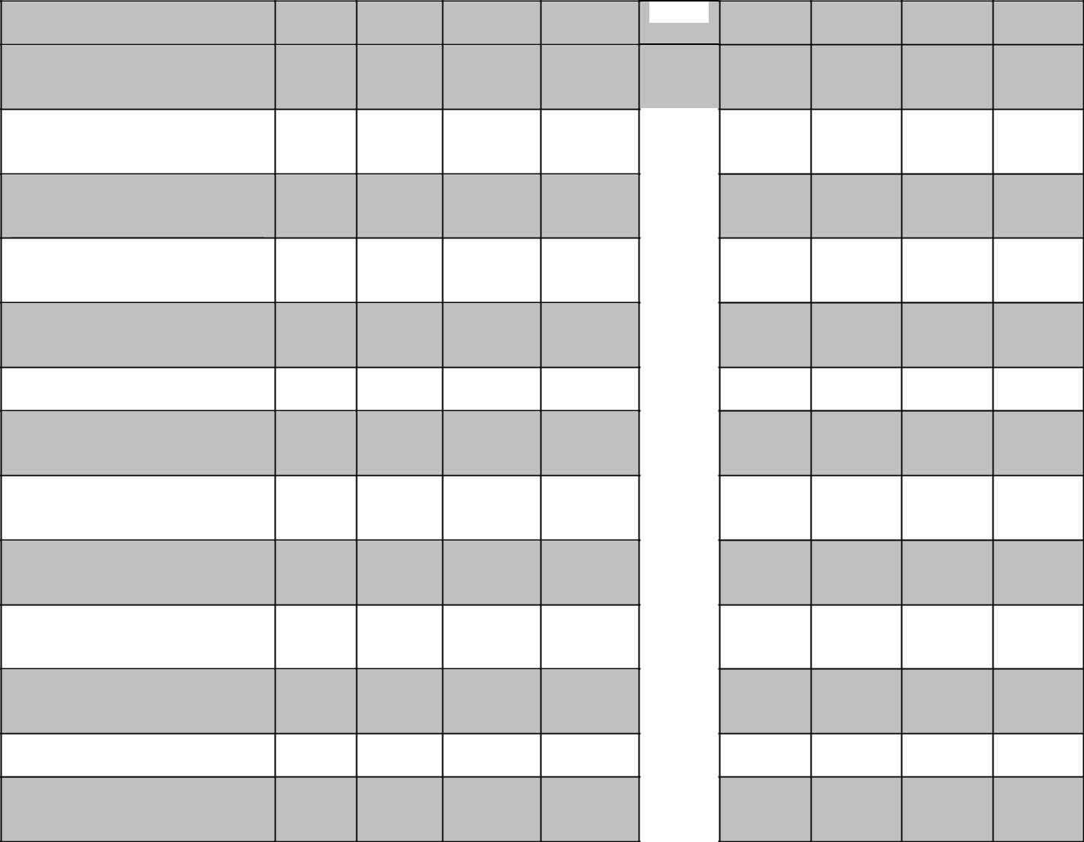
All light bulbs and light fixtures
work. All light fixtures clean,
dusted, not broken.

All electrical outlets work and all
wiring is safe. Fuse box is
accessible.

All plumbing fixtures work.
There are no leaks or existing
water damage.

All windows/mirrors are clean.
No damaged glass/screens/storm
windows.

All carpeting is clean, without
stains, burns or holes.

Wood and cement floors are
clean, dry. No scratches, burn, or
damage.

Doors are clean, no damage.
Handles and locks work.
Doorbell works.

Shades/blinds/curtains and rods
are in place, clean, working, and
in good shape.

Adequate and secure fire escape
routes exist. Working smoke
detectors.

Walls are clean, no stains, holes,
or marks. Wallpaper secure. No
peeling paint.

Furnace works, filters clean.
Water heater works, no leaks.

Tile floors and surfaces are clean,
dry. Tile is secure, grout affixed.

No damage.

Additional Comments (Specify ALL problems below. Use additional paper if necessary.):

Living Room: walls, floor, ceiling, paint/wallpaper,
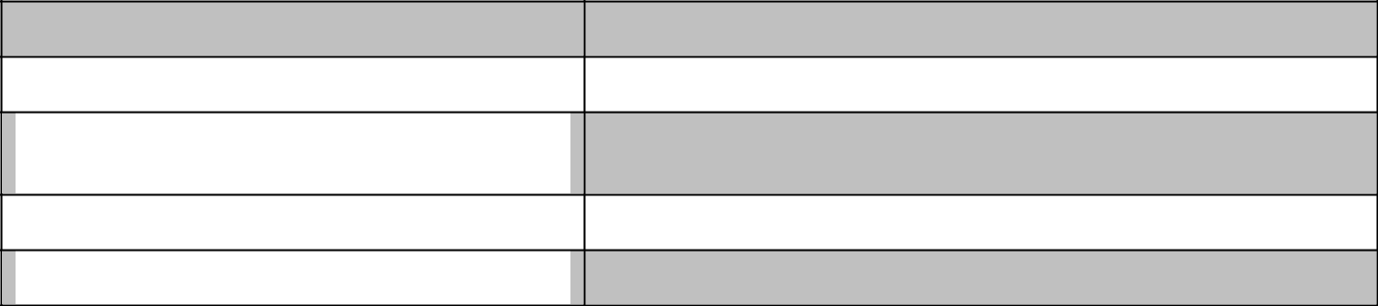
windows, shades, curtain rods, light fixtures, furniture

Dining Room: walls, floor, ceiling, paint/wallpaper,

windows, shades, curtain rods, light fixtures, furniture

Kitchen: walls, floor, ceiling, paint/wallpaper, windows,
shades, curtain rods, lights, cabinets, drawers, countertops,

dishwasher, stove, sink, faucet, disposal, refrigerator

Bathrooms: walls, floor, ceiling, paint/wallpaper,
windows, shades, curtain rods, lights, sink, faucet, toilet

Bedrooms: walls, floor, ceiling, paint/wallpaper, windows,

shades, curtain rods, light fixtures, furniture

Signatures:

Tenant 1: _________________________________________ Rental Manager/Landlord: __________________________________________

Tenant 2: _________________________________________ Date of this Inspection: ____________/________/________________________

Tenant 3: _________________________________________ Date of Move-In: ________________/________/_________________________

Tenant 4: _________________________________________ Rental Unit Address: _______________________________________________

Fair Housing Contact Service – 330-376-6191 – www.fairhousingakron.org

 |  |  | Move Out Checklist
General Condition: Indicate YES | Living | Dining | Bathroom | Bathroom | Kitchen | Bedroom | Bedroom | Bedroom | Bedroom
or NO in the box for each item | Room | Room | 1 | 2 |  | 1 | 2 | 3 | 4
All ceilings and woodwork clean.
No cracks or holes. No dust or
cobwebs.
All light bulbs and light fixtures
work. All light fixtures clean,
dusted, not broken.

All electrical outlets work and all
wiring is safe. Fuse box is
accessible.

All plumbing fixtures work.
There are no leaks or existing
water damage.

All windows/mirrors are clean.
No damaged glass/screens/storm
windows.

All carpeting is clean, without
stains, burns or holes.

Wood and cement floors are
clean, dry. No scratches, burn, or
damage.

Doors are clean, no damage.
Handles and locks work.
Doorbell works.

Shades/blinds/curtains and rods
are in place, clean, working, and
in good shape.

Adequate and secure fire escape
routes exist. Working smoke
detectors.

Walls are clean, no stains, holes,
or marks. Wallpaper secure. No
peeling paint.

Furnace works, filters clean.
Water heater works, no leaks.

Tile floors and surfaces are clean,
dry. Tile is secure, grout affixed.

No damage.

Additional Comments (Specify ALL problems below. Use additional paper if necessary.):

Living Room: walls, floor, ceiling, paint/wallpaper,
windows, shades, curtain rods, light fixtures, furniture

Dining Room: walls, floor, ceiling, paint/wallpaper,

windows, shades, curtain rods, light fixtures, furniture

Kitchen: walls, floor, ceiling, paint/wallpaper, windows,
shades, curtain rods, lights, cabinets, drawers, countertops,

dishwasher, stove, sink, faucet, disposal, refrigerator

Bathrooms: walls, floor, ceiling, paint/wallpaper,
windows, shades, curtain rods, lights, sink, faucet, toilet

Bedrooms: walls, floor, ceiling, paint/wallpaper, windows,

shades, curtain rods, light fixtures, furniture

Signatures:

Tenant 1: _________________________________________ Rental Manager/Landlord: __________________________________________

Tenant 2: _________________________________________ Date of this Inspection: ____________/________/________________________

Tenant 3: _________________________________________ Date of Move-In: ________________/________/_________________________

Tenant 4: _________________________________________ Rental Unit Address: _______________________________________________

Fair Housing Contact Service – 330-376-6191 – www.fairhousingakron.org

