MOVE-IN/MOVE-OUT CHECKLIST

THIS MOVE-IN/MOVE-OUT CHECKLIST is hereby made a part of the Rental Agreement dated __________________, 20___,
by and between |  |  | , the Owner/Agent, and |  |  | , the
Resident for the premises located at |  |  |  | .

Move-In Date:

Move-Out Date:

Inspection Date:

Inspection Date:

This checklist is to be completed by the Owner/Agent upon the Resident moving in and moving out of the residence. The Resident is encouraged to be present during inspections. The Resident shall have Three (3) days after taking possession in which to amend this checklist to include any further defects in the property which were unnoticed at the time of the Move-In Inspection. The Resident agrees that failure to notify the Owner/Agent of such further defects in writing within the time specified shall be conclusive proof that there are no further defects and that in fact the Resident has accepted the premises, its furnishings, and appliances in good and satisfactory condition except as noted herein. Upon vacating the premises, the Resident shall leave the premises in the same or better condition as when accepted by the Resident or as they may be put by the Owner/Agent or the Resident, reasonable wear excepted.

 |  |  |  |  | MOVE-IN |  |  |  |  |  | MOVE-OUT
 | ITEM |  | NEW |  |  | GOOD |  |  | OTHER |  | COND. |  |  |  | CHARGE
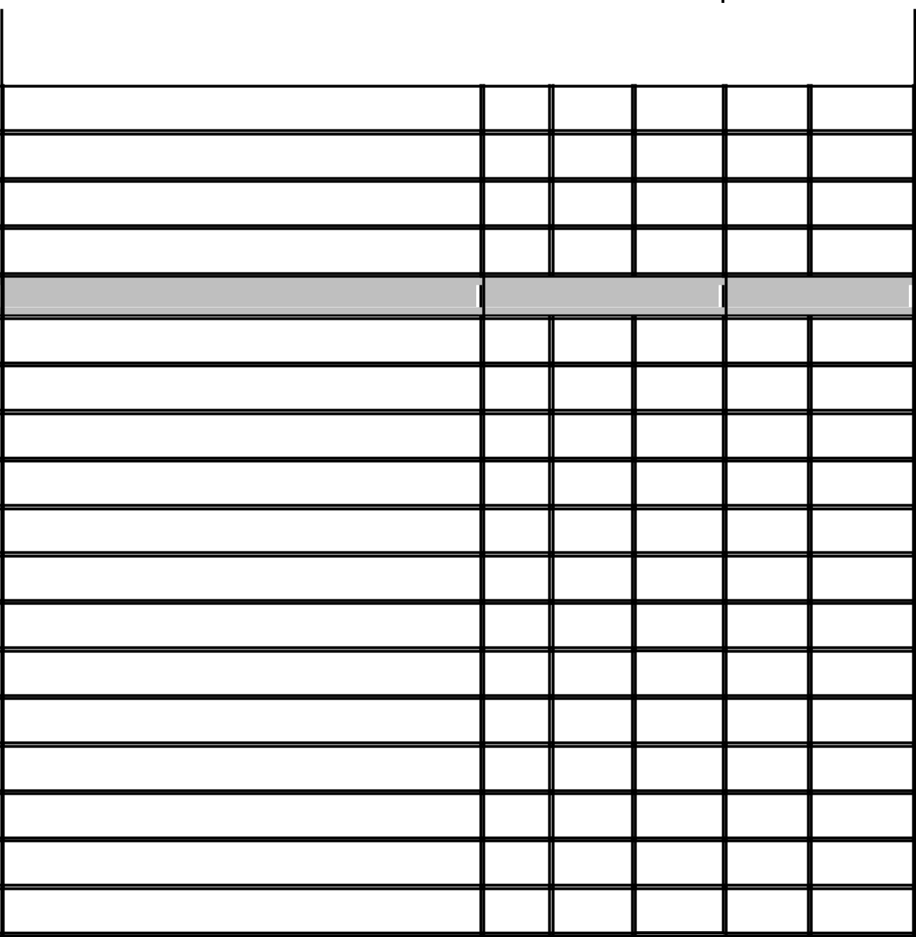

Mailbox Keys

Door Keys

Dead Bolt Keys

Other Keys

KITCHEN

MOVE-IN

MOVE-OUT

Refrigerator - Clean & Working

2 Ice Cube Trays

2 Crispers & Glass Top

Light Bulb

Butter Dish

Ice Caddy

Stove - Clean & Working

Oven Racks #

Broiler Pan #

Light Bulb #

Disposal - Clean & Working

Disposal Top

Chips Or Crack In Kitchen Appliance

Page 1 of 3

Condition Of Counter Tops

Fan, Filter & Hood - Clean & Working

BATHROOM #1 - CLEAN

Soap Dishes, Towel Bars, Shower Rod, Paper Holders Secure

Tub & Sink Stoppers Work

Plumbing Working Properly

Caulking - Clean

Tiles

Fan - Clean & Working

BATHROOM #2 - CLEAN

Towel Bars, Shower Rod, Paper Holders

Tub & Sink Stoppers Work

Plumbing Working Properly

Caulking - Clean

Tiles

Fan - Clean & Working

Heating & Air Conditioner(S) - Clean & Working

Filters

Doors

Windows

Doors & Frames

Screens -In Windows & Windows Clean

Carpet /Flooring

Drapes, Curtains & Rods

Window Shades

Rubbish Removed

Lighting Fixtures & Bulbs

Wall Surfaces

MOVE-IN

MOVE-IN

MOVE-OUT

MOVE-OUT

Page 2 of 3

Door Stops

Door Knobs

Vents & Registers

Electrical - Outlets & Plates

Closet Doors

Mirrors

Smoke Alarm(S)

Other

Comments: ________________________________________________________________________________________________
____________________________________________________________________________________________________________

PERSONAL PROPERTY

THE FOLLOWING PERSONAL PROPERTY IS ALSO INCLUDED IN THE RESIDENCE:

ITEM QUANTITY BRAND COLOR SERIAL # CONDITION

REFRIGERATOR

STOVE

WASHER

DRYER

CARPET/ FLOORING

DRAPES

SHADES

CEILING FANS

SMOKE DETECTORS

The Resident hereby acknowledges that smoke detectors are located on the premises in the following locations and that said smoke detectors are currently operable: ____________________________________________________________________

RESIDENT’S INITIALS: ________________________________________________________________________________________

The Resident agrees to maintain said smoke detectors in operable condition at all times. This includes:
- testing each smoke detector periodically by pushing the test button,
- if battery operated, replacing the battery or batteries as often as necessary, but at least once per year, and
- notifying the Owner/Agent immediately of any malfunctioning smoke detector.

THE RESIDENT AGREES that the above information is an accurate account of the condition and contents of said premises and acknowledges receiving a copy hereof. The Owner/Agent reserves the right to add additional charges for damages or uncleanness, which may be discovered after the Resident, vacates the premises.

Tenant |  |  | Owner/Agent
Tenant |  |  | Owner/Agent
Date Signed |  |  | Date Signed
 |  | Page 3 of 3

