SUBLEASE AGREEMENT

(On-Airport Properties)

THIS SUBLEASE AGREEMENT (this "Sublease"), dated as of the day of

--:----:cc-----::-c:-' 2014, is entered into by and between American Airlines, Inc. ("American"), and

the City of Los Angeles, a municipal corporation acting by order of and through its Board of Airport Commissioners ("Sublessee" or the "City").

WHEREAS, American and the City entered into a Terminal Facilities Lease (LAA-4687) dated November 26, 1984 (the "Original Lease"), pursuant to which American leased certain areas of Terminal 4 at Los Angeles International Airport (the "Airport") and the ground adjacent thereto (the "Base Lease Premises");

WHEREAS, in connection with the issuance in 2002 of the Regional Airports Improvement Corporation Facilities Sublease Revenue Bonds, American Airlines, Inc. Terminal 4 Project (Los Angeles International Airport), the City and American entered into the First Amendment to Lease No. LAA-4687 dated January 18, 2002 (LAA-4687A)(the "First Amendment", and together with the Original Lease, the "Amended Lease") which amended the Original Lease;

WHEREAS, the City previously approved and authorized the financing of the improvements to the Demised Premises through the issuance of bonds by Regional Airports Improvement Corporation ("RAIC," and together with the City, the "Landlords");

WHEREAS, pursuant to the Partial Assignment of Terminal Facilities Lease dated as of December I, 1984, and amended on January I, 2002, American assigned to RAIC certain rights under the Amended Lease for the purpose of financing the acquisition, construction and installation of certain improvements to the Base Lease Premises;

WHEREAS, American and RAIC entered into a Facilities Sublease and Agreement, dated as of December I, 1984, and amended on January I, 2002 (as amended or supplemented, the "Facilities Sublease", and together with the Amended Lease, the "Base Lease") pursuant to which American subleased the Base Lease Premises and agreed to pay rent sufficient in time and amount to pay the principal of and interest on certain bonds;

WHEREAS, American and the Sublessee entered into a Settlement Agreement dated January 24, 20 14 in which the parties agreed on the maintenance and operation cost calculation methodology under the Amended Lease;

WHEREAS, Sublessee wishes to sub-sublease approximately 7,396 square feet of space in the Base Lease Premises as part of its concession program in Terminal4 and for the Terminal4

- I -

Sublease Agreement between

American and LAW A

Kdrive/opentext/Ieases/sublease v.8
connector building (the "T4 Connector"), and American is willing to sublease such space to Sublessee, under the terms and conditions hereinafter set forth;

NOW, THEREFORE, American and Sublessee agree as follows:

- TERM. Except as provided for in Section 2.B. below, the term of this Sublease shall

commence on (the "Commencement Date"), and shall expire upon the expiration or earlier termination of the Amended Lease.

  - PREMISES.

A. American hereby subleases to Sublessee and Sublessee hereby subleases and takes from American a portion of the Base Lease Premises, as more particularly described and delineated on Exhibit A attached hereto and made a part hereof (the "Premises"). The parties acknowledge that the Premises will be modified by the concession program in Terminal4 and construction of the Terminal 4 Connector. American agrees that if the parties agree to a different Premises, Exhibit A shall be amended by the Executive Director of Los Angeles World Airports (the "Executive Director") and American, subject to City Attorney approval as to form, with an appropriate adjustment in rental charges without the prior approval or later ratification by the Board of Airport Commissioners (the "Board") or the Los Angeles City Council (the "City Council"); provided, however, that such modification shall not exceed a cumulative rental adjustment of $150,000 over the term of this Sublease.

    - 1,245 square feet of the Premises is concession space (the "Concession Space"). American acknowledges that during the term of this Sublease Sublessee may return the Concession Space indicated in Exhibit A upon 180 days advance written notice to American. Upon the exercise of City's right to return such space pursuant to this Section 2.B, Exhibit A shall be amended by the Executive Director, subject to City Attorney approval as to form, with an appropriate adjustment in rental charges, without the prior approval or later ratification by the Board or the City Council.

- SUBJECT TO BASE LEASE.

    - This Sublease is made subject and subordinate to all the terms and conditions of the Base Lease, and shall not be construed as granting any rights to Sublessee beyond those granted to American under the Base Lease or any such other agreements. Unless this Sublease expressly provides to the contrary, Sublessee covenants to observe and to comply with all of the terms and conditions of the Base Lease and to perform all the obligations of American as tenant under the Base Lease (excepting only the rental obligations) insofar as the same are applicable to the Premises. Sublessee shall not commit or permit to be committed any act or omission that violates any term or condition of the Base Lease or that would cause American to be in default under the Base Lease. Upon termination of the Amended Lease for any reason, this Sublease also shall immediately terminate and American shall not be liable to Sublessee by reason thereof.

- 2-

Sublease Agreement between

American and LAW A

Kdrive/opentext/leases/sublease v.8
- Sublessee acknowledges that at least a portion of the Premises was financed with proceeds of the special facility bonds issued by RAIC (the "Terminal4 Bonds") and that the use of said portion of the Premises is also governed and restricted by the agreements related thereto (the "Bond Documents"). Sublessee agrees that it shall take no action nor permit any action to

be taken in connection with its use of the Premises that would violate any provision, of, or cause a default under, the Bond Documents. In addition, Sublessee agrees not to use the Premises, conduct its operations therein, or otherwise do anything which adversely affects the exclusion from gross income of the interest on the Terminal 4 Bonds for federal income tax purposes. Sublessee agrees, as a condition to the effectiveness of this Sublease, for the joint benefit of American and RAIC, that Sublessee shall not claim depreciation or an investment tax credit with respect to the Premises for purposes of federal income taxation.

- USE. Sublessee shall use and occupy the Premises for the following purposes and for no other purpose: airport concession space and construction and occupancy by governmental agencies and airline service providers of the Terminal 4 Connector, subject to any limitation or other restriction on use of the Premises or any portion thereof provided in the Base Lease and the documents, instruments and agreements executed and delivered in connection therewith.

- RENT.

A. Rent. Sublessee shall pay as monthly rent (the "Rent"), without setoff or deduction, the monthly rental per square foot (including maintenance and operations costs (the "M&O Costs")) that American is required to pay to the City under the Amended Lease for the Premises hereunder ("American's Rent"). American's Rent is calculated as the area subleased multiplied by the monthly rental per square foot then in effect. American's Rent in effect on the Commencement Date is set forth in Exhibit B attached hereto. The Rent shall be adjusted effective with adjustments to the cotTesponding components of American's Rent under the Amended Lease, and for premises changes allowed in accordance with Section 2. The rental amount will be applied monthly as a credit against Terminal 4 rentals and M&O Costs due from American to City. Rental for any partial month shall be prorated. Sublessee and American agree that the Rent shall offset and be paid towards a portion of the monthly rent for the same month owed by American to the City, in its role as landlord under the Amended Lease, pursuant to Section 6 of the Amended Lease.

B. Additional Rent. Sublessee shall pay American, as additional rent, without setoff or deduction, a proportionate share of American's rental payments, expressed as a monthly rate per square foot, in respect of the debt service payments, for the Terminal 4 Bonds for the use of the Premises (the "Additional Rent"), calculated as the area subleased multiplied by the monthly rate per square foot as shown in Exhibit B, which amount will adjust in accordance with changes to the debt service schedule or premises changes allowed in accordance with Section 2. Sublessee and American agree that the Additional Rent shall offset and be credited towards a portion of the monthly rent for the same month owed by American to the City, in its role as landlord under the Amended Lease, pursuant to Section 6 of the Amended Lease.

- 3 -

Sublease Agreement between

American and LAWA

Kdrive/opentext/leases/sublease v.8
    - Credit. For purposes of clarification, American and Sublessee agree the effect of Section 5.A. and Section 5.B. shall be that, during the term of this Sublease, Sublessee shall not remit a check to American for the Rent and Additional Rent due, and the monthly rent for which the City, in its role as landlord under the Amended Lease, bills American (via an invoice) pursuant to the Amended Lease shall be equal to the rental amounts due to the City, in its role as landlord under the Amended Lease, pursuant to Section 6 of the Amended Lease less the Rent and the Additional Rent for the same month due to American from Sublessee under this Sublease (with the invoice from the City, in its role as landlord under the Amended Lease, showing a line item credit for the Rent and Additional Rent as provided above).

    - Leasehold Taxes. In addition to the charges stated above, Sublessee shall pay and agrees to indemnifY, defend and hold American harmless from and against any and all taxes of whatsoever kind or nature, including but not limited to attorneys' fees, costs and expenses incurred in connection therewith (but excluding American's income taxes) which are or may be assessed against, chargeable to or collectible from Sublessee or American by any taxing authority, federal, state or local, and which are based upon or levied or assessed with respect to the performance of this Sublease or the use of the Premises by Sublessee, or any payments made by Sublessee to any party pursuant to this Sublease.

  - RAIC Fees: This Sublease is subject to the approval of the Regional Airport Improvement Corporation ("RAIC") who may assess American a fee for costs incurred tlu·ough their review and approval process. American and Sublessee hereby agree to share the cost of such fee on an equal basis. Sublessee may pay its share of such fees to American in the form of a direct payment or as a one-time credit against the rent due the City in its role as landlord under the Amended Lease. Before making payment to American, American shall provide Sublessee an invoice detailing the fees assessed by RAIC, and the allocation between American and Sublessee.

- UTILITIES AND SERVICES; OTHER CHARGES. Utilities that are not provided by the City in its role as landlord under the Amended Lease shall be provided to the Premises by Sublessee and paid for by Sublessee. Sublessee shall also be responsible for its telephone and other communications charges.

American shall have no liability or responsibility, and Sublessee hereby waives any claims against American, for any interruption or cessation of any services covered by this Section 6, Sublessee shall be responsible for payment of all other charges for its use of the Airport.

- ACCEPTANCE OF PREMISES. Sublessee has inspected the Premises and accepts the Premises "as is" and acknowledges that, except as otherwise expressly contained herein, American has made no representations, warranties, or guarantees of any kind, including as to the condition thereof or as to the fitness thereof for Sublessee's purposes. In no event shall American's liability of any kind under this Sublease include any special, incidental or consequential damages, including, without limitation, loss of profits, even if American shall have been advised of the possibility of such potential loss or damage.

- 4-

Sublease Agreement between

American and LAWA

Kdrive/opentext/leases/sublease v.8
  - REPAIRS AND MAINTENANCE. Sublessee, at its sole cost and expense, shall keep the Premises in a clean, neat and orderly condition at all times, including without limitation, the provision of janitorial services to the Premises. Further, Sublessee shall, at its own expense, make all necessary repairs to the Premises so as to maintain the Premises in good order and condition, reasonable wear and tear and damage by fire or other casualty excepted.

- TAXES. Sublessee agrees to pay, before they become delinquent, all taxes (both general and special), assessments or governmental charges of any kind whatsoever (the "Taxes") levied or assessed against the Premises, or any property of Sublessee located thereon or any business conducted by Sublessee thereon. Sublessee agrees to use its best efforts to cause the Premises, its personal property and business operations to be assessed and taxed separately from the Base Lease Premises. In the event that American shall be assessed for Taxes on the Premises or any or all of Sublessee's leasehold improvements, equipment, furniture, fixtures, personal property or business operations, Sublessee shall pay to American the amount of the Taxes within 45 days after delivery to Sublessee by American of a written statement setting forth the amount of the Taxes payable by Sublessee. Sublessee shall furnish American with satisfactory evidence of the payments required to be made by Sublessee hereunder within forty-five (45) days after such payments are made. Sublessee shall notify American prior to protesting any assessment of Taxes and upon commencement of audit by any taxing authority with respect to any of the Taxes.

- ALTERATIONS.

A. American acknowledges that Sublessee is entering into this Sublease for the purpose of expanding its concession program in Terminal 4 and constructing the Terminal 4 Connector. Accordingly, American agrees and consents to the alterations and improvements to be made by (i) Sublessee, or (ii) the City's sublessees with the written consent of the City, and which are necessary or desirable for such purpose, provided that all such alterations and improvements do not materially interfere with the use and operation of the Base Lease Premises and are made in compliance with the requirements of the Base Lease and the Bond Documents, including, if required, the receipt of the consent ofRAIC, and that American will assist and support Sublessee's efforts to obtain such consent, provided that American will not incur any cost, expense, or liability or assume any obligation in connection therewith.

B. During the term of this Sublease, title to all improvements and alterations installed by (i) Sublessee, or (ii) the City's sub lessees with the written consent of the City, shall remain in the Sublessee or the City's sublessee, as applicable. Upon the termination or this Sublease, said additions, improvements or alterations shall become a part of the land upon which they are constructed, or of the building to which they are affixed, and title thereto shall thereupon vest in City. In the event Sublessee returns Concession Space during the term of this Sublease to American pursuant to Section 2, alterations, additions or improvements to the Concession Space shall be removed by Sublessee at its own cost and expense, prior to expiration of the term of this Sublease, and Sublessee shall repair any damage to the Base Lease Premises and/or Concession
Space caused by such removal. Further, if American so elects, Sublessee shall re-install or

- 5 -

Sublease Agreement between

American and LAW A

Kdrive/opentext/leases/sublease v.8
replace any fixtures and/or equipment removed or relocated by Sublessee in the Concession Space during the term of this Sublease.

        - Notwithstanding anything to the contrary contained herein, Sublessee hereby specifically acknowledges and agrees that it has the sole responsibility to make, at its sole cost and expense, all alterations, additions, repairs and improvements to the Premises as are necessary to comply with applicable law if the necessity for any such repair, alteration, addition and improvement is attributable to Sublessee's or any City sublessee's use or occupancy of the Premises.

      - SIGN AGE. Sublessee, and the City's sub lessees with the written consent of the City, shall each have the right to install, erect, maintain or display signage or advertising in or about the Premises.

    - RIGHT OF ENTRY. American shall have the right to enter the Premises upon reasonable notice to Sublessee (or without notice in the case of an emergency) for any reasonable purpose, including without limitation to gain access to and egress from those portions of the Base Lease Premises not leased to Sublessee hereunder, to perform such functions as may be necessary or convenient for the maintenance and operation thereof, and to determine whether Sublessee is in compliance with the terms of this Sublease.

  - COMPLIANCE WITH LAWS, RULES AND REGULATIONS. Sublessee shall, and shall cause any City sublessee to, faithfully observe and comply with all laws, ordinances, statutes, rules, orders and regulations of all governmental authorities, at any time issued or enforced, which are applicable to the Premises or the conduct of Sublessee's or any City sublessee's business in, on or about the Premises, and shall comply with all rules and regulations of American for the operation, safety, care or appearance of the Premises or the preservation of good order thereon and all rules and regulations promulgated by the City, in its role as landlord, pursuant to the Amended Lease. Sublessee agrees that it will not use the Premises or permit the use of the Premises in any manner that will violate the terms and conditions of the Base Lease, the Bond Documents or any fire or other insurance policy from time to time carried by American on the Premises. Sublessee shall comply with any reasonable regulations or requests that may be made by insurance underwriters.

- CASUALTY. In the event that the Premises or any portion thereof should be damaged or destroyed by fire, or other casualty, American, at its option, may either terminate this Sublease and American shall not be liable to Sublessee by reason thereof, or diligently proceed to cause the repair of the damage to the Premises. If American elects to repair or rebuild, and if the Premises are so damaged that Sublessee is unable to occupy the Premises or a portion thereof during such repair or reconstruction, then the rental hereunder shall be abated, if and on the same basis that American's rental under the Amended Lease is abated, until the Premises can be occupied by Sublessee. American shall in no event be required to rebuild, repair or replace any improvements, fixtures or personal property of Sublessee. Notwithstanding the foregoing, in the event the Premises or the Base Lease Premises are damaged or destroyed through the negligence

- 6 -

Sublease Agreement between

American and LAW A

Kdrive/opentext/leases/sublease v.S
or willful misconduct of Sublessee, City's sublessee or the customers, vendors, contractors or invitees of either Sublessee or City's sublessee, then Sublessee shall pay to American upon demand, the cost of repairing any such damage. Nothing in this Section 14 is intended to modify or limit the provisions of Sections 15 and 16 of this Sublease.

    - INDEMNITY. To the fullest extent permitted by law, Sublessee hereby releases and agrees to indemnify, defend and hold harmless American, the Landlords, and their respective directors, officers, agents, and employees (collectively, the "Indemnified Parties" and individually, an "Indemnified Party") from and against any and all claims, liabilities, losses, damages, fines, civil penalties, and expenses of any kind or nature whatsoever (including without limitation costs of suit and reasonable expenses oflegal services) which may be suffered by, accrued against, charged to or recoverable from any of the Indemnified Parties to the extent caused by any occupancy, use, or misuse of the Premises by Sublessee, its officers, directors, employees, agents, contractors, or subtenants, City's sublessee or the customers, vendors, contractors or invitees of either Sublessee or City's sublessee. Nothing contained in this Section shall be construed as an indemnity by Sublessee of an Indemnified Party against any loss, liability or claim to the extent arising from the gross negligence or willful misconduct of that Indemnified Party. The indemnification obligations of this Section shall survive termination or expiration of this Sublease.

  - INSURANCE. Sublessee is a permissively self-insured governmental agency with adequate insurance or reserves to fund any reasonably anticipated loss arising from general liability, property casualty, or the workers compensation of its employees for the use and occupancy of the Premises.

- LIENS. Sublessee hereby agrees to keep the Premises, and the improvements thereon, free and clear of mechanics' liens and other liens for labor, services, equipment or materials. In the event such a lien is filed or recorded, Sublessee shall take all action required to remove the same within fifteen (15) days of the filing or recordation. In the event that Sublessee fails to take such action to remove the lien, then American, at its option, may do so and all costs associated therewith plus an administrative fee equal to 15% of such costs shall be due to American from Sublessee upon demand.

- CONDEMNATION.

      - Total Taking. If during the term of this Sublease or any extension or renewal thereof, all or a substantial part of the Premises should be taken for any public or quasi-public use under any governmental law, ordinance or regulation or by right of eminent domain, or should be sold to the condemning authority under threat of condemnation, this Sublease shall terminate on the date of taking of the Premises by the condemning authority and American shall not be liable to Sublessee by reason thereof.

      - Partial Taking. If less than a substantial part of the Premises is taken for public or

quasi-public use under any governmental law, ordinance or regulation, or by right of eminent

- 7-

Sublease Agreement between

American and LAW A

Kdrive/opentext/leases/sublease v.8
domain, or is sold to the condemning authority under threat of condemnation, American, at its option, may by written notice terminate this Sublease and American shall not be liable to Sublessee by reason thereof or shall forthwith at its sole expense restore the remaining Premises (other than leasehold improvements made by Sublessee situated on the Premises) in order to make the same reasonably tenantable and suitable for the uses for which the Premises are subleased. The rent payable hereunder during the unexpired portion of this Sublease shall be adjusted equitably if and on the same basis that rent is established under the Base Lease.

  - DEFAULTS. The occurrence of any of the following shall constitute a default by Sublessee under this Sublease:

    - Sublessee fails to credit to American when due any sum as required hereunder or to pay when due any sums required to be paid hereunder and such failure shall continue for more than thirty (30) days after Sublessee receives notice from American of the failure;

    - Sublessee fails to cure any other breach of this Sublease within thirty (30) days after written notice thereof or within such shorter period of time allowed American under the Base Lease for curing such breach;

    - Sublessee (i) takes any steps leading to its cessation as a going concern or ceases or suspends operations for reasons other than a strike; (ii) becomes insolvent or makes transfers in fraud of creditors or makes an assignment for the benefit of creditors; (iii) has an involuntary bankruptcy petition filed against it which is not dismissed within sixty (60) days; or (iv) files a petition for protection under any state or federal bankruptcy act or a trustee or receiver is appointed for all or substantially all of Sublessee's assets.

- REMEDIES UPON DEFAULT. Upon the occurrence of an event of default hereunder, American may take any one or more of the following actions:

W M

aintain this Sublease in full force and effect and recover any and all rent and other monetary charges as they become due, without terminating Sublessee's right to possession, regardless of whether Sublessee shall have abandoned the Premises.

- Terminate this Sublease by written notice to Sublessee, in which event this Sublease shall be ended as to Sublessee and all persons holding under Sublessee, and all of Sublessee's rights shall be forfeited and lapsed, as fully as if this Sublease had expired by lapse of time. In such event, Sublessee shall be required to vacate the Premises immediately and surrender same to American. In the event of termination in accordance with this provision, the rental or any other sums payable by Sublessee pursuant to this Sublease that have accrued hereunder but are unpaid shall be immediately due and payable by Sublessee to American. In addition, Sublessee agrees to pay to American upon demand the amount of all loss and damages which American may suffer by reason of such termination, including, without limitation, (i) all expenses incurred by American, including court costs and attorney's fees, in recovering

- 8-

Sublease Agreement between

American and LAW A

Kdrive/opentext/leases/sublease v.8
possession of the Premises or enforcing American's rights under this Sublease; (ii) all costs and charges for care of the Premises while vacant or unused; and (iii) all costs of restoring the Premises to a good condition.

        - Cure the default on the behalf of the Sublessee, in which event the Sublessee shall, upon demand by American, pay or, in the alternative, if American so elects, credit American all sums expended by American in accomplishing such cure plus an administrative charge of 15% of said sums.

        - Exercise any right available to American in law or in equity.

  - CUMULATIVE RIGHTS. Each right and remedy of American provided for in this Sublease, or now or hereafter existing at law, in equity or by statute or otherwise, shall be cumulative and concurrent, and the exercise or beginning of the exercise of any one or more of such rights or remedies shall not preclude the exercise of that right or remedy in the future or the exercise of any other right or remedy at any time.

  - SURRENDER OF PREMISES. At the expiration or earlier termination of this Sublease, or upon American's termination of Sublessee's right of possession in accordance with the provisions of this Sublease, Sublessee shall surrender the Premises to American in good condition, reasonable wear and tear, and damage by fire or other casualty covered by insurance excepted.

- ASSIGNMENT AND SUBLETTING.

A. This Sublease is personal to Sublessee and Sublessee shall not assign this Sublease, sublet the Premises or any portion thereof, or permit use by others without the prior written consent of American and, to the extent required by the Base Lease, Landlords. American's acceptance of rent from any person other than Sublessee shall not be deemed to be a waiver of this provision. Consent to one assignment, subletting or use shall not be deemed to be consent to any subsequent assignment, or subletting or use. Notwithstanding the foregoing, Sublessee shall have the right to sublease the Premises, without the prior written consent of American, to (i) a branded coffee concessionaire that is a part of Sublessee's airport concessions program for Terminal 4 and (ii) governmental agencies and tenant service providers that wish to occupy the Terminal 4 Connector, provided such subtenant's use of the Premises conforms to the requirements of the Base Lease and Bond Documents. If The Bank of New York Mellon Trust Company, N.A. 's (as trustee (the "Trustee") and assignee of certain ofRAIC's rights under the Base Lease, pursuant to the Indenture (as defined in the Facilities Sublease)) acknowledgment of or consent to such assignment, subletting or use is required by the parties hereto, it is understood that the Trustee shall acknowledge such only with the written direction or consent of the holders of a majority in aggregate principal amount of the Terminal 4 Bonds and RAIC.

B. Upon the completion of the Terminal4 Connector, American, subject to receiving certain internal approvals, intends to sub-sublease a portion of the Premises where the Terminal 4

          - 9 -

Sublease Agreement between

American and LAW A

Kdrive/opentext/leases/sub lease v. 8

Connector is located from the City and in such case shall enter into a sub-sublease with the same terms and conditions, including, but not limited to, terminal rates, as the Los Angeles International Airport Passenger Terminal Tariff that is then in effect.

      - FORCE MAJEURE. Neither pmty shall be deemed to be in breach of this Sublease by reason of a failure to perfonn any of its obligations hereunder to the extent that such failure is caused by strike or labor troubles, unavailability of materials or utilities, riots, rebellion, terrorist attack, insurrection, invasion, war, action or interference of governmental authorities, acts of God, or any other cause whether similar or dissimilar to the foregoing which is reasonably beyond the control of the parties; provided, however, this clause shall not apply to Sublessee's obligation to pay rent or other sums due hereunder, such obligation being absolute and unconditional.

    - ATTORNEY'S FEES. In any action or litigation by American or Sublessee for recovery of any sum due under this Sublease, or to enforce any of the terms, covenants or conditions contained herein, the prevailing party shall be entitled to reasonable attorney's fees in addition to costs and necessary disbursements incurred in such action. Each party shall give prompt notice to the other of any claim or suit instituted against it that may affect the other party.

    - GOVERNING LAW. This Sublease shall be governed by and construed under the laws of the state in which the Premises are located.

  - ENTIRE AGREEMENT. This Sublease constitutes the complete agreement of the parties with respect to the subject matter hereof and supersedes all previous agreements, representations and understandings concerning the same, whether written or oral. The provisions of the Sublease may be modified, amended or waived only by a written instrument, executed by American and Sublessee.

  - WAIVER AND CONSENT. A waiver by either party to this Sublease of any breach of the covenants, conditions or agreements contained herein shall not be construed as a waiver of any succeeding breach of the same or other covenants, conditions or agreements. American's acceptance of any rent or other payments due hereunder shall not be deemed a waiver of any default. Whenever American's consent or approval is required under this Sublease, such consent or approval may be granted or withheld in American's sole discretion for any or no reason. American's consent to any act by Sublessee requiring American's consent or approval shall not be deemed to waive or render mmecessary American's consent or approval to any subsequent or similar acts by Sublessee.

- SEVERABILITY. If any provision or term of this Sublease shall be determined to be illegal, invalid or unenforceable, the remainder of this Sublease shall not be affected and shall remain valid and enforceable to the fullest extent permitted by law.

- 10-

Sublease Agreement between

American and LAWA

Kdrive/opentext/leases/sublease v.8
- LANDLORDS CONSENT. The Landlords consent to this Sublease may be necessary. In the event such consent is required and is denied, this Sublease shall terminate and Sublessee shall immediately vacate and smTender the Premises.

- NOTICES. Any notices, requests or other communications required or permitted to be given hereunder shall be in writing and shall be delivered by hand, by overnight courier, or by facsimile transmission ("fax"), or mailed by United States registered or certified mail, return receipt requested, postage prepaid, and addressed to the appropriate party at its address or to its fax number, as appropriate, as set forth below:

Sublessee: | Department of Airports
 | I World Way
 | Post Office Box 92216
 | Los Angeles, CA 90009-2216
Attention: | Executive Director
Fax No.: | (424) 646-9220
With a copy to:
 | Department of Airports
 | I World Way
 | Post Office Box 92216
 | Los Angeles, CA 90009-2216
Attention: | City Attorney
Fax No.: | (424) 646-9212
American: | American Airlines, Inc.
 | 4333 Amon Carter Blvd.
 | Fort Worth, TX 76155
Attention: | Vice President, Facilities & Airport Affairs, MD5317
Fax No.: | (817) 931-0024

Any such notice, request, or other communication shall be considered given on the date of hand or courier delivery if delivered by hand or overnight courier, on the date of receipt if delivered by fax, or on the day of deposit in the United States mail as provided above. Rejection or other refusal to accept or inability to deliver because of changed address or fax number of which no notice was given shall not affect the validity or the effectiveness of the notice, request, or other communication. By giving at least ten (I 0) days' prior written notice thereof, either party may from time to time and at any time change its mailing address or fax number hereunder.

- QUIET ENJOYMENT. Upon Sublessee's payment of all sums due hereunder and provided that Sublessee is not otherwise in default hereunder, Sublessee shall peaceably and quietly hold, occupy and enjoy the Premises for the term of this Sublease without hindrance, ejection or interruption by American, or persons lawfully claiming through American.

-II-

Sublease Agreement between

American and LAW A

Kdrive/opentext/leases/sublease v.8
    - BINDING EFFECT. Subject to prohibitions against assignment, this Sublease shall be binding upon the parties, their personal representatives, successors and assigns.

    - NONDISCRIMINATION. Without limiting the generality of any of the provisions of this Sublease, the Sublessee in its operations on the Premises, and the exercise of any privileges under this Sublease, shall not on the grounds of race, creed, sex, color or national origin discriminate or permit discrimination against any person or group of persons in any manner whatsoever and shall comply with Part 21 of the Regulations of the Office of the Secretary of the Department of Transportation, as it may be amended, and any other present or future laws, rules, regulations, orders, or directions of the United States of America with respect thereto which from time to time may be applicable to the Sublessee's operations on the Premises, whether by reason of agreement between City and the United States Government or otherwise.

  - SECURITY. Without limiting the generality of Section 13 of this Sublease, Sublessee shall adopt and enforce appropriate procedures as required by applicable law or regulation or the operator of the Airport to prevent or deter unauthorized access on the part of its customers, passengers, employees, vendors, licensees, and invitees to the Airport operations areas and aircraft. Such procedures shall include, without limitation, a requirement that all of Sublessee's employees visibly display a photographic identification badge on their person at all times while within an area covered by this Sublease which is not open to the general public, and a requirement that all passengers and other persons who are present in such an area at the invitation of Sublessee shall at all times while within such area be in the company of, and escorted by, a properly identified employee of Sublessee. Sublessee further agrees to indemnity, defend and hold harmless American with respect to any fine, levy or penalty which may be imposed upon American by the Federal Aviation Administration or any other governmental authority for violation of any law or regulation pertaining to aircraft or airport security as a result of any act or omission on the part of Sublessee, such indemnity to include all attorneys' fees and other costs of defense incurred in connection therewith. The indemnity obligations of this Section 35 shall survive the expiration or termination of this Sublease.

- ENVIRONMENTAL MATTERS.

A. Indemnity. Sublessee shall be responsible for and shall indemnity, defend and hold the Indemnified Parties harmless from and against all liability, claims, penalties, fines, causes of action, suits, liens, losses, damages, costs and expenses of any kind (including, without limitation, all reasonable attorneys' fees and costs) arising from (i) any Release or threat of a Release on, at or from the Premises of a Hazardous Substance during the term of this Sublease (or any holdover by Sublessee after expiration of the term), or (ii) any violation of any Environmental Law in connection with the use of the Premises during the term of this Sublease (or any holdover by Sublessee after the expiration of the term); provided, however, nothing contained in this Section shall be construed as an indemnity by Sublessee of an Indemnified Party against any loss, liability or claim arising from the gross negligence or willful misconduct of such

Indemnified Party. Nothing herein shall be construed to waive any of American's obligations

-12-

Sublease Agreement between

American and LAW A

Kdrive/opentext/leases/sublease v.8
under the Base Lease or this Sublease. The indemnity obligations of this Section 36 shall survive the expiration or termination of this Sublease.

- Definitions. For purposes of this Sublease, the following terms shall have the meanings noted:

- "Environmental Law" shall mean all applicable federal, state and local laws, rules, codes, regulations, ordinances, and orders with respect to environmental protection or worker health and safety, including, but not limited to the Comprehensive Environmental Response, Compensation and Liability Act of 1980, as amended; the Superfund Amendments and Reauthorization Act of 1986, as amended; the Hazardous Materials Transportation Act, as amended; the Resource Conservation and Recovery Act, as amended; the Toxic Substance Control Act of 1976, as amended; the Federal Clean Air Act, as amended; the Federal Water Pollution Control Act, as amended; the National Environmental Policy Act, as amended; any so-called "Superfund" or "Superlien" law; the Occupational Safety and Health Act, as amended; all regulations promulgated by the United States Environmental Protection Agency; all regulations promulgated by the Occupational Safety and Health Administration; and all rules adopted pursuant thereto.

  - "Hazardous Substance" shall mean all substances defined or listed as "hazardous substances," "toxic substances," "hazardous waste," "toxic pollutants" in, or otherwise regulated under, any Environmental Law, including without limitation petroleum products and wastes and asbestos-containing materials.

  - "Release" shall mean any actual escape, seepage, leakage, spillage, discharge, emission, pumping, emptying or release.

- Notice. Releases or threatened Releases any Hazardous Substance into the environment resulting from or related to the Premises or relating to Sublessee's presence thereon or Sublessee's activities under this Sublease shall be reported immediately by Sublessee to American and all necessary or appropriate governmental authorities with jurisdiction under applicable Environmental Laws.

- Hazardous Substance Release. Upon discovery of a Release or threatened Release of a Hazardous Substance into the environment at or from the Premises or related to or arising from Sublessee's performance or activities under this Sublease including, without limitation, use of the Premises, Sublessee shall immediately initiate all necessary or appropriate procedures to report, investigate, mitigate, and remediate the same, to a condition existing as of the Commencement Date of the Sublease, and immediately report the same to American. All such actions shall comply with all applicable Environmental Laws. Sublessee shall be solely responsible for undertaking and completing the investigation and/or prevention of any such Releases or threatened Releases, as well as the complete removal, remediation, and proper disposal of any Release, to the satisfaction of American and all government authorities with jurisdiction over such Releases or threatened Releases. To the extent American or governmental

-13-

Sublease Agreement between

American and LAW A

Kdrive/opentext/leases/sublease v.8
authorities may determine that remediation is required, Sublessee shall coordinate such remediation with American's operations and ensure that such remediation does not unduly interfere with American's operations. Sublessee also shall ensure that upon the conclusion of such remediation, the affected property has been returned to its condition prior to such Releases or threatened Releases. Sublessee shall sign all waste manifests related to the remediation and/or disposal of any Hazardous Substance that has been released in relation to, or as a result of, Sublessee's performance hereunder, as the generator thereof. Sublessee shall promptly submit to American copies of all remediation and/or disposal work plans, reports, sampling data, and analytical results, manifests and correspondence with governmental authorities in connection with Sublessee's activities as described in this paragraph.

  - Environmental Condition on Termination. The Premises shall be returned to American in the same environmental condition that existed upon the Commencement Date of the Sublease and free of any Hazardous Substance introduced after possession of the Premises was transferred to Sublessee.

- THE TRUSTEE. By its execution hereof, American, as sole holder of the Terminal4 Bonds, hereby authorizes and directs the Trustee to acknowledge this Sublease.

- BROKERS.

  - Sublessee represents and warrants that it has had no dealings or negotiations with any broker or agent in connection with the consummation of this Sublease and Sublessee does hereby agree to indemnity and hold American harmless from and against any and all liabilities, losses, obligations, damages, penalties, claims, costs and expenses (including, without limitation, attorneys' fees and other charges) arising out of any claim, demand or proceeding for a real estate brokerage commission, finder's fee or other compensation made by any person or entity in connection with this Sublease claiming to have dealt with Sublessee. The provisions of this Section 38(a) shall survive the expiration or earlier termination of this Sublease and/or the Prime Lease.

  - American represents and warrants that it has had no dealings or negotiations with any broker or agent in connection with the consummation of this Sublease and American does hereby agree to indemnity and hold Sublessee harmless from and against any and all liabilities, losses, obligations, damages, penalties, claims, costs and expenses (including, without limitation, attorneys' fees and other charges) arising out of any claim, demand or proceeding for a real estate brokerage commission, finder's fee or other compensation made by any person or entity in connection with this Sublease claiming to have dealt with American. The provisions of this Paragraph 38(b) shall survive the expiration or earlier termination of this Sublease and/or the Prime Lease

- MISCELLANEOUS.

- 14-

Sublease Agreement between

American and LAW A

Kdrive/opentext/leases/sublease v.8
    - This Sublease may not be modified, amended, extended, renewed, terminated or otherwise modified except by a written instrument signed by both of the parties hereto.

    - It is acknowledged and agreed that all understandings and agreements heretofore had between the parties hereto are merged in this Sublease, which alone fully and completely expresses their agreement with respect to the subject matter hereof. This Sublease has been executed and delivered after full investigation by each of the parties hereto, and neither party hereto has relied upon any statement, representation or warranty which is not specifically set forth in this Sublease.

  - This Sublease does not constitute an offer to sublease the Premises to Sublessee and Sublessee shall have no rights with respect to the leasing of the Premises unless and until American, in its sole and absolute discretion, elects to be bound hereby by executing and unconditionally delivering to Sublessee an original counterpart hereof.

  - The section and paragraph headings in this Sublease are inserted only as a matter of convenience for reference and are not to be given any effect in construing this Sublease.

  - All of the terms and provisions of this Sublease shall be binding upon and inure to the benefit of the parties hereto and, subject to the provisions of Paragraph 23 hereof, their respective successors and assigns.

- This Sublease may be executed in multiple counterparts, each of which shall be deemed an original but all of which taken together shall constitute one and the same agreement.

[signature page follows]

-15-

Sublease Agreement between

American and LAW A

Kdrive/opentext/leases/sublease v.8
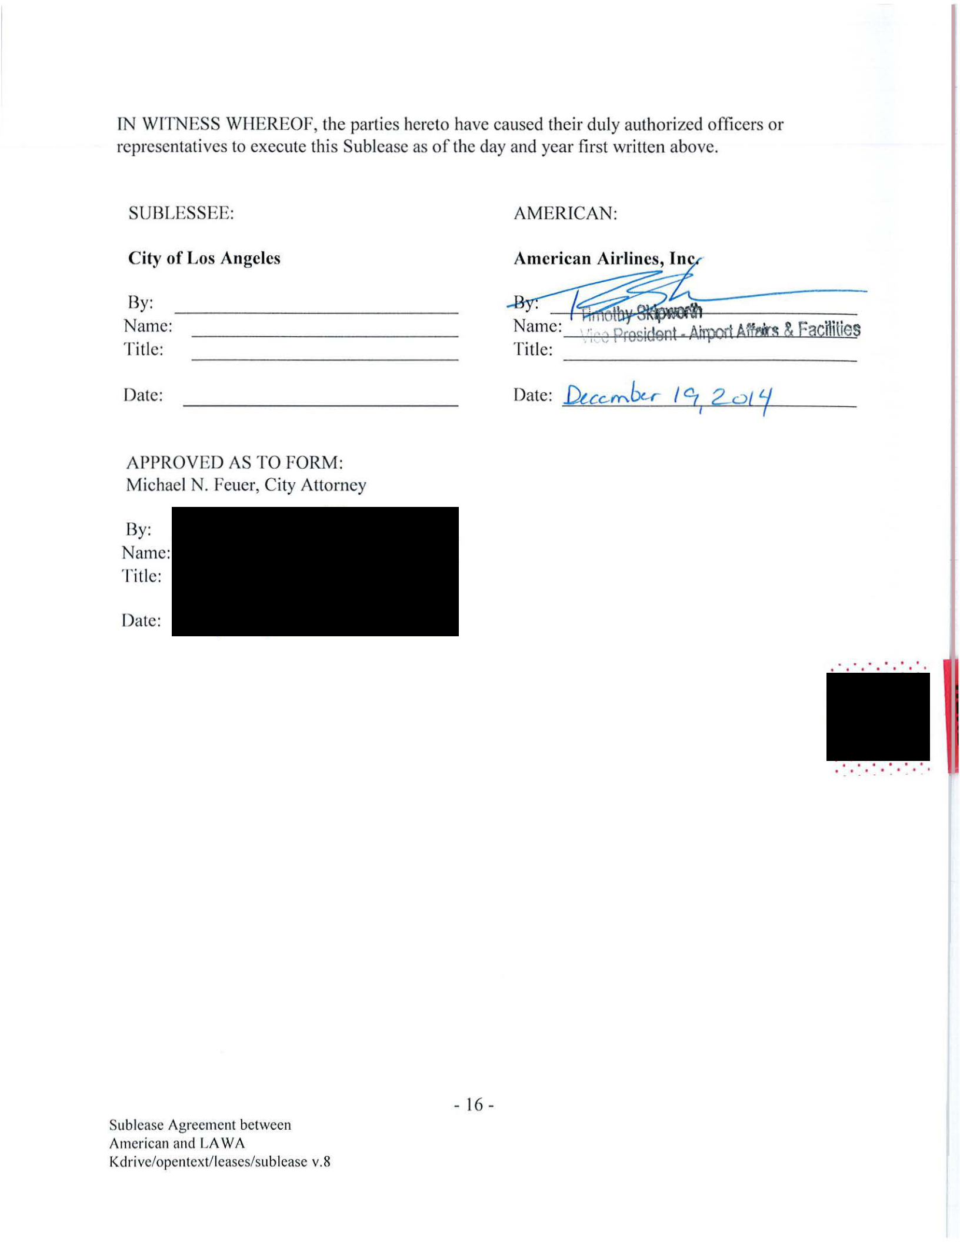
IN WlTNESS WHEREOF, the parties hereto have caused their duly authorized officers or representati ves to execute this Sublease as of the day and year first written above.

SUBLESSEE: AMERICAN:
City of Los Angeles |  |  | Ame~---------------
 |  |  | ~N ~II. |  |  | ~··
By: |  |  |  |  |  | ~··
Name: |  |  | ame: | ·: ., orosident . A~ Afftirs & Facu1t1es
Titl e: |  |  | Title: | · ''' | "i"'-""'

Date:

APPROVED AS TO FORM:
Michael N. Feuer, City Attorney

By:

Name:

Title:

Date:

.... . .. .
• " I • I I I

- 16-

Subl ease Agreement between

American and LA WA

Kdri ve/opentext/ leases/sub lease v.S

CONSENT

OF

REGIONAL AIRPORTS IMPROVEMENT CORPORATION

The Regional Airports Improvement Corporation hereby consents to this Sublease for all purposes of the Facilities Sublease (as defined herein) and hereby directs the Trustee to acknowledge this Sublease.

By:

^{Name:}-------------------------

Title: _______________

^{Date:} -----------------

Acknowledged by:

The Bank of New York Mellon Trust Company, N.A., as Trustee

By:

^{Name:}-------------------------

^{Title:} ----------------

^{Date:} ----------------

- 17-

Sublease Agreement between

American and LAW A

Kdrive/opentext/leases/sublease v.8
EXHIBIT A

Premises

-18-

Sublease Agreement between

American and LAW A

Kdrive/opentext/leases/sublease v.8

EXHIBIT A

Los Angeles World Airports

Sublease Agreement with American Airlines

Old | Old | New | New |  |  |  | lAW A Sublease From
Sheet# | Space# | Sheet# | Space# | Location Description | Space Description |  | AA(SF)
7 | 32 | 7 | 22 | Second Level West Ticketing | LAWA Bus Port | 2,450
12 | Port. of 71 | 12 | Port of 3 | Public Level Connector | Secure Connector | 2,095
15 | 2 | 15 | 10 | Mezzanine Level West Ticketing | Secure Connector | 1,606
13 | 3 | 13 | 3 | Public Level Satellite | Concession (Gate 45) | 1,000
11 |  | 11 | Port. of 1 | Public Level Ticketing | Concession (Secure Con ector) | 129
13 | 3 | 13 | 4 | Public Level Satellite | Concession (Gate 45) | 116
 |  |  |  |  |  | 7,396

I | I | I | I | I | I
-~-·--·T-·1~--·1, |  |  |  | , | £I
I | I | I | I | I
-!- -P~--+---iq

---.-9- ~- Q
~I I I
. !!!1·1I
- ~T=q ~ m9
I
I

'
l'
.•'7
~~
"
~~

.."
"
"
20
,.~
"
,.
,".
17
"'

t..AWA- LAX
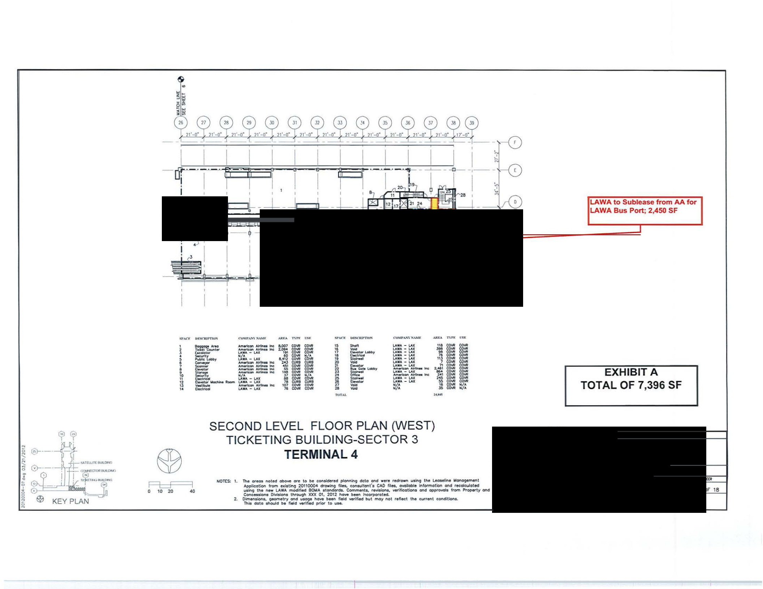
lAWA- LAX
lAWA- LAlC
LAWA - LAX
LAWA - LAX
LAWA - LAX ....
U.WA - LAX
~- ........._.
LAWA- LAX

I,AWA - LAX

LAWA -LAX
N/A
•I•

LAWA to Sublease from AA for

LAWA Bus Port; 2,450 SF

EXHIBIT A

TOTAL OF 7,396 SF

Fl:::J===J
0 10 20 40

SECOND LEVEL FLOOR PLAN (WEST)

TICKETING BUILDING-SECTOR 3

TERMINAL4

,.,OTtS: 1. The oreo• noted above ore to be eonsldefed pfonnlng dcto ond wore redrawn using the Leoscflne l.fonogement
Application from exla tng 20110004 drawin9 flies. con.ullont't CAO n... ovolloble lnfonnotlon ond re<:olculoted ~ t"• now t.AWA mocfin.d BOtrAA etondorct.. Commentt , ,.,.ion~. voeriftCOtions ond approval• from PToperty ond CoftcONIIoM OM.iont; through XXX 01. 2012 hove b&en hcorpofot"-
2. OlmenaJont, ~try and uf091t n.ov. bHf\ r.-.d verified b4.1t moy not r.tlect the current cOI'Idltlona.
Thil dolo llhould be r.eld vwif.ct pt1or to use.

JO\NISCT,..._
07 OF 16

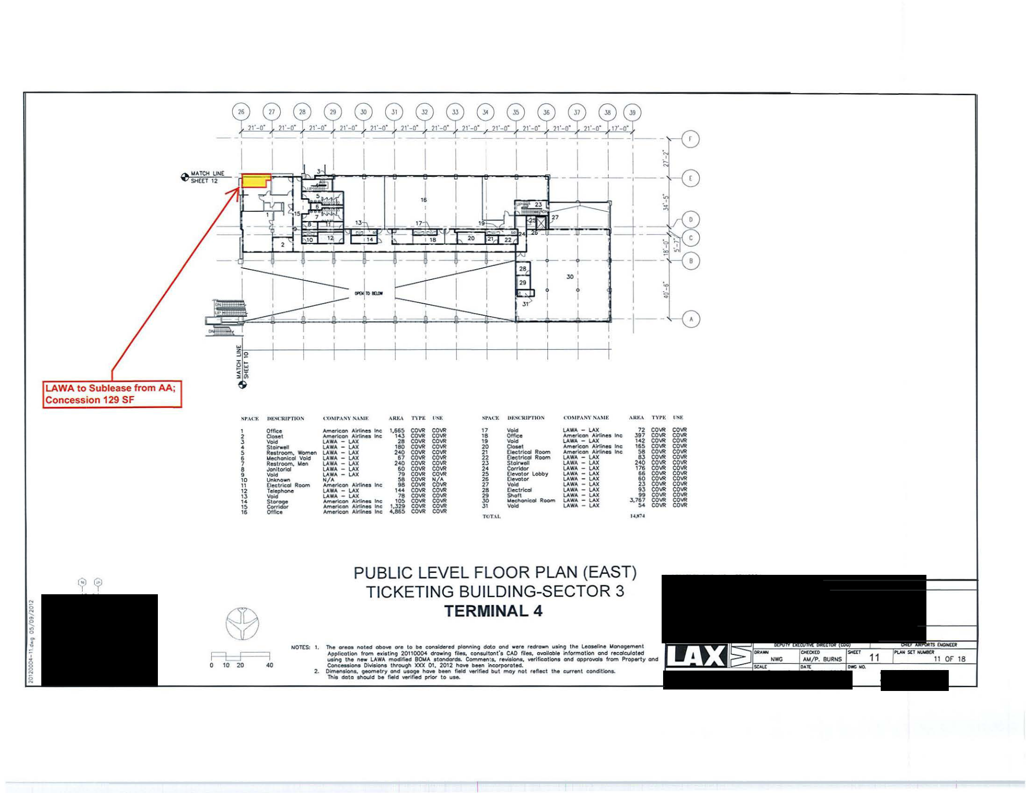

Q!l •.rCH UN(
SHEET 12

."'t',\(:,.; | m ;11o'C'RII"TIOI'o | ~ '0~11'',\N\' N,\,\IK |  | o\RI>:A | rn~: | IINJo: | SI'M .:Y. | UK."<'WIY'riUN | ( 'O)IJ',\N\'N,\Mt: |  |  | A NK.\ | TVJ'I-: | U.St:
1 | Of flea | Ametkon | AWtltles Inc: | 1,1565 | COVR | co"' | 17 | Void | LAWA - | LAX |  | 72 | co"' | COVR
2 | Clooe1 | Amff'lcon Airlines Inc |  | 14J | COVR | CO"' | 18 | Otrce | Amerlcon | AlrllMs | lne | J97 | co"' | CO"'
J | Void | LAWA - | LAX | 28 | CO"' | co"' | 19 | Void | t.AWA- LAX |  |  | 142 | co"' | co"'
4 | Stolrwel | LAWA - | LAX | 180 | COVR | co"' | 20 | 0...1 | Americoft | Alr1inu | tnc | 1$5 | co"' | CO"'
5 | R••troom, Women | LAWA - | LAX | 240 | CO"' | co"' | 21 | Elect~ Room | A.mer'con A1r1ines Inc |  |  | 58 | co"' | co"'
6 | Mechonk:ol Votd | LAWA - | LAX | $7 | co"' | CO"' | 22 | Elec:t~ Room | LAWA - | LAX |  | 8J | co"' | co"'
7 | Restroom. lolen | LAWA - | LAX | 240 | COVR | CO"' | 2J | St olrwoll | LAWA - | LAX |  | 240 | COVR | co"'
8 | Jonltodol | LAWA - | LAX | so | CO_,. | co"' | 24 | Corrldor | LAWA - | LAX |  | 176 | co"' | CO"'
• | 1/old | LAWA - | LAX | 79 | COVR | COVR | 25 | EleWJtor lobby | LAWA - | LAX |  | ••₆₀ | CO\IR | COVR
10 | Unknown | N/A |  | 58 |  | ~6C. | 26 | Elevator | LAWA - | LAX |  | ••₆₀ | CO\IR
11 | Electrical Room | Amerkon | Alriinu Inc | 98 | COVR | ~6C. | 27 | Vold | LAWA - | LAX |  | 2J | CO\IR | CO\If!
12 | Teleptwlne | LAW.4 - | LAX | 144 | COVR | COVR | 28 | Electrk:ol | lAWo\- LAX |  |  | 9J | COVR | CO\If!
1J | Void | LAWA - | LAX | 78 | CO"' | COVR | 29 | Sholl | LAWA - | lAX |  | 3,767 | co"" | CO\If!
u |  | Amer1con | Alttinet Inc | 105 | COV1! | CO\If! | JO | .._KhonCol Room | LAWA - | lAX |  | 3,767 | CO"' | co"'
15 | ~~ | Amerkon Airf1nos Inc. |  | 1,329 | CO"' | CO\If! | J1 | Void | LAWA - | lAX |  | $4 | CO"' | CO\If!
16 | 01fle• | Americon | A1rllnes Inc | 4,885 | CO"' | CO\If! | TOT.\l |  |  |  |  | l.tJrN

FLF=I
0 10 20 40

PUBLIC LEV EL FLOOR PLAN (EAST)

T ICKETING BU ILDING-SECTOR 3

TERMINAL 4

NOTES: 1. Tho oroos Aoted obove OUI t o be c:ons;def'd planning doto and were redl"own using tho loosolino lolonogemont Application from e• l•tlng 20110004 drawing f~o•. conaultonfa CAD filoa. ovo~obJe lnforrnotlon and rocalculot ed utin9 th• new LAWA mod111ed 90t.CA atondordf. Commen:e. ro'li1ion1. verlticotionl ond opproval• from Propetty ond
Conco..Jon. Oivielonl throuoh XXX 01. 2012 hovt b"n i-lcotpototed.
2.. Olmenalont, geometry ond u•ovo hove been field verlftOd but moy not reflect tho curront conditions.
Thtl doto ahould be field ...etiflllld pr5or to use.

...... "'........
11 OF 18

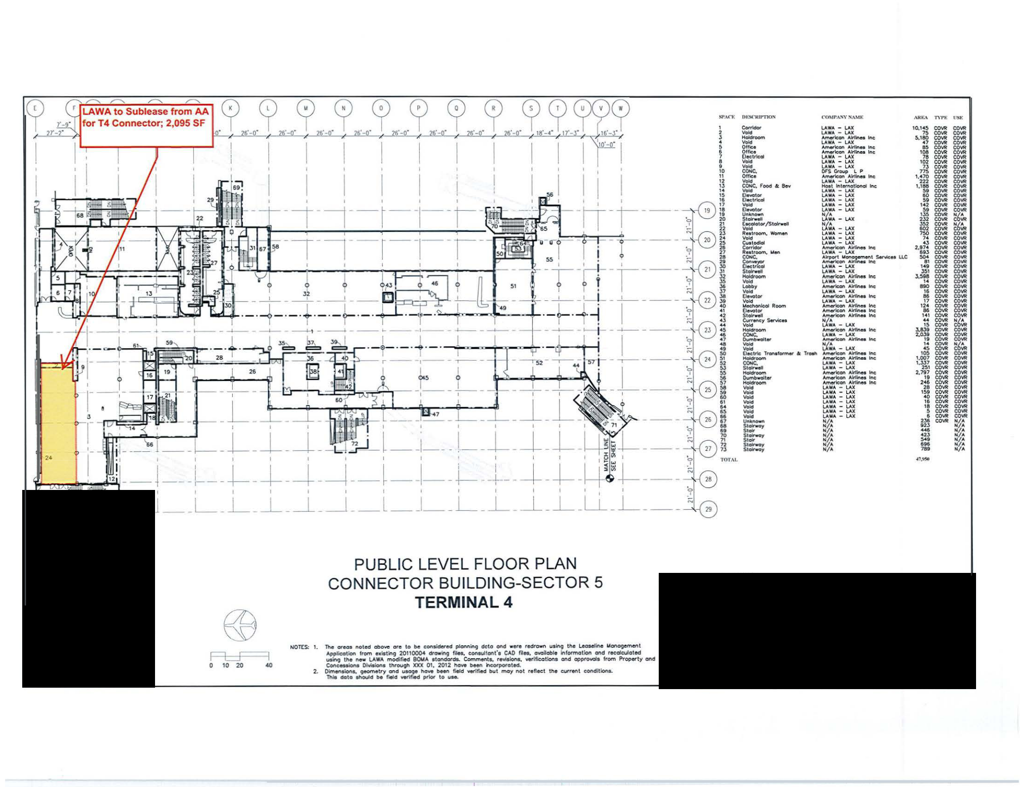
<'0\II'A''\N..U IIt

~ |  | U.WA - |  | LAX
Void |  | I.AWA | - | LAX
 |  | ~Atrflrwlall\t
Void |  | LAWA - |  | LAX
Ottlu |  | Al'r'lef'W:orl lrllrlee |  |  |  | Inc
Office |  | ~Airllr.es lne
⁻⁻(I.etried |  | I.AWA |  | L.AX
Void |  | LAWA | - | .AX
Void |  | I.AWA | - | LAX
CONC. |  | Of'S C&-oup |  |  | l P
Oftlu |  | LAWA |  | LAX
CONe. f OOd ft 8ov |  | --Inc
CONe. f OOd ft 8ov |  | Hoe.t | itt.tOMOtioftollnc:
 |  | LAWA - |  | LAX
0..010< |  | LAWA - |  | V.X
(t..;t~ |  | LAWA - |  | LAX
⁻O...otor |  | LAWA - |  | lAX
⁻O...otor |  | I.AWA -LAX
u....... |  | t'f~" | -\.A)(
Stok'well |  | t'f~"
- |  | t'f~"
C.c;olotor/Stolfwoll |  | ~~A -LAX
Void
ReetrOOM, Women |  | LAWA - |  | lAX
Void |  | I,AWA | - | LAX
C~o~1todlal |  | LAWA - |  | LAX |  | tnc
CON'idot |  | Amer'\can Airiinoa |  |  |  | tnc
R••ttoom., Uen |  | U.WA - |  | LAX
COOIC. |  | ~~~..!c~.. uc
&c:~
&c:~ |  | LAWA |  | LAX |  | Inc
$ 1 - |  | t.AWA - |  | LAX |  | Inc
=y |  | Amwic:on AK'nes |  |  |  | Inc
=y |  | t.AWA - |  | LAX |  | Inc
=y |  | --U.WALAX |  |  |  | Inc
Elevotor |  | Atl\el'1cotr. A~lnot.lftc
⁻Void |  | LAWA - |  | LAX
1.\oc.honicol Room |  | Atncrioan |  |  | A\l'tlnn Inc
[ 1.110101' |  | A.tnerlc.on |  |  | Alrtlnoa | Inc
Stolrwell |  | ~A1rtlnMinc
C~Hrency Serkn |  | t:(:,.- |  | l.AX
Void
CONe. |  | ~an ~Ina
CONe. |  | LAWA- LAX
o.. 1> olt., |  | ~an~tnc.
Void |  | t'f~ ... |  | lAX
-- |  | t'f~ ...
tle>etrk lrOMf0t1'1'*' • | lroel'l | --._Inc..........
"""'
CONe. |  | LAWA | - | lAX
51 |  | LAWA- LAX |  |  |  | Inc
⁻⁻Oumbwoller |  | AIMricon Alr11nn |  |  |  | Inc
⁻⁻Oumbwoller |  | ~Aittr.011inc.
 |  | ""'-'rtconAlrtlnn tnc
Vo~ |  | LAWA - |  | LAX
vo~ |  | LAWA | - | LAX
Vo~ |  | LAWA - |  | LAX
\lo~ |  | LAWA - |  | lAX
-- |  | I.AWA - |  | lAX
\loki
Void |  | LAWA - |  | LAX
u...... |  | LAWA - |  | lAX
u...... |  | N/ A
S1-,. |  | •Z•
- |  | •Z•
.... |  | ~~
Stc*woy |  | ~~
51.. |  | •Z•
St~y |  | •Z•

TYf'll\
1Q,14~ cow
7..,,$ ^{cow}
~.180 cow
cow
COIIR
- COIIR
- COIIR
¹⁰² COIIR
7l CCVI! ns CDIIR
1.• ..10 COIIR
222 cow
1. 188 cow cow
00 cow •• cow 1<2 cow
•• cow
1lS cow 2l2 CDIIR
lS2 CCVI!
.802, CDIIR
7$0
., COIIR CCVI! CCVI!
2,97-,4 C0\10_{COIIR} SO<,.., COIIR ,.... ^{COIIR} COIIR
lS1 COIIR
..,. ^{cow}_{CDIIR} cow

"""10 cow
.., ^{cow}COIIR 12<.. CCVI!
COIIR
1 , CCVI!
,...1S,. ^{COIIR}
COIIR
COIIR
2.0l0.. cow
,¹⁰ ^{COIIR} cow
cow
10$ cow
1,007 cow
1.3J.7 cow
251 CDIIR
2.'107 COIIR
- CDIIR 2••... COIIR
28 C0\10 C0\10
<0 COIIR
- C0\10
18 | CDIIR
s | cow
...., | cow
...., | cow
• | cow
2l6
02l

co"'
co"'
co"'
co"'
COIIR
COIIR
COIIR
COIIR
COIIR
"""'co"'
co"'
c""'
~
cow
COIIR
co"'
co"'
u~
u~
co"'
COIIR
COIIR
COIIR
co"'
co"'
co"'
CDIIR cow
COIIR
co"'
COIIR
cow
C0\10
co"'
C0\10
COIIR
COIIR
~~
co"'
co""
co""
u~
~
co"' cow CO"'
C0\11t
CO"'
co"'
COI/O
co""
co""
co""
co"'
co"'
co"'
_{•Z•}N/?<
•Z•
N/ A
•Z•
N/A

Stolrwoy N/ A
780 _{N/A}

4'1.~

if ~)

~~;----~

~ 0-----~
i

 | PUBLIC LEVEL FLOOR PLAN
 | CONNECTOR BUILDING-SECTOR 5
 | TERMINAL4
 | NOT!S: 1. The Of'eOInoted obove are to be COI'Isidef"ed planning delta ond were redrawn using the Lc03eline Uonogernent
Fi=J=-1 | Applicolio" from edating 20110004 df'owlng flies. c:ons u!lont't CA0 Res, ovailoble Information ond recofeuloted
Fi=J=-1 | usio\t the new I.AWA modified BOUA ttondotde. Comments, r~. verif~Cetlons ond opproo.oola from Property and
10 20.00 | tone.eMioN I»Miona through XXX 01, 201 2 hove been hcorpcwoted.
 | 2. Oimen~a. ~try and UaQ9e hove bHn f*d Yerif.ed but tnOY not r.tleet the current conditlona.
 | Thif dolo ~ould be feeld verified prior to use.

UASTER l.£ASt EXH18$T

TERMINAL4

20120004

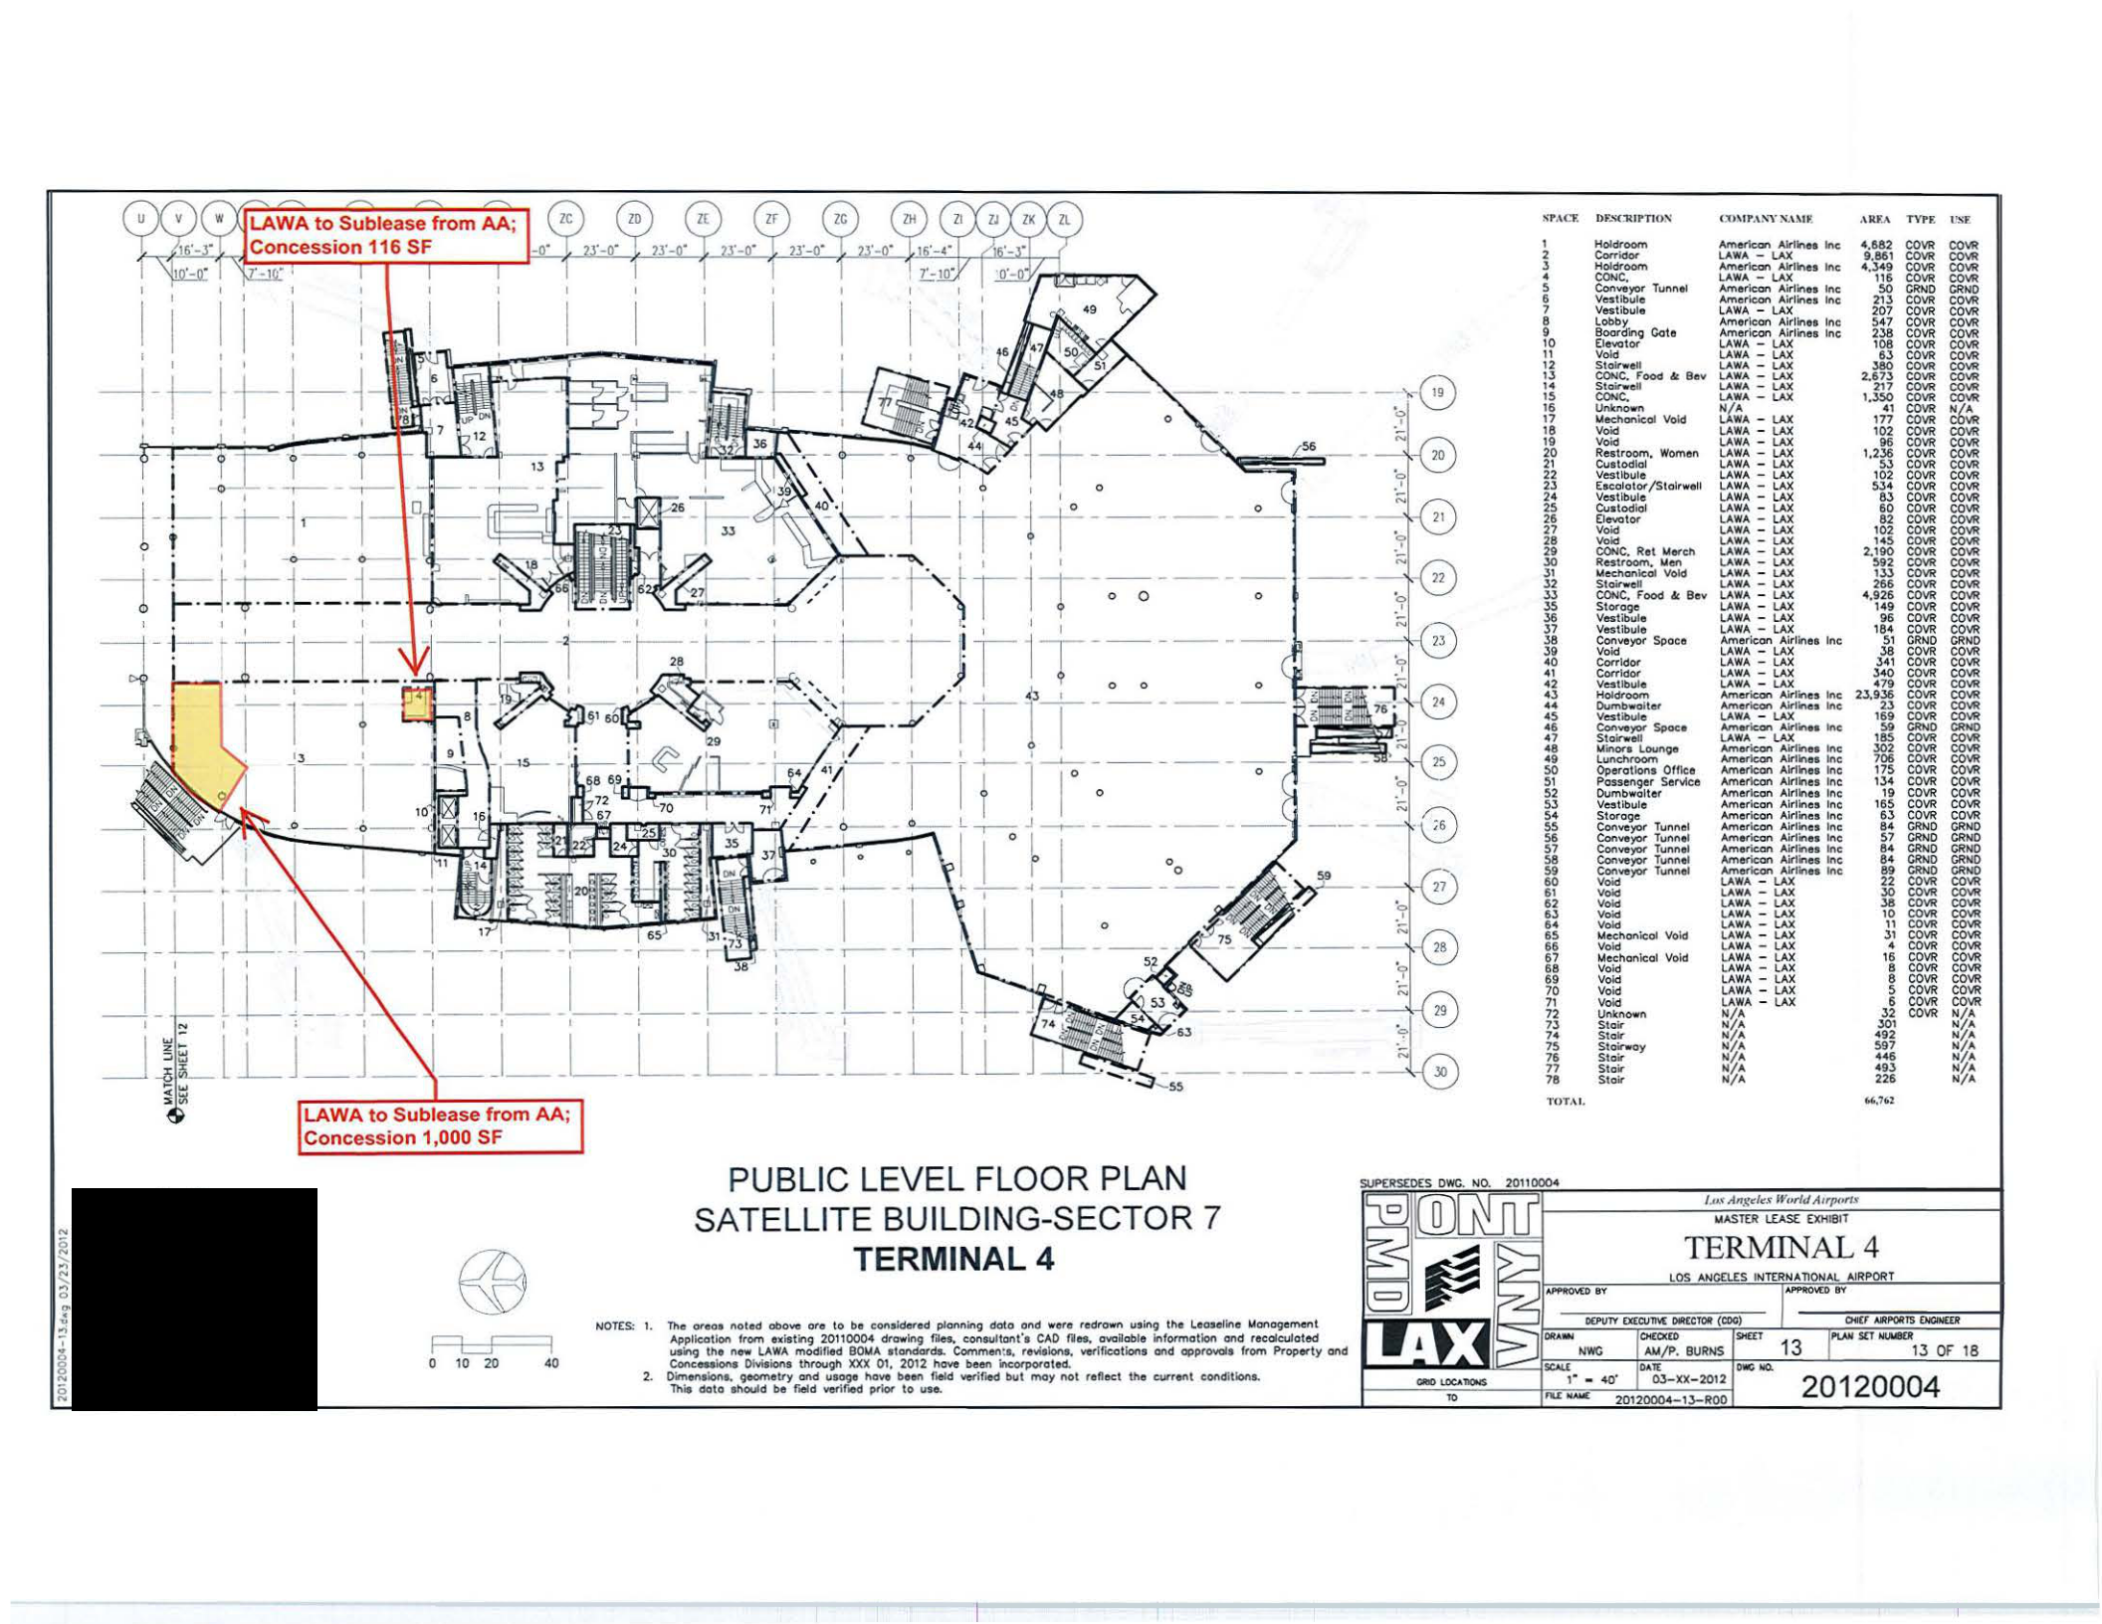

I
,-- -,-- ~
I I I ! I II

~.--.--.--[~L~L[L

- Holdroom

- Con--
- Holdroom
4 | CONC, | Tunn ..
5 | Conve.yor | Tunn ..
6 | Vestibul e
7 | Vest ibule
8 | Lobby
g | Boorifn~ | Cot e
10 | Oevator
, | Void
12 | Stolrwe#
13 | CONC. rooe~ & Bev
14 | Stoirwol
15 | CCNC.
16 | Unl<no-
1? | Uechonicol Vo;d
18 | Void
19 | Void
20 | Restroom, Women
21 | Cu l todkJI
22 | Vestibule
23 | Eac.olotor /Stolrwell
- Vest ibule

- Cuatodiol
- 0$'o'Ot01"
- Void

- Void
- CONC. Ret Wweh
- Restroom. Wen

- Wechonlccl \fold
- St oit'wel
^{;})} CONC, Food 4c Bev
- Storage

- Vastibule

- VesUbule
- e~\11111)'01" Spoce
- -
- Co<• !do<
- Co<•ldo<
- Vestibule
- .....
- Oumbwoiter
45 | Vestibule
46 | Cot'lve.)'Ot Spoc:e
., | Stoirwllllll
- Wlnor'l lounQo
- Lunchn>om
- OperoUons Oftk:e
..51 Possen~r SeMee
- Dumbwaiter
- _{St«oge}Vestibule
- Conveyor Tunnel
- Conve)'O"Tunnel
- Con...yor Tunnel
- ConYepTunnel
- ~ve)'Otl~

- "'""
- VOid

- VOid
6 4 | Void
•• | Uee.honic:ol Vo'kt
66 | Void
6? | Uechank:ol Void
68 | Void
69 | Void
70 | Void
71 | Void
72 | Unl(nown
73 | Stair
74 | Stalr-
75 | Stoirwoy
76 | Stair
77 | Stair
78 | Stair

T OTA l .

Cl)\11'.\S\'X.\MF.

An\ef1ean Alrtlnee Inc
LAWA - LAX
Am~ AJrShes Uw:
LAWA - LAX
Amer\con Alrilnes Inc
Atncrk:.on Airllnu Inc
I.AWA - L AX
American Airllnea Inc
American Airlinee Inc
LAWA - LAX
LAWA - LAX
l.A.WA - lAX l,AWA - lAX LAWA - lAX
LAWA - LAX
N/ A
LAWA - LAX
LAWA - lAX
LAWA - LAX
LAWA - LAX
LAWA - LAX
LAWA- LAX
LAWA - LAX
LAWA - LAX
LAWA - LAX
LAWA - LAX
LA.WA - LAX
LAWA - LAX
LAWA - LAX
LAWA - LAX
LAWA - LAX
LAWA - LAX
I.AWA - LAX
I.AWA - LAX
LAWA - LAX
LAWA - LAX Amede.on Airline• Inc LAWA - LAX

LAWA - LAX
LAWA - LAX
LAWA - LAX Atnarieon Airlines Inc:
American Airlines Inc.

LAWA - LAX Amflric:cn Airtinee Inc

LAWA - LAX
Atnerie.on Alrlinee Inc:
Ametk;on Alf'llneeInc
Arnet1c:an Ai11nee Inc
Amerk:on Ai11nes Inc
Amerlcon Alrtlnes Inc:
Afl'lericon Alrtlnea Inc
AMerleon Airlines Inc
Amerlcon Alr11nes Inc
Am..-k:on Airlines Inc
American Airlines Inc
American A.ittlnes Inc:
Arner\con AlrtiMs Inc
LAWA - LAX
LAWA - LAX
lAWA - lAX
LAWA - LAX
LAWA - LAX
LAWA - LAX
LAWA - LAX
LAWA - LAX
LAWA - I..AX
LAWA - I..AX
LAWA - t.AX

LAWA - LAX
N/A
N/.A
•Z•
N/.A
•1.•

N/.A
•I•

,\RF.A TVI'F. 1'SF

•.882 COVR COVR 9 ,861 COVR COVR

- .3-49 COVR CO\'R 116 COVR COVR
50 CI!ND CRNO
213 COVR COVR
207 COVR CO\'R
547 COVR CO\'R
238 COVR CO\'R
108 COVR CO\'R
03 COVR CO\'R
380 COVR COVR
2.673 COVR _{co""}
217 COVR COVR
1.350 | COVR | COVR
4 1 | COVR | ~
177 | COVR | ~
102 | COVR | CO\'R
.. | COVR | CO\'R
.. | COVR | CO\'R
1,2~ | COVR | co""
102 | COVR | COVR
102 | COVR | CO\'R
534 | COVR | COVR
83 | COVR | COVR
60 | COVR | COVR
82 | COVR | COVR
102 | COVR | COVR
14S | COIM | COVR
2.190 | COVR | CO\'R
592 | COVR | CO\'R
1:>3 | COVR | COVR
266 | COVR | COVR
4,926 | COVR | CO\'R
149 | COVI! | COVR
.. | COVR | COVR
184 | COVR | COVR
51 | CRNO | CRNO
38 | CCVI! | COVR
341 | COVI! | COVR
340 | COVR | CO'JR
479 | COVR | CO\'R
23,936 | CCVI! | CO\'R
23 | COVR | CO\'R
169 | CCVI! | CO\'R
50 | CRNO | CO\'R
1115 | COVR | CO\'R
302 | COVR | """"
302 | COVR | CO'JR
706 | COVI! | CO\'R
175 | COVI! | CO'JR
134 | COVI! | CO\'R
19 | COVI! | CO\'R
165 | COVI! | COVI!
03 | COVI! | CCVI!
84 | CRNO | CRNO
57 | CRND | CRND
84 | CRNO | CRNO
84 | CRNO | CRNO
89 | CRNO | CRNO
22 | COVR | CO\'R
30 | COIM | CO\'R
38 | COVR | CO\'R
10 | COVR | COVR
, | COVR | CO\'R
³¹.COVI!^{COVR} |  | CO\'R^{CO\'R}
16 | COVI! | CO\'R
•₈ | COVR | COVR
•₈ | COVR | CO\'R
5 | COVI! | CO\'R
6 | COVR | CO\'R
32 | COVR | N/ A
••2 |  | •1.•
301 |  | •I.•
S97 |  | •I.•
.... |  | N/.A
 |  | •Z•
- N/.A
- N/A

 | PUBLIC LEVEL FLOOR PLAN
 | SATELLITE BUILDING-SECTOR 7
 | TERMINAL4
R=F=l | NOTES: 1. The areas noted obavo ore to be con,Jdet'ed planning doto and were redrawn usift9 the Leoullne L4onagcrnent
R=F=l | Appllcat~ from exieti'lg 20111J()C)4 drawing r.ae-. coneultont'tCAD tie., ovailoble information and recalculated
R=F=l | us"'9the new LAWA modified BOMA stondatda. Commen~. re*1ons, verlfiCOtion!l and approvoll from Property ond
10 2040 | Cone~ DMeions WWQh XXX 0 1, 2012 hove been i'lcotpototl'd.
KEY PLAN | 2. Dmentionl. 960fi'Olry and usage have been Geld WJrif..cS but tnay not refhtc:t the Cl,ln'entconditions.
KEY PLAN | lhje; doto thOuld be flltlid verlf.od pf1or to use.

TERMINAL 4

lUll SCI ......
13 or 1s

20120004

LAWA to Sublease from AA for T4

Connector; 1,606 SF

..1".\CF. | ut:"C 1UPTIU S |  | c'0!\11",\~Y N,.\\111 |  |  |  | ,\IU'.A | n ·rv. | ''"F.
1 | Offce |  | Ametteon A~in.. Inc |  |  |  | 7J1 | co"" | co""
2 | Void |  | LAWA | - | lA.lC |  | 102 | co"" | co""
J | Cotrldo< | Room | lAWA - |  | LAX |  | :>47 | co"" | co""
4 | lrAechonlc:ol | Room | LAWA - |  | LAX |  | 2.431 | co"" | co""
 | Stairwell |  | LAWA - |  | LAlC |  | 212 | co"" | COIIR
6 | Re• troom, | Men | Amarieon |  | Airline• | Inc | 406 | COIIR | COIIR
'7 | Restroom, | Women | Amcrleon |  | Airline• | 11\C | J61 | COIIR | COIIR
8 | Jonitoriol |  | Amerieon |  | Atfltles | Inc | 8 2 | COII!l | COII!l
9 | '-IKhonic:ol | Void | LAWA - |  | LAX |  | 85 | COII!l | COII!l
10 | Offtc:e |  | Amcricon |  | Alrtlnos | Inc | 6,694. | COII!l | COII!l
11 | St__...l |  | LAWA. - |  | LAX |  | 243 | co"" | COII!l
12 | Oewtor Lobby |  | L.AWA - |  | LAX |  | S2 | COII!l | CCVI!
tJ | Oewt or |  | LAWA - |  | LAX |  | &0 | CCVI! | C0\11
14 | Void |  | LAWA | - | LAX |  | 2 4 | C0\11 | C0\11
,, | Void |  | L.AWA | - | LAX |  | 66 | C0\11 | COII!l
16 | t.lecl'lank"' | Shaft | lAWA - |  | LAX |  | 15S | COIIR | C0\11
17 | Locker Root'tl |  | •I• |  |  |  | 47 | COII!l | N/A
18 | Oulet ROOf"''' |  | N/A |  |  |  | 2JS | C0\11 | N/A
TOTAl. |  |  |  |  |  |  | ll,J.U
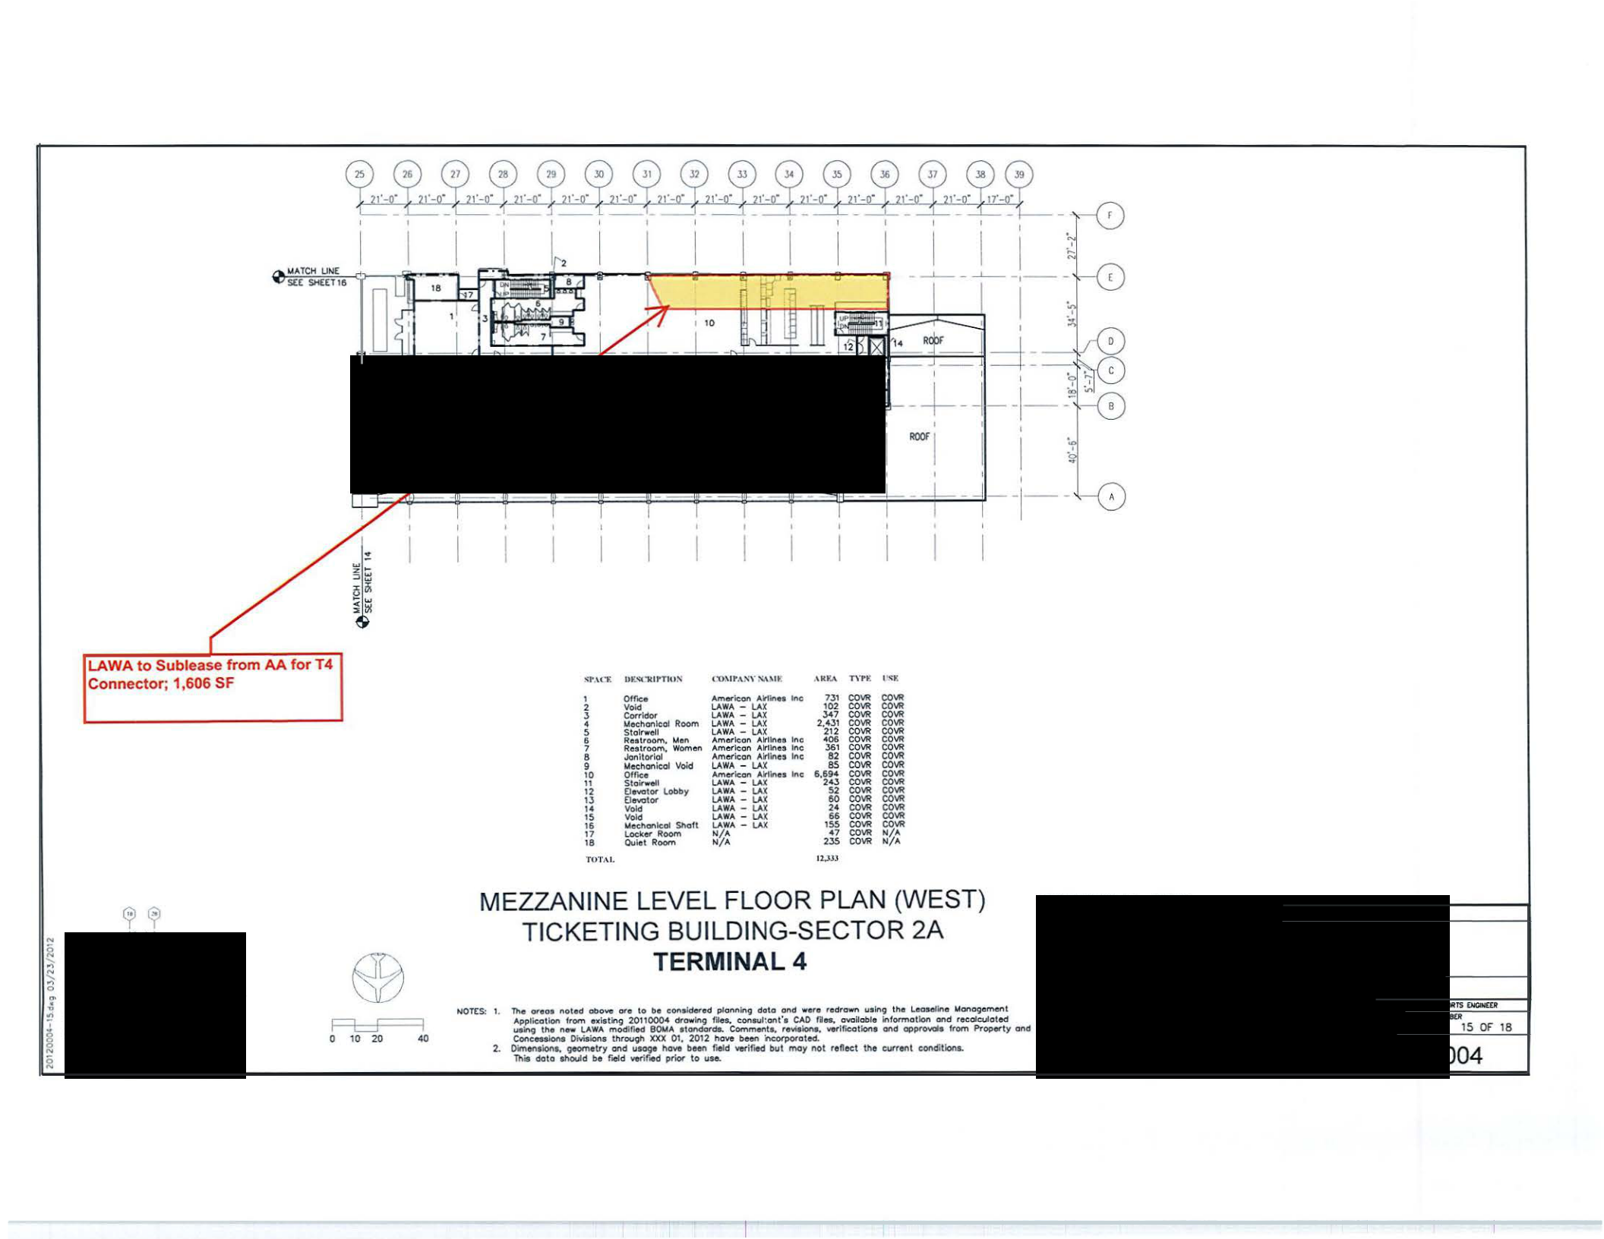

Fl::::F-==1
0 10 20 40

MEZZANINE LEVEL FLOOR PLAN (WEST) TICKETING BUILDING-SECTOR 2A TERMINAL 4

NOT(S: 1. Tho Of"eoe note d above oro to bo con-'dered plonnln9 d oto oncl wero redrawn using the Leosellno lolanogement

Application from n ie:t lng 20110004 dtowlftg tau. c:oneul·.ont'•CAD Rn. ovaVoble lntonnotlon ond recofculot ed

  - tM new I.AWA modifted 90MA •tondotde. Comment.. r e""-iotle. Yerifleotlon• ond appr~• from Property and Cone..~ Dhli•ion• throc.J9h XXX 01, 2012 hove been fteo(poroted.
- Oimentlont, geometry ond uaoge hOYt been f.etd verifMtd but moy not refteet the current conditionL
Thill dolo should be faeld verif.ct prior to u.ae.

/_,,., Ang~l~es World Au'(HH'I.t

"-""' sn lrUoi!D
15 OF 18

EXHIBIT B

Rent and Additional Rent

Effective January I, 2014:

I. Fair Rent:

 | Location Description | Space Description | SF | Annual Rental
 | Location Description | Space Description | SF | Rate
 | Public Level Connector | Secure Connector | 2,095 | $0.00
 | Second Level West Ticketing | LAWA Bus Port | 2,450 | $0.52
 | Mezzanine Level West Ticketing | Secure Connector | 1,606 | $0.52
 | Public Level Ticketing | Concession (Gate 41) | 129 | $0.52
 | Public Level Satellite | Concession (Gate 45) | 116 | $0.52
 | Public Level Satellite | Concession (Gate 45) | 1,000 | $32.00
 | Total |  | 7,396

- M&O Rent: $52.51 per square foot per annum; $4.3758 per square foot per month

- Additional Rent, effective as shown in the table below:

 | Effective Date | Per Square Foot Per Annum | Per Square Foot Per Month
 | October I, 2014 | $47.0947 | $3.9246
 | January I, 2015 | $47.6047 | $3.9671
 | January I, 2016 | $48.1440 | $4.012
 | January I, 2017 | $48.7355 | $4.0613
 | January I, 2018 | $49.3734 | $4.1145
 | January I, 2019 | $50.0518 | $4.1710
 | January I, 2020 | $50.7922 | $4.2327
 | January I, 2021 | $51,5737 | $4.2978
 | January I, 2022 | $52.4310 | $4.3692
 | January I, 2023 | $53.3418 | $4.4551
 | January I, 2024 | $353.5587 | $29.4332

Rent and Additional Rent are subject to adjustment as set forth in Section 5. above.

- 19-

Sublease Agreement between

American and LAWA

Kdrive/opentext/leases/sublease v.8

