HRM | Residential and Commercial Property Management
 | Commercial Leasing
 | Property Management Accounting
A Property Management Company | COMMERCIAL LEASE APPLICATION
 | COMPLETION INSTRUCTIONS

Thank you for your interest in this property. Please complete and return our Application Packet forms. You may either mail or deliver the documents to the address shown on the application. Commercial Tenants: Some items may not be applicable to you. Please call to clarify.

NOTE: Rent is due on or before the 1st of each month (no exceptions); we regularly inspect the property and expect that you will care for the property as if it was your own. Moreover, we expect our tenants to respect their neighbors (i.e., noise to be kept to a minimum, no violations of House Rules and HRM Policies and Procedures).

PROCESSING OF APPLICATION: If you don’t complete all items on the application (or explain why the items are not applicable), we will not consider your application. Further, you must complete and submit our release of information forms with your application. If your current and previous Landlords and Employers refuse to release information to us, we will not consider your application. PRINT CLEARLY SO THAT THE INFORMATION PROVIDED CAN BE READ.

RENTAL APPLICATION INSTRUCTIONS:

- Please carefully read and complete the forms included in this packet.

- A consumer credit report shall be ordered for tenancy purposes. Your application should be accompanied with an application processing fee of $20.00 per applicant (call for clarification if in doubt). This must be paid in cash, money order, cashier’s check or by charge card authorization. Personal checks are not accepted. Indicate your payment preference below.
- A deposit is not necessary when you return the application and other required forms. We will be verifying the information included. Incomplete or vaguely completed applications will not be processed.
- Should you be offered the unit to rent, you will be required to pay, in advance, the first month’s rent and the security deposit in cash or bank issued cashier’s check.
- You must return the forms packet with a photocopy of your State of Hawaii driver’s license or State of Hawaii Identification Card that contains your picture. If you are from out-of-state, provide your current state ID and driver’s license with picture included. If you are from another country, provide us with a copy of your passport (plus Form I-20 A-B/I-201D If Nonimmigrant (F-1)

- If employed, you must include a copy of your pay stubs/statements for the most recent two month period.

- You may either mail or deliver the forms packet to Hawaii Realty Management Corporation, 2745 South King Street, Honolulu, HI 96826. Should you choose to deliver the forms packet, we recommend that you enclose the documents together with photocopies of your IDs in an envelope. We are a small company and our office may not be open when you arrive. In that event, you can place the application documents in an envelope and place the envelope in our mail drop in the front door.

- You may also fax the forms packet and other required documentation to (808) 526-2299; however, this will delay processing of your application until we receive the application processing fee. Retain the originals. Should you be offered the unit to rent, the original documents must be provided.

CREDIT REPORT FEE (Payment Method):
Cash (Attach to Application Documents) |  |  | Money Order/Cashier’s Check (Attach to Application Documents)
Credit Card (Check one, enter card information & sign below) [Your statement will show a charge from NUI MONO]
NOTE: A CREDIT CARD CONVENIENCE FEE OF $5.00 WILL BE ADDED TO THE TOTAL OF THE ABOVE FEES
Visa | MasterCard |  |  | Novus |  | Am Express
Account Number: | - |  | - | - | Three Digit
 |  |  |  |  |  | Code:
Signature (for Credit Card payment): |  |  |  |  |  | Expiration Date:
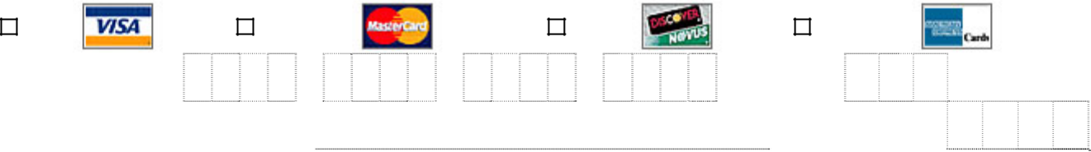

THIS APPLICATION PACKET INCLUDES THE FOLLOWING DOCUMENTS: (1) Completion Instructions, (2) Application, (3) Employment Verification Form, (4) Landlord Questionnaire Form, and (5) Tenant/Applicant Release Form for obtaining a Consumer Credit Report on tenant/applicant.

If you have any questions about completing the Rental Application and other forms, please contact us at (808) 526-3561 or (808) 941-2948.

Applicant hereby acknowledges receipt of this Application Packet and understands that applicant must complete all required forms and must return the entire package with appropriate fees, if any, when applying to rent an HRM managed unit by signing below and submitting the Application Packet and fees.

Rental Applicant Name (Print):

Date:

Rental Applicant Signature:

SSN:

L:\HRM Folders\HRM Residential Tenant\00 Vacancy Promotion\Email Rental Packet\01 Rental Application, Completion Instructions, Commercial Tenant (Rev 07-0105).doc

Hawaii Realty Management Corporation, 2745 South King Street, Honolulu, Hawaii 96826

COMMERCIAL TENANT APPLICATION

Prepared For: Hawaii Realty Management Corporation

Business Name:

Street Address:

 | City: |  |  |  | State: |  | Zip Code:
 | Phone No: |  |  |  | Fax No:
 | Name of Parent Company:
 | Type of Business: |  |  |  |  | GET License No:
 | Date Incorporated: |  |  |  |  | Taxpayer Identification No:
 | Date Business Started:
 | State Incorporated In:
 | Incorporated For:
 | Amount Actually Paid In:
 | At Present Location Since:
 | Location Is: |  |  | Owned | Rented | Other:
 | Monthly Mortgage/Rent:
 | If location rented, Landlord/Property Manager is:
 |  | Address:
 |  | Telephone: |  |  | Contact:
 | SUBJECT PROPERTY
 | Property Interested in Leasing:
 | Desired Lease Terms:
 | Principals:
 |  | Name & Title |  | Address |  |  | Social Security Number
 | Bank References:
 |  |  |  |  |  |  | Account
 |  | Name |  | Address |  |  | Type | Account No

Created on 4/30/2001 12:52 PM

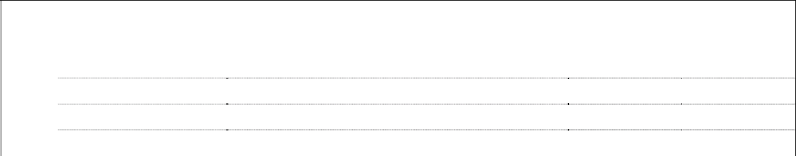
Trade and Credit References:

 | Name | Address | Svc/Product | Account No
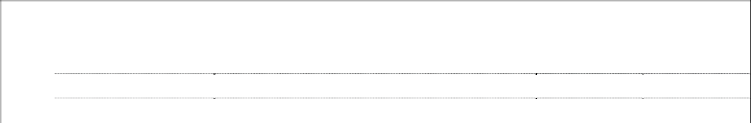

Real Estate Owned:

 | Name | Address | Value | Loans
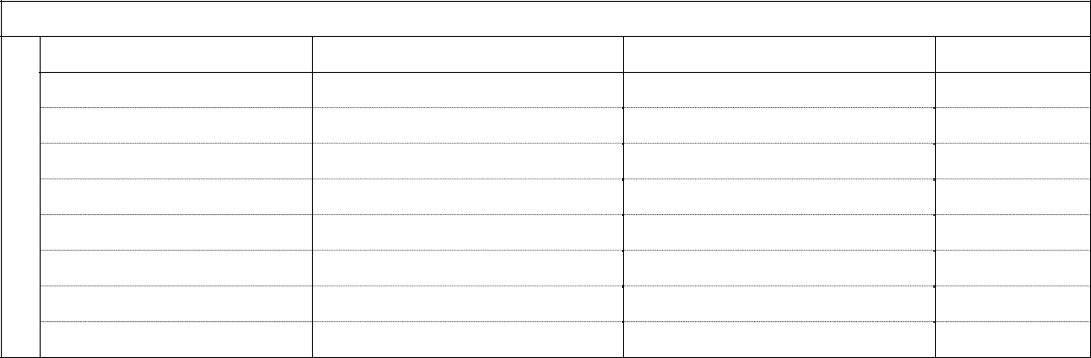

Insurance Carried & Agent:

Policy Type | Insurer | Agent | Limits

Auto – Business

Fire Policy

Umbrella – Commercial

Worker’s Compensation

Package

Umbrella – Personal

Flood Policy

Fire Loss?
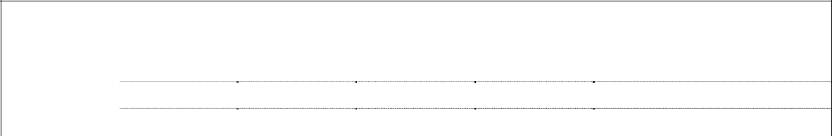

Company Owned Vehicles:

 | Year | Make | Model | License | Comments
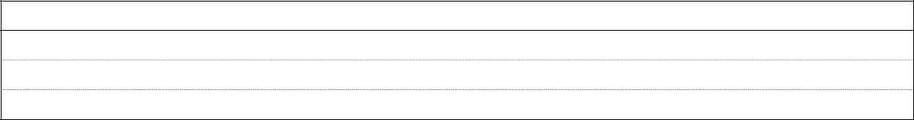

Other Information/Conditions:

I hereby certify that the information in this commercial tenant application is correct. The information included in this application is for the use of Hawaii Realty Management Corporation, Agent for Landlord, in determining if applicant is qualified to lease the above reference commercial real estate. I understand that Hawaii Realty Management Corporation may also utilize the other sources of credit, which it considers necessary in making the determination to lease to applicant. Further, I hereby authorize the banks and trade references listed in this commercial tenant application to release the information necessary to assist Hawaii Realty Management Corporation in making this determination.

Print Name Signature Title Date

Created on 4/30/2001 12:52 PM
RENTAL APPLICATION
RENTAL APPLICATION |  | Print Clearly
(A separate application must be completed by each adult occupant) |  | Print Clearly

IMPORTANT:

- Each financially responsible party applying to rent this property must complete a separate Rental Application. Make additional copies, if needed. Your spouse or co-applicant, if any, should complete a separate Rental Application.
- Attach copy of your driver’s license or other official State of Hawaii Identification.
- If self-employed, submit your Federal Income Tax Returns for the past two years and your State of Hawaii, General Excise Tax Annual Returns for the past two years.
- Other proposed occupants 18-years and older must complete a rental application even if they are not a rental applicant.

Fax: | (808) 526-2299, | (808) | 949-0896 or | (808) 000-0000 | Hawaii Realty Management Corporation
Tel: | (808) 941-2948, | (808) | 526-3561 or | (808) 000-0000 |  | 2745 South King St., Honolulu, HI 96826
Othr: | (808) 306-0754, | (808) | 000-0000


This application may be submitted to RENTCHECK, TENANT CHECK, CREDIT BUREAU OF THE PACIFIC and/or NATIONAL DATA SEARCH for verification. Please furnish all information requested. Use another sheet of paper if needed. You must sign this application.

Lease Term Desired |  |  |  |  |  |  |  |  |  |  |  | Lease Start Date |  |  |  | For Rental Unit Located At:
Six (6) Months |  | Twelve (12) Months
Applicant |  |  |  |  | Work Phone No. |  |  |  |  |  |  | Home Phone No. |  |  | Email: |  |  | Social Security No:
How Long In Hawaii? |  |  | Spouse’s Name or Co-Applicant |  | Name(s) |  |  |  |  | (Needed for Credit Information) |  |  |  |  |  |  |  | Social Security No.
Proposed | Children |  |  | Social Security No. |  |  |  |  |  |  |  |  | Other Occupant Name |  |  |  |  | Social Security No.
Occupants
(Non-Applicant)
(Non-Applicant) | Children |  |  | Social Security No. |  |  |  |  |  |  |  |  | Other Occupant Name |  |  |  |  | Social Security No.
Housing | Present Address |  |  |  |  |  | From: |  |  |  |  | Landlord’s | Name |  |  | Telephone Number |  |  |  |  | Rent Paid
Data
 | City |  |  | Zip Code |  |  | Why Are You Moving?
 | Previous Address |  |  |  |  |  | From |  | To |  |  | Landlord’s Name |  |  |  | Telephone Number |  |  |  |  | Rent Paid
 | City |  |  | Zip Code |  |  | Why Did | you Move?
Employment | Employer |  |  |  |  |  | Address |  |  |  |  |  |  |  |  | Supervisor |  |  |  |  | Phone No.
Data
 | Position? |  |  |  |  |  | How Long at Present Job? |  |  |  |  |  |  | Monthly Salary |  | Housing Allowance Amount |  |  |  |  | Rotation Date
 | Previous Employer |  |  |  |  |  | Address |  |  |  |  |  |  |  |  | Supervisor |  |  |  |  | Phone No.
 | Position? |  |  |  |  |  | How Long at Previous Job? |  |  |  |  |  |  | Monthly Salary |  | Housing Allowance Amount |  |  |  |  | Rotation Date
Other | Other Income (Monthly) |  |  | Source |  |  |  |  |  |  |  | DSS Assistance |  |  |  | Monthly Amount |  | Worker’s Name |  |  | Unit
Income
Bank | Bank Name |  |  |  |  |  | Branch |  |  |  |  |  |  | Savings Account No. |  |  |  | Checking Account No.
Data
 | Bank Name |  |  |  |  |  | Branch |  |  |  |  |  |  | Savings Account No. |  |  |  | Checking Account No.
Credit And | Firm Name |  |  | Branch |  |  | Account No. |  |  |  |  |  |  | Amount |  | Mo. Payment |  | Loan Type
Loan Data
 | Firm Name |  |  | Branch |  |  | Account No. |  |  |  |  |  |  | Amount |  | Mo. Payment |  | Loan Type
 | Firm Name |  |  | Branch |  |  | Account No. |  |  |  |  |  |  | Amount |  | Mo. Payment |  | Loan Type
Vehicle | Automobile (Year) |  |  | Make |  |  | Model |  |  |  |  | License No. |  | Mo. Payment |  | Loan Company |  |  |  |  | Phone No.
Information
 | Automobile (Year) |  |  | Make |  |  | Model |  |  |  |  | License No. |  | Mo. Payment |  | Loan Company |  |  |  |  | Phone No.
 | Other Vehicle/Motorcycle (Year) |  |  | Make |  |  | Model |  |  |  |  | License No. |  | Mo. Payment |  | Loan Company |  |  |  |  | Phone No.

C:\Documents and Settings\Steven M. Costello\My Documents\HRM Folders\HRM Residential Tenant\01 Vacancy Promotion\Email Rental Packet\02 Rental Application, Letter Size (Rev 06-0601).doc Created on 06/21/06, 9:15 AM
Personal | Name of Nearest Living Relative |  | Relationship | Address |  |  |  |  |  |  | Telephone No.
References
 | Personal Reference (Hawaii Resident) |  | Telephone No. | Personal Reference (Hawaii Resident) |  |  |  |  |  |  | Telephone No.
Emergency | In Case of |  | Address |  |  |  |  | Relationship |  |  | Telephone No.
Information | Emergency, Notify:
Rental | Rental Term | To: |  | Monthly Rent |  |  |  |  |  | Security Deposit
Information | From:
Receipt | Receipt Is Hereby Acknowledged |  | Security Deposit |  |  |  |  | Rent |  |  | Credit Check Fee
Receipt | For the Following: |  | $ |  |  |  |  | $ |  |  | $
 |  | HAVE YOU OR CO-APPLICANT EVER:
 |  |  |  | Yes No |  |  |  |  | Further Explanation (If any)

Been sued for non-payment of rent?
Been evicted or asked to move out?
Been sued for damage to rental property?
Broken a Rental Agreement or Lease?
Declared Bankruptcy?

Please give any additional information that might help management evaluate our application:

How did you hear about our property?

If management has any questions about your application, please give Phone Numbers where you can be located.

I hereby apply to lease the above described premises for the term and upon the conditions above set forth and agree that the rental is to be payable on the 1st day of each month in advance. As an inducement to the owner of the property and to the agent to accept this application, I warrant that all statements set forth above are true. However, I understand should any statement made above be a misrepresentation or not a true statement of facts, $100.00 of the deposit may be retained by Hawaii Realty Management Corporation to offset the agent’s cost, time, and effort in processing this application.

If this application is accepted, I hereby agreed to deposit, in cash, money order, or cashier’s check, an amount equal to one month’s rent plus the security deposit as earnest money. Further, I agree to execute a Rental Agreement for the “Lease Term Desired” shown above. Should I fail to execute a Rental Agreement within one (1) business banking day(s) after being notified of acceptance, $100.00 of the deposit will be forfeited as liquidated damages in payment for the agent’s time and effort in processing my application, including making necessary investigation of my credit, character, and reputation, and for agent’s time for drafting the necessary documents in connection with the rental of the subject property. If this application is not approved and accepted by the owner or agent, I understand that the credit reporting fee, in the amount stated on the 1st page of this Rental Application, will not be refunded. The applicant hereby waives any claim for damages by reason of non-acceptance.

I AUTHORIZE YOU TO CONTACT PREVIOUS LANDLORD(S), CREDIT AND PERSONAL REFERENCES THAT I HAVE GIVEN IN THIS APPLICATION. I ALSO AUTHORIZE MANAGEMENT TO OBTAIN MY CONSUMER CREDIT REPORT.

The above information, to the best of my knowledge is true and correct.

 |  | Tenant
Manager’s |  | Applicant
Signature | Date: | Signature | Date:

C:\Documents and Settings\Steven M. Costello\My Documents\HRM Folders\HRM Residential Tenant\01 Vacancy Promotion\Email Rental Packet\02 Rental Application, Letter Size (Rev 06-0601).doc Created on 06/21/06, 9:15 AM

HRM

Residential and Commercial Property Management

Commercial Leasing
Property Management Accounting

A Property Management Company

Request for Verification of Employment

Privacy Notice: This information is to be used by HRM in determining whether you qualify as a prospective renter under its program. It will not be disclosed outside of HRM. You do not have to provide this information, but if you do not, your application for approval as a prospective renter will be rejected.

Instructions: Tenant – Complete items 1, 7, 7a & 8 below for each employer.

Hawaii Realty Management – Complete items 2 – 6 below.
Employer – Please complete either Part II or Part III as applicable. Complete Part IV and return directly to Landlord named in item 2 below.

Part I - Request

1. To (Name and address of employer. Include phone and fax number.)

Company Name: ____________________________________________________________________

Address: ____________________________________________________________________

City, State & Zip: ____________________________________________________________________

Phone & Fax:

2. From (Name and address of Landlord or its agent)

Hawaii Realty Management Corporation
2745 S. King Street
Honolulu, HI 96826
Tel: (808) 941-2948 Fax: (808) 526-2299

I certify that this verification has been sent directly to the employer and has not passed through the hands of the applicant or any other interested party.

3. Signature of 4. Title 5. Date 6. Landlord’s Reference (Optional)
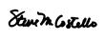
prospective Landlord
or its agent. Steven M. Costello Property Manager

I have applied for a rental property and stated that I am now or was formerly employed by you. My signature below authorized verification of this information.

7. Name and Address of Applicant (include employee or badge number in 7a) 7a. Social Security, employee or badge #. 8. Signature of Applicant

Part II – Verification of Present Employment

9. Applicant’s Date of Employment |  |  |  |  | 10. Present Position
12A. Current Gross Base Pay (Enter Amount and Check Period) |  |  |  |  | 13. For Military Personnel Only
 |  | Annual | Hourly |  | Pay Grade
 |  | Monthly | Other (Specify) |  | Type | Monthly Amount
$___________________ |  | Weekly |  |  | Base Pay | $
 | 12B. Gross Earnings |  |  |  | Rations | $
Type | Year To | Past Year |  | Past Year | Flight or Hazard | $
Type | Date | 20___ |  | 20__
Base Pay | $ | $ |  | $ | Clothing | $
Overtime | $ | $ |  | $ | Quarters | $
Commissions | $ | $ |  | $ | Pro Pay | $
Bonus | $ | $ |  | $ | Overseas or Combat | $
Total | $ | $ |  | $ | Variable Housing | $
 |  |  |  |  | Allowance
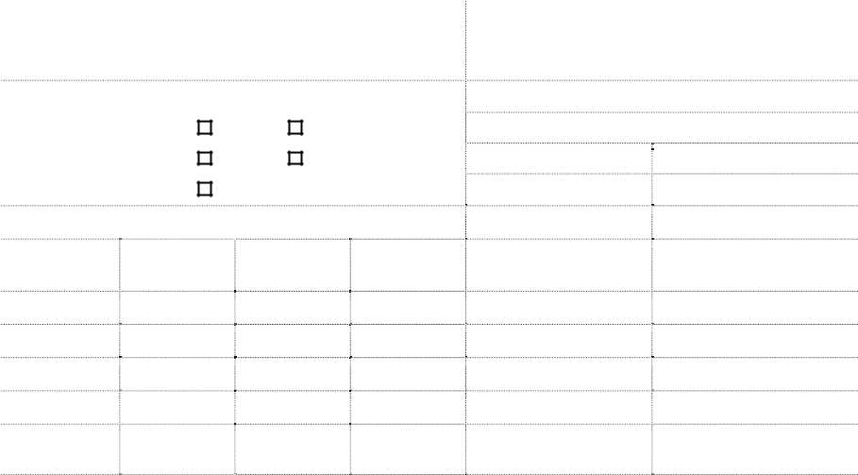

20. Remarks (If employee was off work for any length of time, please indicate time period and reason)

11. Probability of Continued Employment


14. If Overtime or Bonus is Applicable, Is its Continuance Likely?
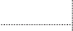

Overtime | Yes | No
Bonus | Yes | No



- If paid hourly – average hours per week:

- Date of applicant’s next pay increase:

- Projected amount of next pay increase:

- Date of applicant’s last pay increase:

- Amount of last pay increase:


Part III – Verification of Previous Employment

21. | Date Hired | 23. Salary/Wage at Termination Per (Year) (Month) (Week)
22. | Date Terminated | Base: | Overtime: | Commissions: | Bonus:
24. | Reason for Leaving |  | 25. Position Held

Part IV – Authorized Signature

26. | Signature of Employer | 27. Title (Please print or type) | 28. Date
29. | Print or type name signed in item 26 | 30. Phone No.

Hawaii Realty Management Corporation, 2745 South King Street, Honolulu, Hawaii 96826

HRM

Residential and Commercial Property Management

Commercial Leasing
Property Management Accounting

A Property Management Company

Request to Landlord for Questionnaire Completion

Privacy Notice: This information is to be used by HRM in determining whether you qualify as a prospective renter. It will not be disclosed outside of HRM. You do not have to provide this information, but if you do not, your rental application will be rejected.

Instructions: Tenant – Complete items 1, 7, 7a & 8 below for each current and/or past Landlord.

Hawaii Realty Management – Complete items 2 – 6 below.
Current or Past Landlord – Please complete either Part II or Part III as applicable. Complete Part IV and return directly to prospective Landlord named in item 2 below.

Part I - Request

1. To (Name and address of current or previous Landlord. Include phone and fax number.)

Company Name: ____________________________________________________________________

Address: ____________________________________________________________________

City, State & Zip: ____________________________________________________________________

Phone & Fax:

2. From (Name and address of Prospective Landlord or its agent)

Hawaii Realty Management Corporation
2745 S. King Street
Honolulu, HI 96826
Tel: (808) 941-2948 Fax: (808) 526-2299

I certify that this verification has been sent directly to the Landlord named in item 1 above and has not passed through the hands of the applicant or any other interested party.

3. | Signature of |  | 4. Title | 5. | Date | 6. Landlord’s Reference (Optional)
 | prospective Landlord |  | Property Manager
 | or its agent. | Steven M. Costello | Property Manager
I have applied for a rental property and stated that I am now or was formerly your tenant. My signature below authorizes you to provide the information requested in Part II and Part III below.
7. | Name and Address of Tenant |  | 7a. Social Security | 8. | Signature of Tenant/Applicant

Part II – Current/Previous Landlord Questionnaire

- Current/ Previous Rental Property Address (Street, City, State & Zip):

- How long has your tenant rented from you?

- What is the current rent paid?

- Has tenant given you written notice of his/her intent to vacate your property?

- What is tenant’s reason for moving?

- Does your tenant pay the rent and utilities on time?

- Does your tenant smoke?

- Has the tenant ever given excuses for late payment? If so, what where they?

- Does the tenant pay in person, with a messenger, or by mail?

- Has the tenant ever withheld rent? If so, why?

- Has the tenant properly maintained the interior and exterior of the property?

- Were tenant’s children well behaved?

- Did tenant keep pets in violation of the lease?

- Did tenant allow unauthorized persons to occupy the unit?

- Have other tenants or neighbors ever complained about tenant or tenant’s guests?

- What was the condition of the property when the tenant vacated?

- Did the tenant receive all of the security deposit back? If not, why not?


Part III – Previous Landlord Questionnaire

If Previous Landlord is completing this form, please the box to the left and complete Part II above.

Part IV – Authorized Signature

26. | Signature of Current/Previous Landlord | 27. | Title (Please print or type) | 28. Date
29. | Print or type name signed in item 26 | 30. | Phone No.

Hawaii Realty Management Corporation, 2745 South King Street, Honolulu, Hawaii 96826

HRM | Residential and Commercial Property Management
 | Commercial Leasing
 | Property Management Accounting
A Property Management Company

Applicant Consent and Specific Release for Tenant Screening

I certify and declare under penalty of perjury under relevant state and federal law that the information contained in my tenant application is complete, true and accurate. I acknowledge that falsification or omission of information may result in immediate dismissal or retraction of any offer of tenancy.

In consideration of the review of my application for tenancy by Hawaii Realty Management Corporation (herein referred to as LANDLORD) I hereby voluntarily consent to and authorize LANDLORD, or its authorized agents bearing this release or copy thereof, to obtain a consumer report for tenancy purposes. I agree that this consumer report may include any of the following:

- Banking Verification, Credit Reports, Criminal Records, Employment Verification

- Personal Reference Verification, Rental History Verification, SSN Trace, Sex Offenders Verification, and Unlawful Detainer Search

I authorize all persons and organizations that may have information relevant to this research to disclose such information to LANDLORD or its authorized agents. I hereby release LANDLORD, its authorized agents, and all persons and organizations providing information from all claims and liabilities of any nature in connection with this research. I hereby further authorize that a photocopy of this authorization will be considered as valid as the original.

I understand that I have specific prescribed rights as a consumer under the federal Fair Credit Reporting Act ('FCRA'), and may have additional rights under relevant state law. I hereby certify that I have been presented with a summary of my rights as a consumer under the FCRA, and under relevant state law.

Applicant Information

First Name: |  |  | Last Name: | Driver’s Lic. | M.I.:
DOB: | SSN: | / | / | No./State: | /
Address:
Signature: |  |  |  |  | Date:

The document(s) accompanying this telecopy transmission contain confidential information belonging to the sender, which is legally privileged. The information is intended only for the individual or entity named above. If you are not the intended recipient, you are hereby notified that any disclosure, copying, distribution or taking of any action in reliance on the content of this telescoped information is strictly prohibited. If you have received this telecopy in error, please immediately notify National Data Search, Inc. by telephone to arrange for return of the document(s).

Applicant Consent and Specific Release for Tenant Screening -- Confidential and Proprietary Page 1

C:\Documents and Settings\Steven M. Costello\My Documents\HRM Folders\HRM Residential Tenant\01 Vacancy Promotion\Email Rental Packet\05 Tenant Screening Authorization 05-0403.doc

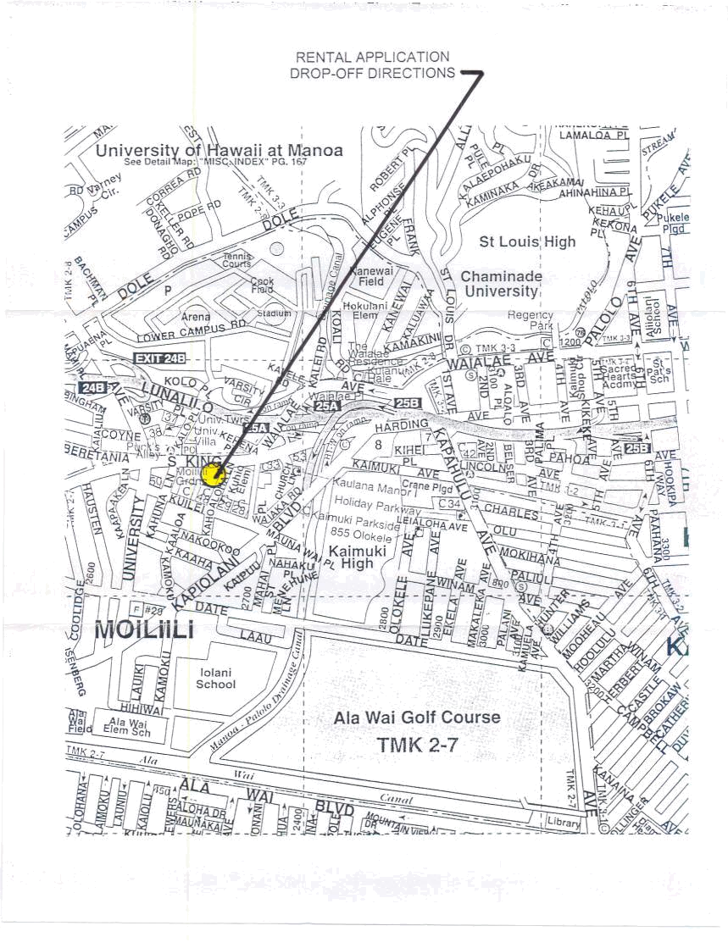
Hawaii Realty Management Corporation, 2745 South King Street, Honolulu, Hawaii 96826

