VACATION RENTAL LEASE AGREEMENT

1213-C Duck Road Duck, NC 27949
Property: CC161: Mulligan

Res #: 207171

Guest: Booth Scates

146 Samantha Lane

Front Royal, VA 22630

Phone: 540-635-6155

E-Mail: booth_scates@dell.com

Arriving: Saturday, May 28, 2016 at 4:00 p.m.* *Unless otherwise advertised.

Departing:Saturday, June 4, 2016 at 10:00 a.m.

CC161: Mulligan

533 Hunt Club Drive, Corolla, NC 27927 Property Phone: 252-457-0010

Bedrooms: 5

Bathrooms: 5.1
Community: Currituck Club
Check-In : 1213-C Duck Road, Duck Office

Phone:(877) 642-3224 |  |  |  |  | www.BrindleyBeach.com
Fax: (252) 261-6555 |  |  |  |  | rentals@brindleybeach.com
 | Total Rent: |  |  |  | $ 1,975.00
 | Travel Insurance: |  |  |  | $ 177.58
 | Cleaning Fee: |  |  |  | $ 75.00
 | Pet Fee: |  |  |  | $ 200.00
 | Tax: |  |  |  | $ 286.87
 |  |  |  |  | $ 2,714.45
 | Total |  | Due:
 | Received on Account: |  |  |  | $ 0.00
 | Payments Due 12/15/2015: |  |  |  | $ 1,165.08
 | Due 30 Days Prior to Arrival: |  |  |  | $ 1,549.37
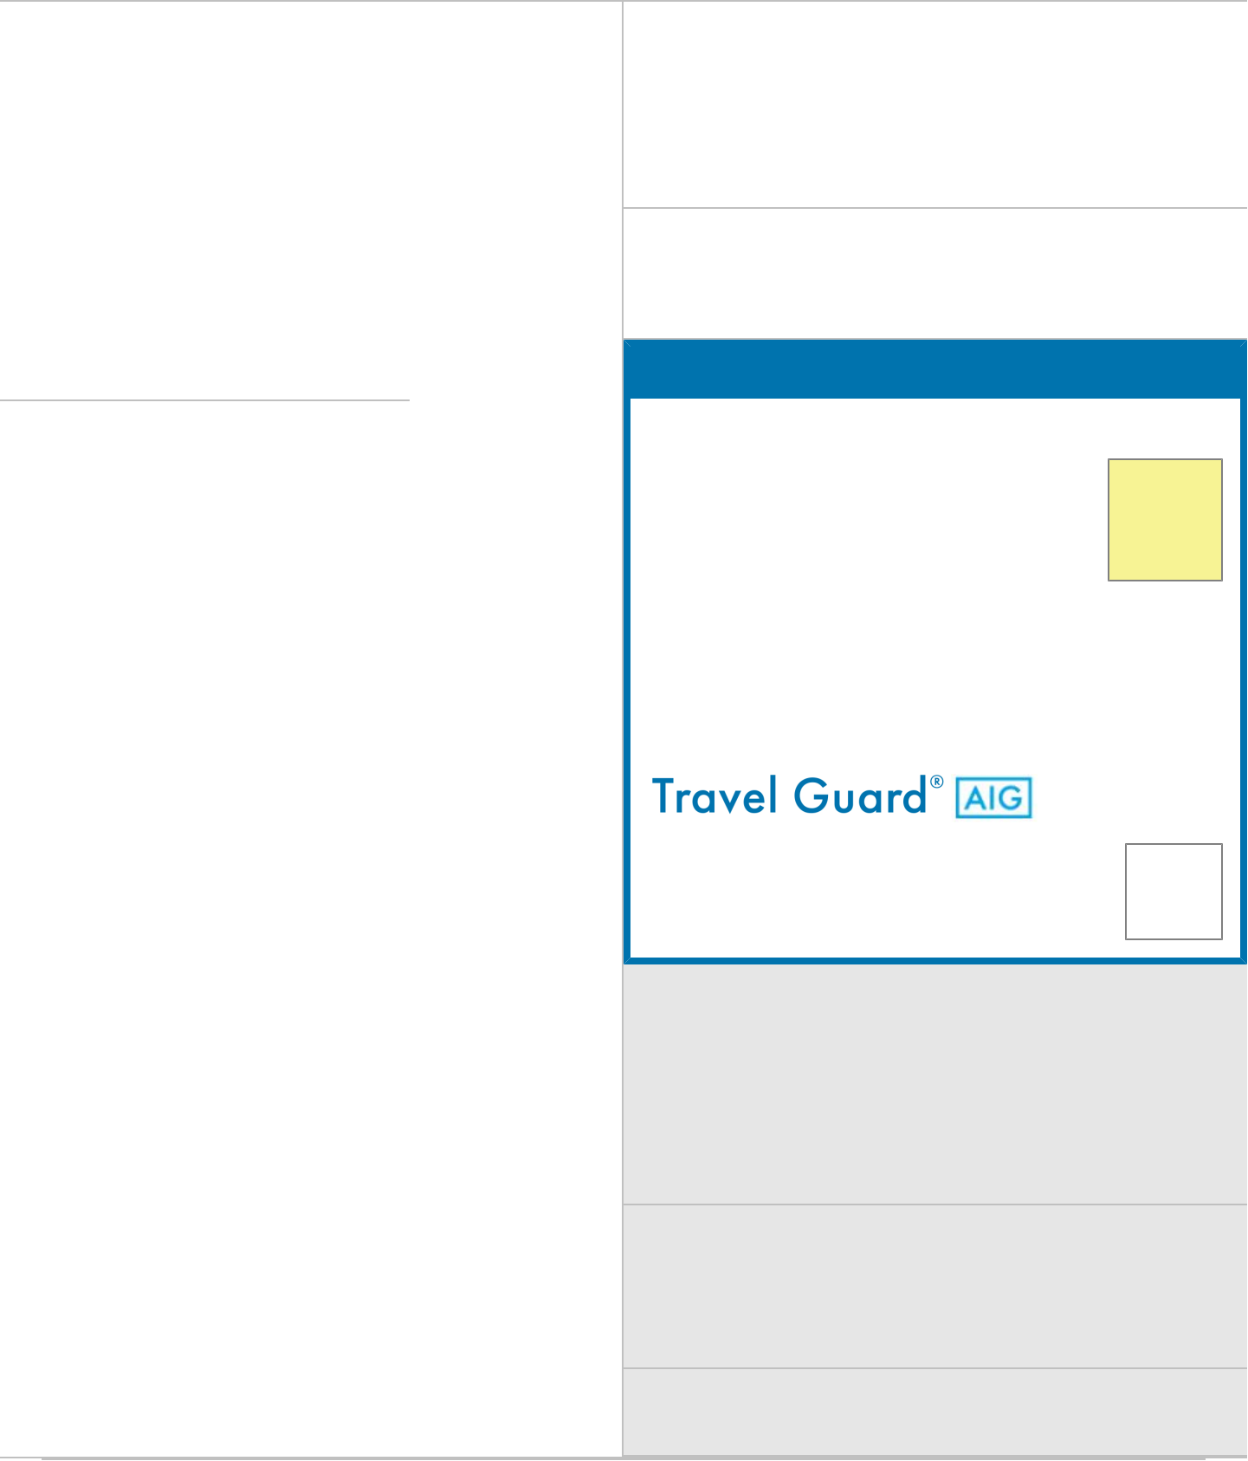

Travel Guard Travel Insurance

Do you want Trip Insurance?

Yes,

include
travel
insurance.

Available to U.S. Residents only. I have read and understand the Certificate of Insurance, Terms and Conditions, and agree to the terms and conditions of the insurance coverage provided. Coverage is offered by Travel Guard Group, Inc. and limitations will apply: click here for full disclaimer.

Initial here to confirm your travel insurance | Guest
 | Initials:
selection above.
 | bs
Decline Pet Fee
 |  | (initial)
Initial here to decline the PET FEE, if the home you're
renting allows dogs and you're NOT bringing a dog. Note:
Please review the information regarding Pet Fee, section 9 of
this agreement. Pet welcome homes allow 2 domestic,
housebroken and nondestructive dogs with a weight limit of 60
pounds each (unless otherwise advertised). Please initial above
to deduct the pet fee and tax, which will be deducted from your
final payment.

Add Early Check-In (initial)

A limited number of 1:00pm check-ins are offered at a cost
of $150 (plus tax). Certain homes cannot offer Early
Check-Ins and you will be notified if we are unable to
deliver this special service so you can plan your travel time
accordingly.

Pool Heat

Pool heat is available. Call the office at (877) 642-3224 for
pricing.

Brindley Beach Vacations & Sales: Vacation Rental Lease Agreement

THIS IS A VACATION RENTAL AGREEMENT UNDER THE NORTH CAROLINA VACATION RENTAL ACT (HEREINAFTER, “VRA”). THE RIGHTS AND OBLIGATIONS OF THE PARTIES TO THIS AGREEMENT ARE

DEFINED BY LAW AND INCLUDE UNIQUE PROVISIONS PERMITTING THE DISBURSEMENT OF RENT PRIOR TO TENANCY AND EXPEDITED EVICTION OF TENANTS. YOUR SIGNATURE ON THIS AGREEMENT, OR PAYMENT OF MONEY OR TAKING POSSESSION OF THE PROPERTY AFTER RECEIPT OF THE AGREEMENT, IS EVIDENCE OF YOUR ACCEPTANCE OF THE AGREEMENT AND YOUR INTENT TO USE THIS PROPERTY FOR A VACATION RENTAL.

The advance rent payment and signed lease as stated above must be received by December 15, 2015 or your reservation will be cancelled and the time period made available to another party. Balance will be due 30 days prior to arrival.

This Vacation Rental Agreement, hereinafter "Agreement," is by and between Tenant and Brindley Beach Vacations & Sales (hereinafter, “Brindley Beach”), a corporation, and provides that for and in consideration of the rent set forth herein and other terms and conditions of this Agreement, Tenant does hereby rent the vacation rental property identified herein.

- PAYMENT. The rent required under this agreement is set forth in the Terms and Conditions attached hereto (hereinafter, “Advance Payment”) plus Trip Cancellation Insurance Premium, as described below and this signed Agreement, must be returned to Brindley Beach by December 15, 2015 or your reservation will be cancelled without notice. Once this executed Agreement and the Advance Payment are returned, you shall receive a confirmation of this Agreement summarizing the terms and conditions of your rental. This confirmation shall serve as your receipt for the Advance Payment. The balance due on the rent must be received by Brindley Beach within thirty days (30) prior to arrival. All reservations made less than 45 days from check-in must be paid immediately. A final confirmation will be mailed once reservation is paid in full.

- METHOD OF PAYMENT. The payments required herein must be made in U.S. funds and may be made by personal check, cashier’s check, certified check, money order or credit card (Visa, MasterCard or Discover). A $35.00 handling fee will be charged for all returned checks. No company or personal checks will be accepted within the 30-day period prior to check-in and possession of property.
- TRUST ACCOUNT. Any monies paid by Tenant shall be deposited in a trust account with BB&T Bank, Kill Devil Hills, NC. Tenant agrees that any monies paid may be deposited in an interest-bearing trust account and that any interest thereon shall accrue for the benefit of Brindley Beach, and shall be paid as it accrues and as often as is permitted by the terms of the account.
- DISBURSEMENT OF RENT AND THIRD PARTY FEES. Tenant authorizes Brindley Beach to disburse up to fifty percent (50%) of the rent set forth herein to the owner (or as the owner directs) prior to Tenant’s occupancy of the Premises, and the balance of the rent upon the commencement of the tenancy, a material breach of this Agreement by Tenant, or as otherwise permitted pursuant to the North Carolina Vacation Rental Act. Tenant also authorizes Brindley Beach to disburse prior to Tenant’s occupancy of the Premises any fees owed to third parties to pay for any goods, services, or benefits procured by Brindley Beach for the benefit of Tenant, including, but not limited to any fees set forth herein payable to Brindley Beach for reservation, transfer or cancellation of Tenant’s tenancy.

- TAXES. The following taxes shall be collected by Brindley Beach pursuant to North Carolina law: State and County Tax is 12.75%. All taxes are subject to change without notice. Taxes will be disbursed upon termination of tenancy or a material breach of this Agreement.
- TRIP CANCELLATION INSURANCE. This coverage is OPTIONAL. Choose Yes, include travel insurance or No, I decline the option to purchase travel insurance and initial in the space provided above. Please call Travel
Guard directly at 1-877-249-5376 with any questions regarding coverage.
- DAMAGES/ACCIDENTS TO RENTAL UNIT. Leaseholder agrees to notify Brindley Beach immediately as to any damages or accidents that occur to the premises, to both real property and personal property during your rental period. If Brindley Beach determines that no intentional or wanton or willful misconduct was done, Brindley Beach will repair/replace as needed up to $1500. Any damage or accident that exceeds $1500 will be the responsibility of the leaseholder. DAMAGES MUST BE REPORTED IMMEDIATELY PRIOR TO CHECK-OUT IN ORDER
FOR BRINDLEY BEACH TO REPAIR/REPLACE SAID DAMAGES. OTHERWISE, ALL DAMAGE COSTS WILL BE THE RESPONSIBILITY OF THE LEASEHOLDER. ALL PET DAMAGE IS THE SOLE RESPONSIBILITY OF THE LEASEHOLDER.
- ARRIVAL/DEPARTURE. Tenant does not have the right to occupy the rental property or use the pool/spa before 4:00 PM on check-in day, unless otherwise advertised. Guests must check-in at the appropriate advertised check-in location, unless otherwise advertised. Brindley Beach cannot guarantee the property will be ready at 4:00 pm, but we will make every effort to insure your property is ready on time. Departure is strictly at 10:00 am. This is a must, due to logistics of turnover.
  - EARLY CHECK-IN. A limited number of 1:00pm check-ins are offered at a cost of $150 (plus tax). Certain homes cannot offer Early Check-In and you will be notified if we are unable to deliver this service so you can plan your travel time accordingly.
- PETS. Absolutely no pets in non-pet rental properties. There is a $200.00 (plus tax) non-refundable pet fee on rental properties that allow pets. Rental properties allowing pets are designated in the property descriptions. Pets are limited to two (2) domestic, housebroken and nondestructive dogs (NO CATS or other pets) with a weight limit of sixty (60) pounds each (except as otherwise noted). Please remember, your pets are in unfamiliar surroundings and should not be “locked up” or left unattended. Non-compliance will result in the VRA expedited eviction procedure. If you are not planning to bring a pet you may initial to decline the pet fee.
- OCCUPANCY. Signatory of this lease must be at least 24 years of age and be present during the entire term of the lease. Any leaseholder found to be in breach of this contract will be subject to the VRA expedited eviction procedures. If, in Brindley Beach’s opinion, the rental property you have rented is unable to be occupied Brindley Beach will make every effort to move you to a property comparable in price. If no comparable property is available, your rent will be refunded.
- ACCOMMODATIONS. Rental properties offered for rental are individually owned and reflect the tastes of each

owner. Every effort has been made to assure accurate descriptions. Brindley Beach shall not be held responsible for changes made by owners or printing errors.

- CANCELLATIONS. All cancellations must be in writing and received by Brindley Beach prior to check-in. Tenant is responsible for verifying that Brindley Beach has received the cancellation letter. The rental home must re-rent for the original rental amount in order for tenant to receive a full refund on rent paid, less the $150 cancellation fee (plus tax). If the home is re-rented for a reduced rental rate the difference will be taken from the advance payment paid, less a $150 cancellation fee (plus tax). If you purchased the optional Trip Cancellation Insurance, the premium will not be refunded. If your home does not successfully re-rent you will forfeit all monies paid to Brindley Beach.
- SUBDIVISIONS/PROPERTY ASSOCIATIONS. Brindley Beach works with subdivisions and property associations in providing tenants information on their rules and regulations including dates and use of amenities. Brindley Beach is not responsible for conduct or operations of subdivisions and property associations and cannot be held liable for any loss or liability in connection with said subdivision or community association. A list of these restrictions by community is located on the Brindley Beach website.
- REPAIRS. Even the best or newest equipment occasionally malfunctions and cannot be guaranteed. Problems are corrected as soon as possible. Tenant agrees that Brindley Beach, an authorized employee, or repairman may enter the premises during business hours for purposes connected with repairs, care or maintenance of premises. Gas fireplaces are available for use from November 1 to April 30, unless otherwise advertised.
- CONSTRUCTION. The Outer Banks is a highly desirable area with rental properties under construction. We do not move people, give refunds due to construction noise, or guarantee views. If you reserve a property that is under construction, in the event that the home is not completed in time for your vacation we will make every effort to find a comparable home for you, but Brindley Beach is not responsible for price differences you may incur.
- CONSIDERATION. Brindley Beach will make every effort to correct any problems you may experience in a timely manner. Recompense will not be issued due to malfunctioning equipment, housekeeping issues, or other tenant’s dissatisfaction.
- TELEPHONE. All rental properties are equipped with telephones for your convenience and safety, unless otherwise advertised. Do not abuse this privilege by charging long distance calls to the owner’s phone. Your rental property phone number appears on the front of lease.
- MOVING. If you have rented two different rental properties for two consecutive weeks, every effort will be made to provide a smooth and timely transition. Please contact our office during your first week, so we are aware of the move.
- LOST AND FOUND. Brindley Beach returns lost items upon request by Tenant. Returns are done through U.S. Postal system or any other source deemed necessary at the expense of the Tenant. Brindley Beach makes every effort to locate lost items but is not responsible for items left or lost by Tenant.
- EVACUATION. Under North Carolina General Statutes, Chapter 42A: Vacation Rental Act, Section 42A-36. Mandatory evacuations. If State or local authorities, acting pursuant to Article 1A of Chapter 166A of the General Statutes, order a mandatory evacuation of an area that includes the residential property subject to a vacation rental, the tenant under the vacation rental agreement, whether in possession of the property or not, shall comply with the evacuation order. Upon compliance, the tenant shall be entitled to a refund from the landlord of the rent, taxes, and any other payments made by the tenant pursuant to the vacation rental agreement as a condition of the tenant's right to occupy the property prorated for each night that the tenant is unable to occupy the property because of the mandatory evacuation order. The tenant shall not be entitled to a refund if: (i) prior to the tenant taking possession of the property, the tenant refused insurance offered by the landlord or real estate broker that would have compensated the tenant for losses or damages resulting from loss of use of the property due to a mandatory evacuation order; or (ii) the tenant purchased insurance offered by the landlord or real estate broker. The insurance offered shall be provided by an insurance company duly authorized by the North Carolina Department of Insurance, and the cost of the insurance shall not exceed eight percent (8%) of the total amount charged for the vacation rental to the tenant less the amount paid by the tenant for a security deposit. (1999-420, s. 1; 2005-292, s. 3; 2009-245, s. 2; 2012-12, s. 2(h).).
- TRANSFER OF PROPERTY. If the owner voluntarily transfers the property, Tenant has the right to enforce this Agreement against the grantee of the property if Tenant’s occupancy under this Agreement is to end 180 days or less after the grantee’s interest in the property is recorded. If Tenant’s occupancy is to end more than 180 days after such recordation, Tenant has no right to enforce the terms of this Agreement unless the grantee agrees in writing to honor this Agreement. If the grantee does not honor this Agreement, Tenant is entitled to a refund of all advance rent paid by Tenant (and other fees owed to third parties not already lawfully disbursed). Within 10 days after transfer of the property, the grantee or the grantee’s agent is required to: (i) notify Tenant in writing of the transfer of the Premises, the grantee’s name and address, and the date the grantee’s interest was recorded; and (ii) advise Tenant whether Tenant has the right to occupy the Premises subject to the terms of this Agreement or receive a refund of any payments made by Tenant. Upon termination of the owner’s interest in the Premises, whether by sale, assignment, death, appointment of a receiver or otherwise, the owner, owner’s agent is required to transfer all advance rent paid by Tenant (and other fees owed to third parties not already lawfully disbursed) to the owner’s successor-in-interest within 30 days, and notify Tenant by mail of such transfer and of the transferee’s name and address. However, if Tenant’s occupancy under this Agreement is to end more than 180 days after recordation of the interest of the owner’s successor-in-interest in the property, and the successor-in-interest has not agreed to honor this Agreement, all advance rent paid by Tenant (and other fees owed to third parties not already lawfully disbursed) must be transferred to Tenant within 30 days.
- INDEMNIFICATION. Tenant agrees to indemnify and save individual homeowners, Brindley Beach and its employees, free and harmless for any liabilities or any loss or damage whatsoever arising from, related to or in connection with rental of the premises including but not limited to any claim or liability for personal injury or damage or loss of property which is made, incurred or sustained by tenant or guests of tenant.
- FORUM SELECTION CLAUSE. This agreement shall be governed by and interpreted in accordance with the law of the State of North Carolina, and this agreement shall be treated as though it were executed and were to have been

performed in Currituck County, North Carolina. Any action relating to this agreement shall only be instituted and prosecuted in the courts of Currituck County, North Carolina. Tenant specifically consents to such jurisdiction and to extraterritorial service of process.

- AGENT RESPONSIBILITIES. Brindley Beach agrees to provide the premises in a fit and habitable condition. If at the time tenant is to begin occupancy of the premises, Brindley Beach cannot provide the premises in a fit and habitable condition or substitute a reasonably comparable property in such condition, Brindley Beach shall refund to Tenant all payments made by tenant. Brindley Beach shall conduct any brokerage activities in regard to this Agreement without respect to the race, color, religion, sex, national origin, handicap or familial status of any tenant.
- TENANT RESPONSIBILITIES. Inspect the home and notify Brindley Beach of any unsafe conditions that are discovered. Under the VRA, the tenant is required, at a minimum, to do the following with respect to maintenance of the property: (1) Keep that part of the property which he or she occupies and uses, as clean and safe as the conditions of the property permit and cause no unsafe or unsanitary conditions in the common areas and remainder of the property that he or she uses. (2) Dispose of all ashes, rubbish, garbage, and other waste in a clean and safe manner. (3) Keep all plumbing fixtures in the property or used by the tenant as clean as their condition permits. (4) Not deliberately or negligently destroy, deface, damage, or remove any part of the property or render inoperable the smoke detector provided by the landlord or knowingly permit any person to do so. (5) Comply with all obligations imposed upon the tenant by current applicable building and housing codes. (6) Be responsible for all damage, defacement, or removal of any property inside the property that is in his or her exclusive control unless the damage, defacement, or removal was due to ordinary wear and tear, acts of the landlord or his or her agent, defective products, supplied or repairs authorized by the landlord, acts of third parties not invitees of the tenant, or natural forces. (7) Notify the landlord of the need for placement of or repairs to a smoke detector. (8) Comply with all mandatory evacuations orders. Failure to comply with these terms may result in the expedited eviction procedure of the VRA.
- EXPIDITED EVICTION. If the tenancy created hereunder is for 30 days or less, the expedited eviction procedures set forth in the VRA will apply. Tenant may be evicted under such procedures if Tenant: (i) holds over in possession after Tenant’s tenancy has expired; (ii) commits a material breach of any provision of this Agreement (including any addendum hereto) that according to its terms would result in the termination of Tenant’s tenancy; (iii) fails to pay rent as required by this Agreement; or (iv) has obtained possession of the premises by fraud or misrepresentation.
- SEVERABILITY. It is expressly understood and agreed that in the event any one or more of the provisions of this Agreement shall be unenforceable for any reason, the remaining portions of this Agreement shall, nevertheless, remain in full force and effect, and the unenforceable provision or provisions shall be deemed deleted.
- ERRORS. All property descriptions and photos are subject to change. Although every precaution is taken administrative errors do occur. We reserve the right to correct any such error.

By initialing in this box, I acknowledge that I have read, understand and accept the terms set forth within the Vacation Rental Agreement and Policies incorporated therein, including provisions concerning Trip Insurance and Cancellation.

If I pay by Visa, MasterCard or Discover, I understand that I also have to submit a physically signed lease agreement (printed and signed by hand) to Brindley Beach Vacations & Sales either by fax to (252) 261-6555 or email to rentals@brindleybeach.com.

To signify your acceptance of this agreement, type your name below exactly as it appears on Page 1 of this Rental Agreement.

Guest

Initials:

bs

Guest

Initials:

bs

X Booth Scates | Brindley Beach Inc.
 | Qualifying Broker:
IP Address: 73.40.39.45 Date: 12/16/2015 | Douglas R. Brindley
 | License #79789
 | Agent for Landlord

Guest Signature

