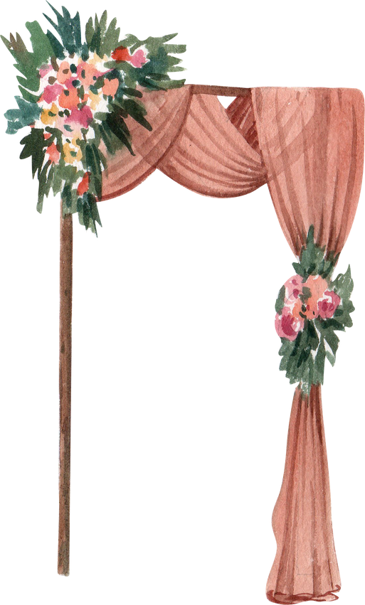

8:00 PM

9:00 PM

6:45 PM

7:30 PM

Bouquet and

Garter Toss

Last Dance

6:30 PM

Cocktails

Arrival of Bride

& Groom

Reception

6:O0 PM

Opening

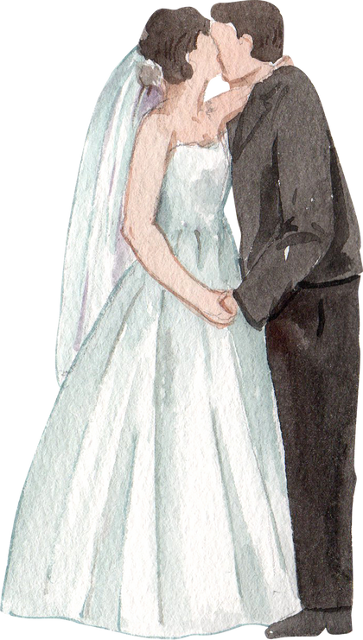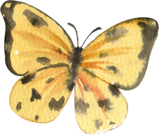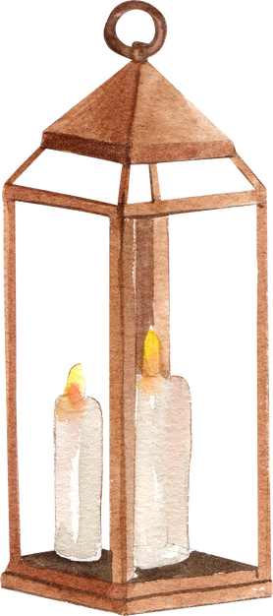

Tony & Flav's

Wedding day

Wedding Timeline