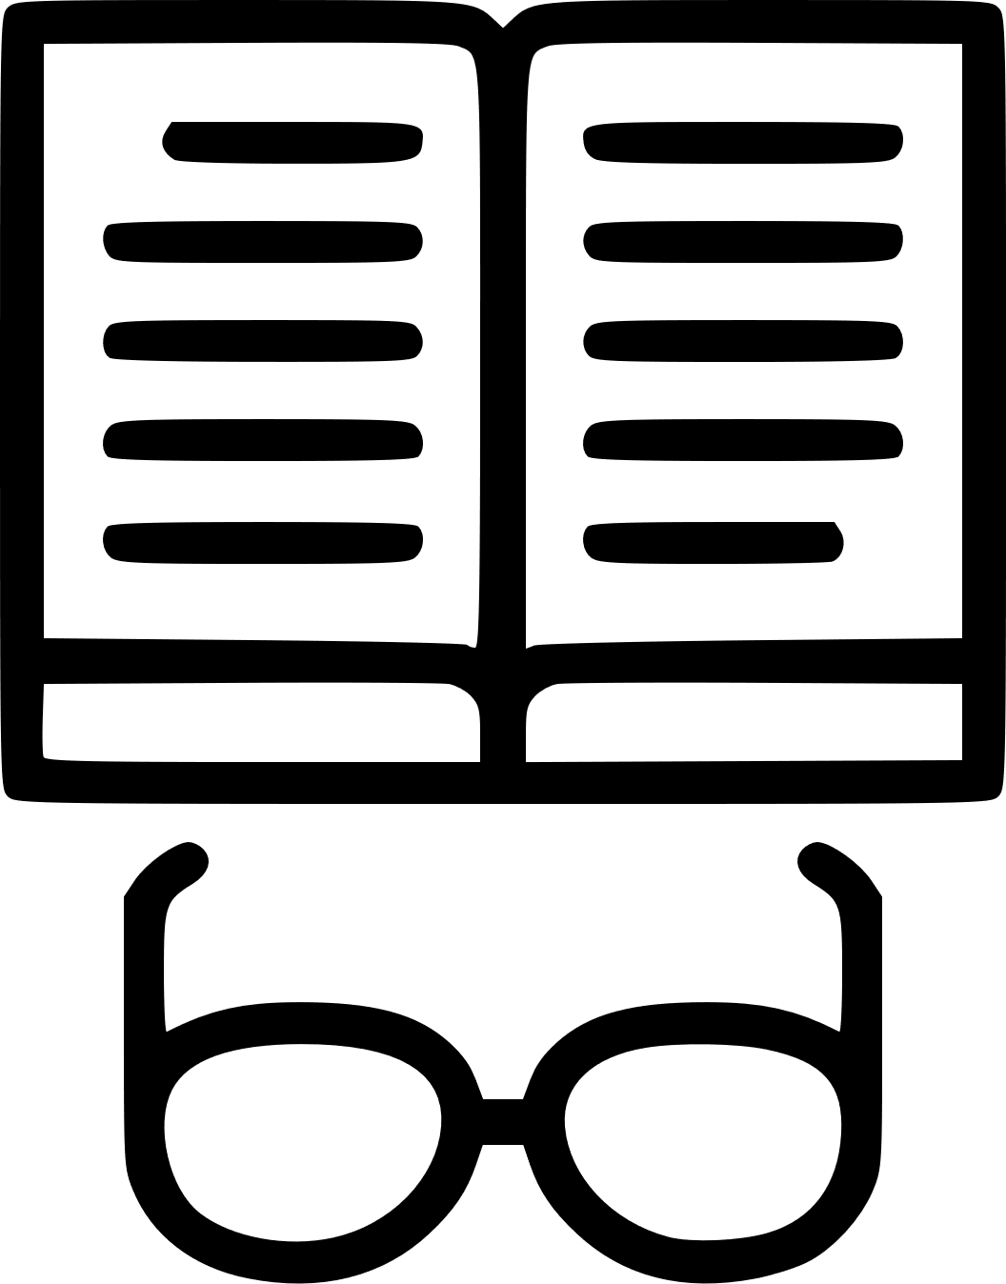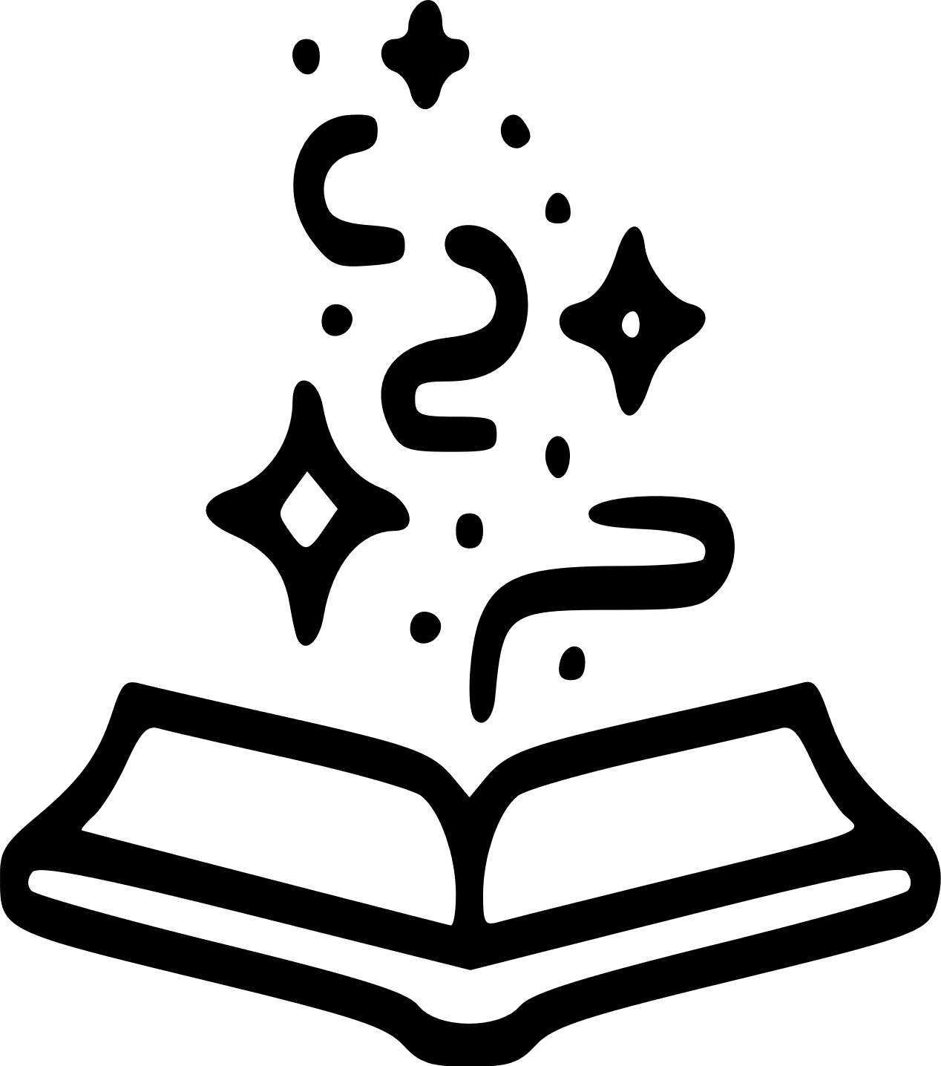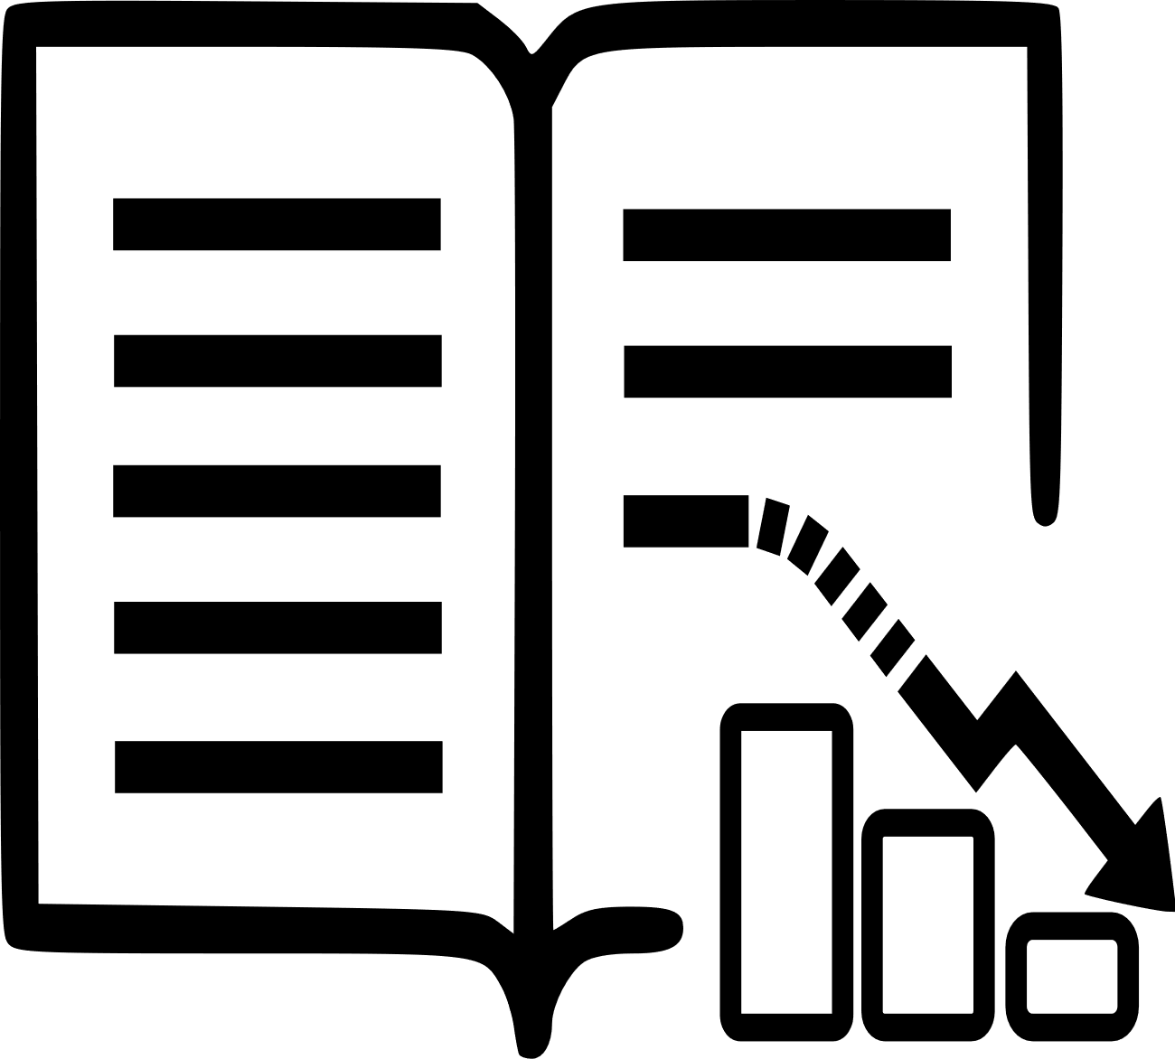[](https://templatelab.com/)

**FEB**

2024

**NOV**

2023

**AUG**

2023

**MAR**

2023

**JAN**

2023

STORY TIMELINE

**1. Introduction**

This is the start of the story, where we meet the main character or characters, understand the setting, and deduce the conflict.

For example, we might meet a main character, named Fiona, who just moved to Ireland, and is writing her first book. There, we meet the main character, understand she's in a new country, and will watch her push to overcome the trials and tribulations that come from each of these new elements.

**3. Climax**

The climax of a story is the peak of the action. At this point, we've watched the main character confront the action or conflict, and now something major has to come to a head.

Perhaps Fiona makes a new acquaintance who takes on a motherly role, reducing those feelings of doubt about moving so far away from home. Perhaps she submits the revised version of her book and it's accepted. Maybe she tells the devilish lad she's not interested so she can focus on her work.

**4. Falling Action**

In the falling action, we see things start to wind down.

Fiona and her new motherly acquaintance might have settled into a steady rhythm of Sunday dinners by now. As for her book, maybe the only thing she's waiting for is the advanced copy. Perhaps the devilish lad has come back around and they're in a steady relationship.

**2. Rising Action**

In the rising action, we watch a series of events unfold. There's not much in a story if everything works out perfectly and there are zero bumps in the road. We need a little conflict.

Conflict can come in many forms. Continuing with Fiona, perhaps she's battling some sort of internal conflict. We might see her doubt her decision to move so far away from home. Or, with regard to her book, perhaps she submits it to her agent and it's torn to shreds.

**5. Resolution**

In any story, it's important to conclude with a solid resolution, sometimes called the denouement. Here, we learn of the final outcome of the tale. Short stories, in particular, need a defined ending. Books, however, can remain somewhat open-ended. But, you must bring the story to a close with either a tragic or a happy ending.

Readers want to experience some sort of finite conclusion, or resolution.

[**© TemplateLab.com**](https://templatelab.com/)