tony and flav



WHEN WE FIRST MEET

FIRST TRIP TOGETHER

BIKE TRIP IN SOUTH AMERICA

BOAT TRIP IN CARIBBEAN

WE GOT ENGAGED

OUR LOVELY FARMSTAY

WE GOT MARRIED

MARCH 2021

APRIL 2021

JUNE 2022

AUGUST 2024

MAY 2025

JUNE 2026

MARCH 2028

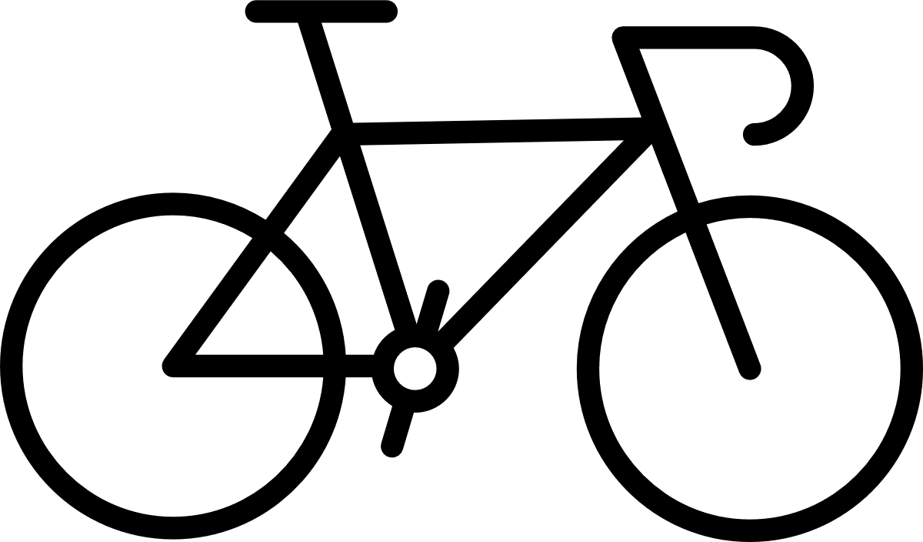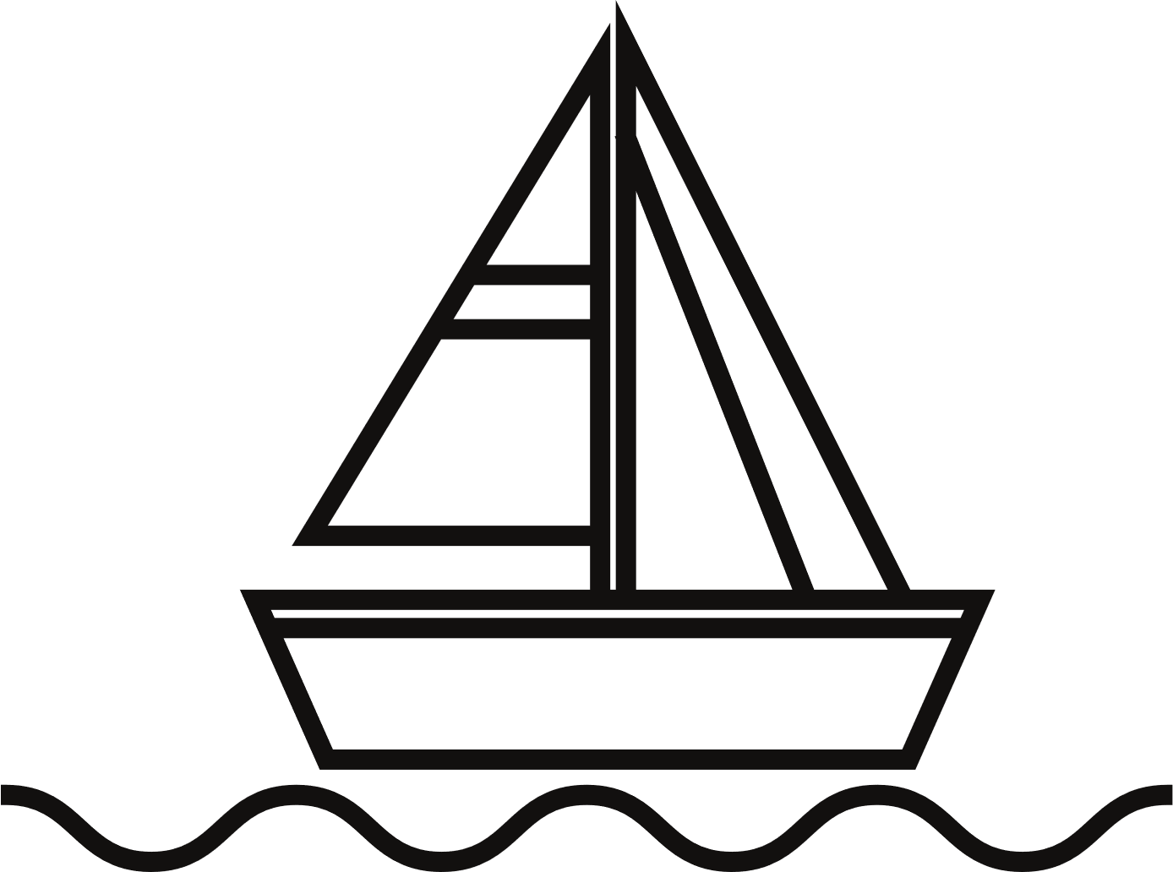

AND THEN...

RELATIONSHIP TIMELINE