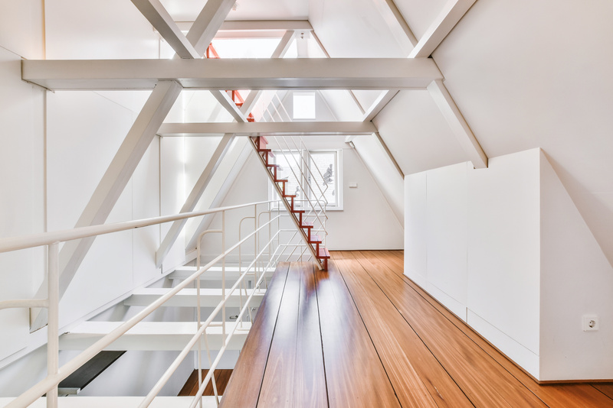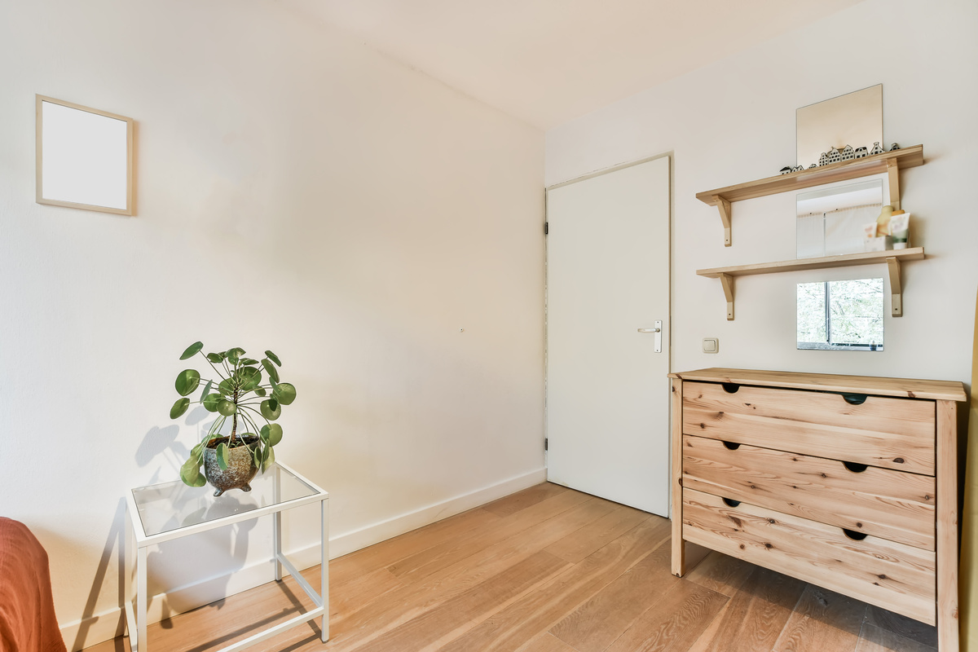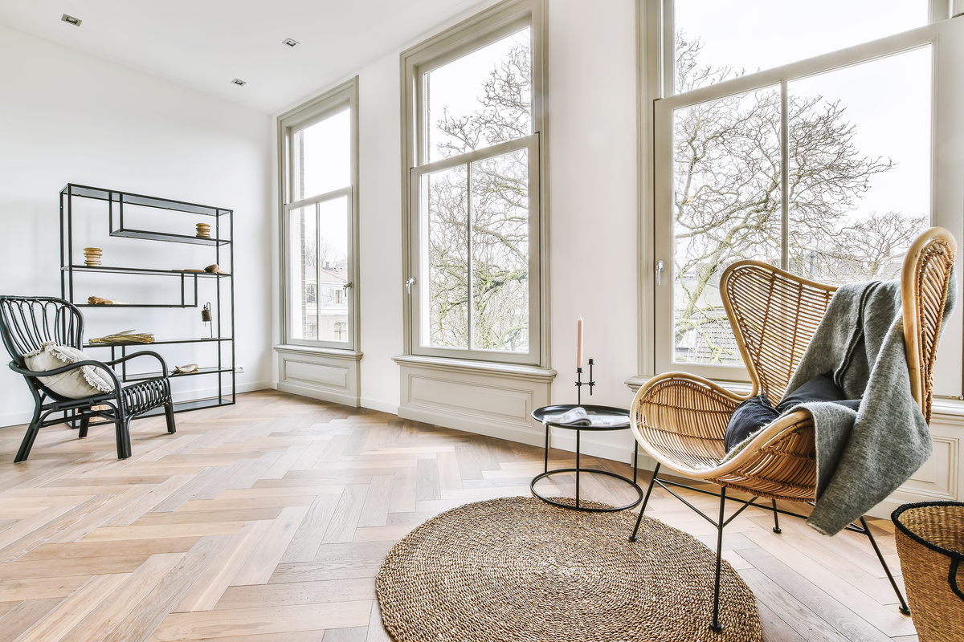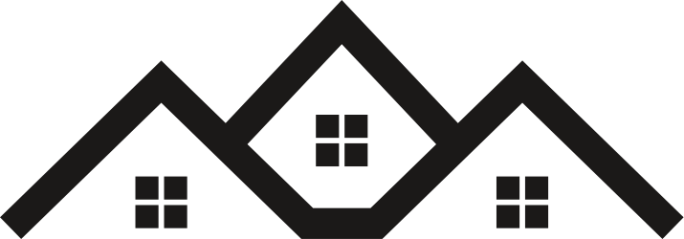

$2000

/MONTH

HOUSE FOR RENT

HOUSE NAME

Lorem ipsum dolor sit amet, consectetur adipiscing elit. Nam tortor leo, commodo sit amet pharetra sed, varius nec orci. Praesent vitae gravida mauris. Donec dignissim sollicitudin risus non aliquet.

House Name

+123-456-7890

House Name

+123-456-7890

House Name

+123-456-7890

House Name

+123-456-7890

House Name

+123-456-7890

House Name

+123-456-7890

House Name

+123-456-7890

House Name

+123-456-7890

House Name

+123-456-7890