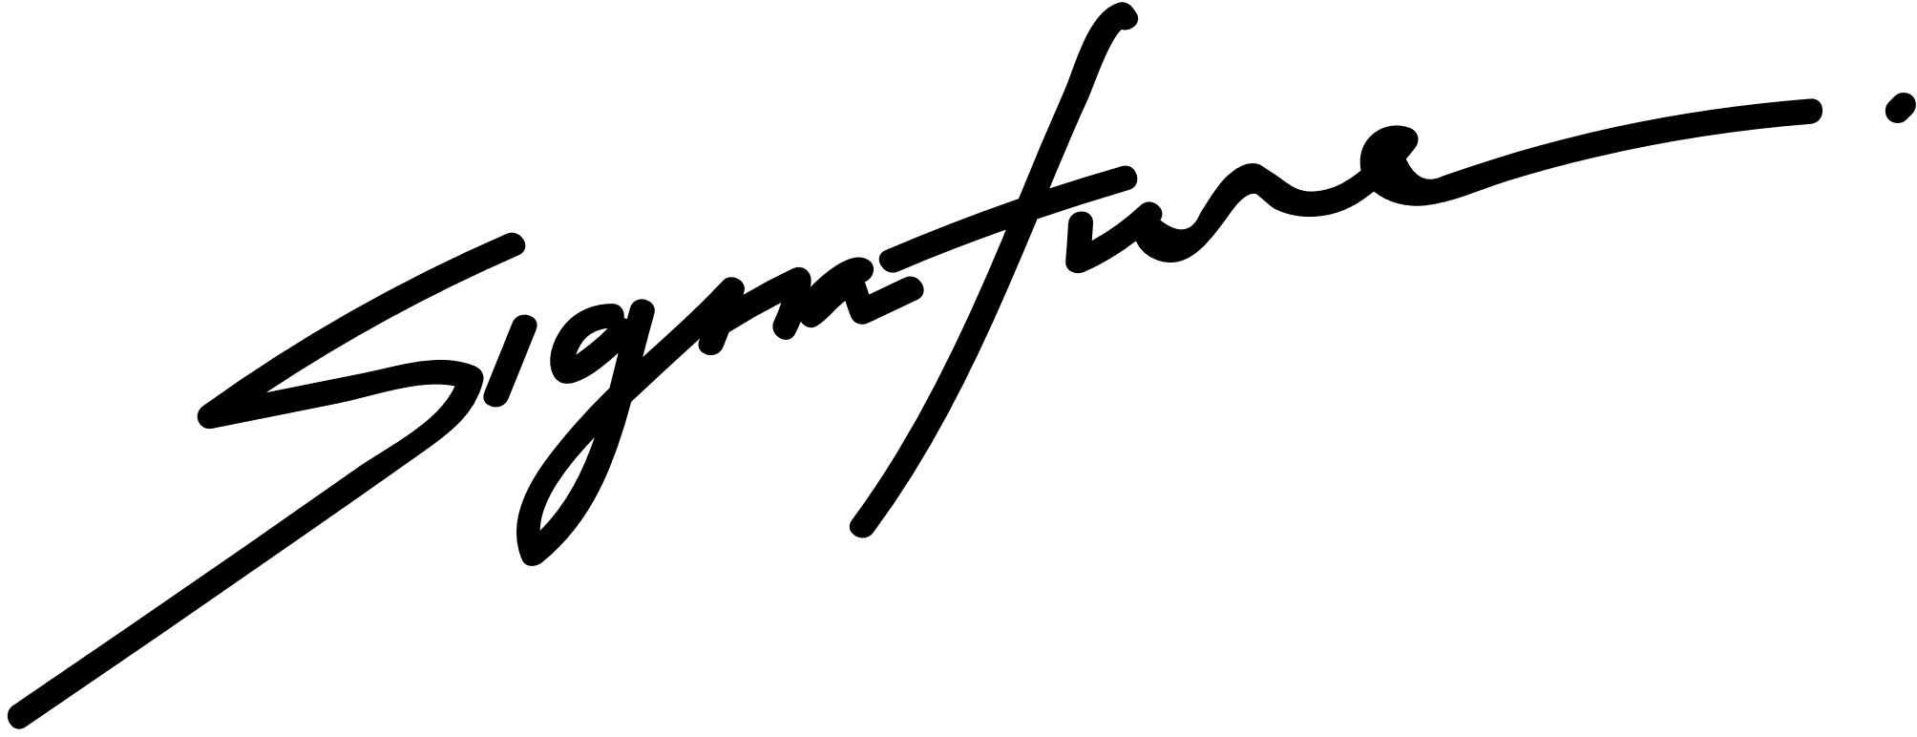

CERTIFICATE OF SCHOLARSHIP

PROUDLY PRESENTED TO

KORINA VILLANUEVA

in honor of your outstanding performance in the ABC Program.

BENJAMIN SHAH

School President

08 AUGUST 2028

Date