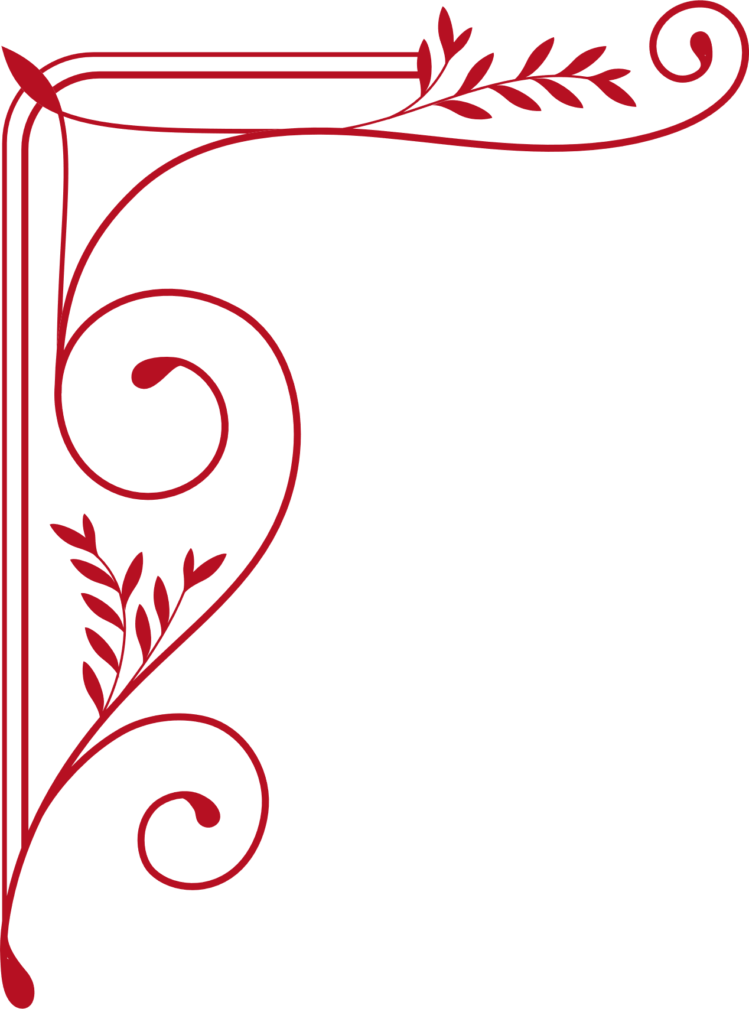

Lorem donec massa sapien faucibus et molestie ac feugiat sed lectus vestibulum mattis ullamcorper velit sed ullamcorper morbi tincidunt rnare massa eget egestas purus viverra accumsan in nisl nisi scelerisque eu ultrices.

CERTIFICATE

OF SCHOLARSHIP

This is to certify that

Connor Hamilton

Curriculum Dean

School Director

