

Certificate of

Scholarship

Curriculum Dean

CHRISTINA SHERLY

School Director

CLAIRE A. MAURA

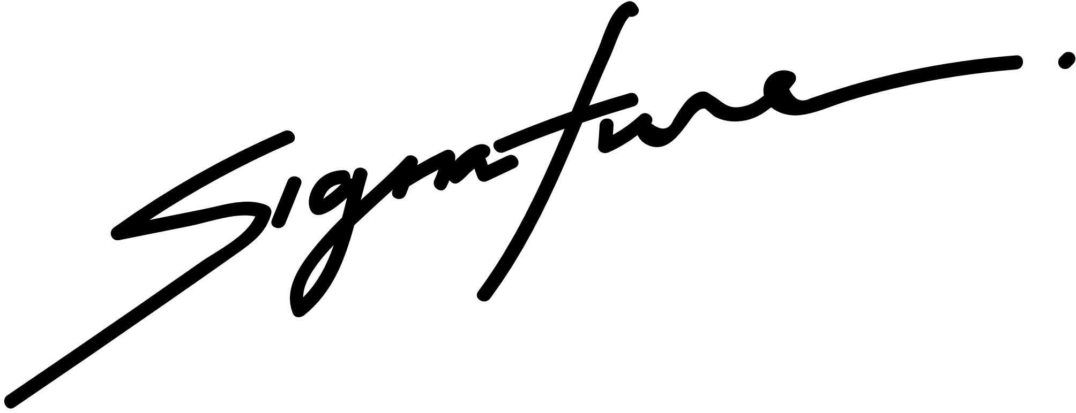

in honor of your outstanding performance

in the ABC Program.

Isabel Mercado

This certifies that