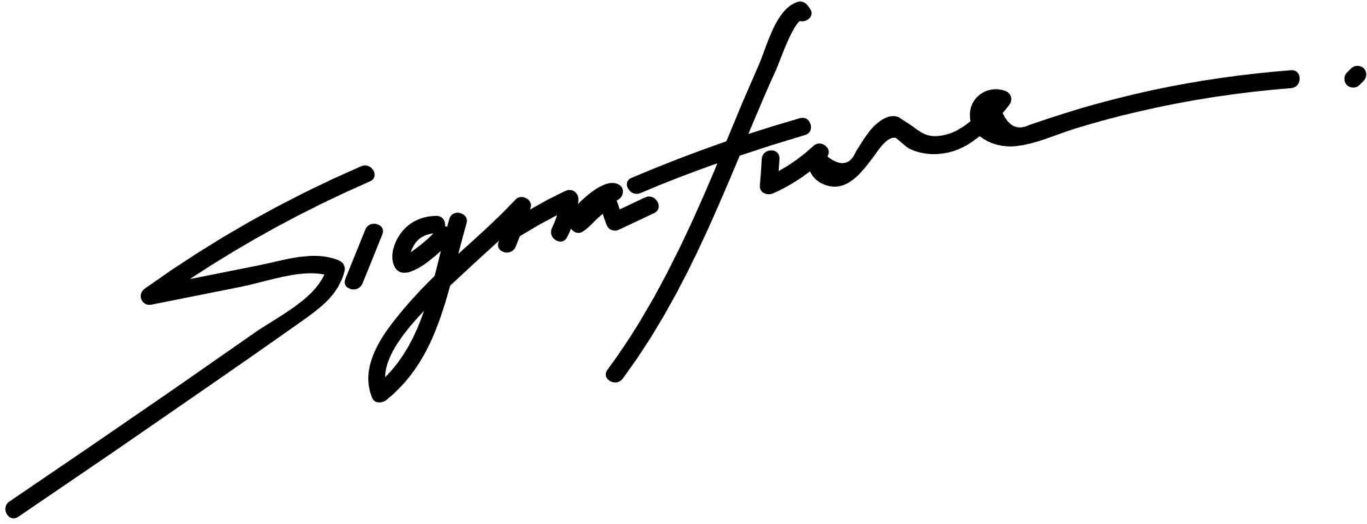

**NOAH SCHUMACHER**

**CERTIFICATE OF SCHOLARSHIP**

**THIS IS TO CERTIFY THAT**

**Marceline Anderson**

*in honor of your outstanding performance in the ABC Program.*

*The Chariman*

**10 DECEMBER 2029**

*Date*

