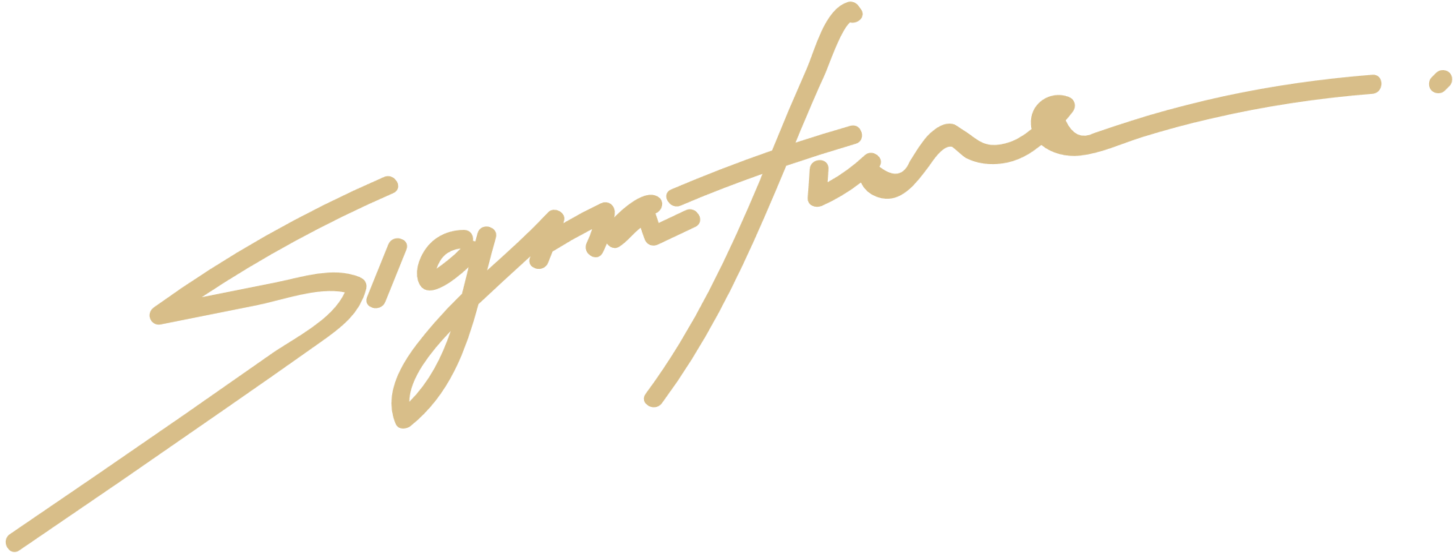

CERTIFICATE OF COMPLETION

THIS IS TO CERTIFY

Morgan Maxwell

For completing an internship program in Aldenaire & Partners Law Firm period July-Sept year 2024

INTERNSHIP SUPERVISOR



DIRECTOR

