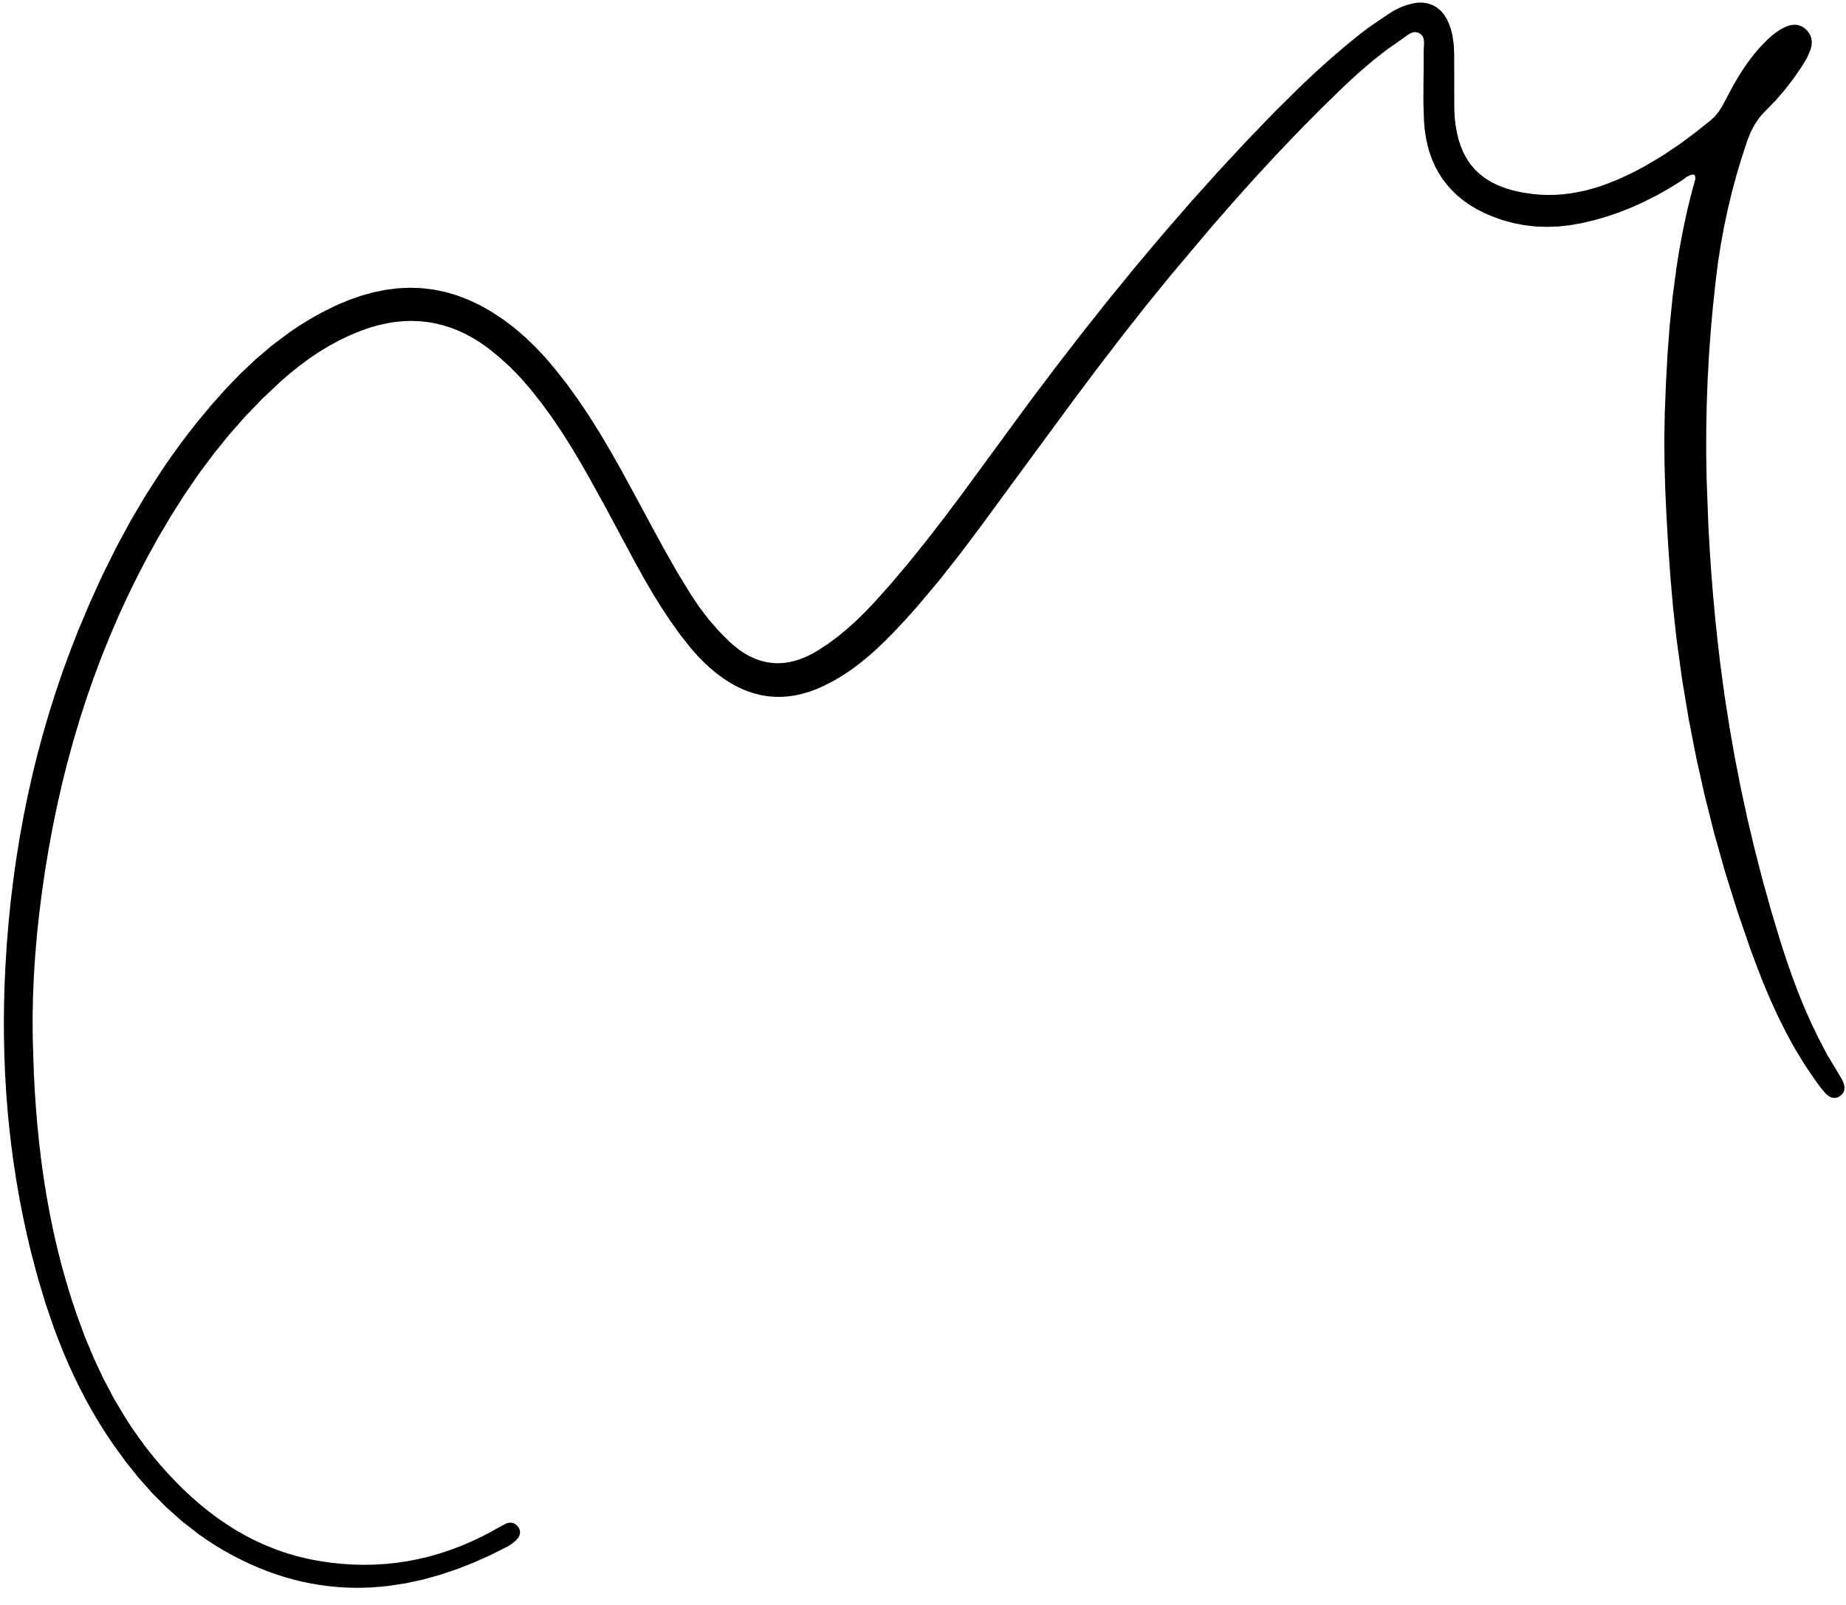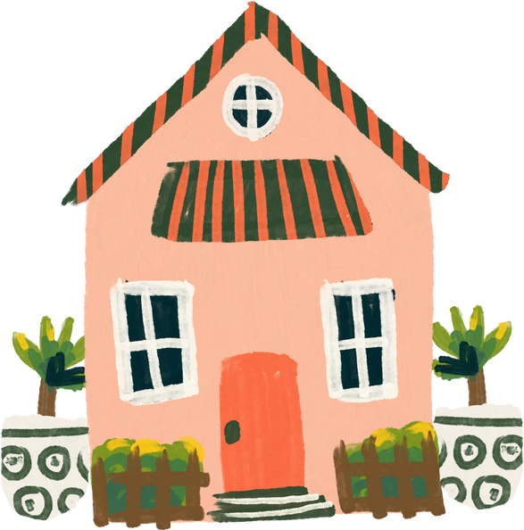

Signature

Nathan Clanchy

Certificate of Completion

BENJAMIN

VERNON

This Certificate Present to

Congratulations on the completion of the Homeschool course.