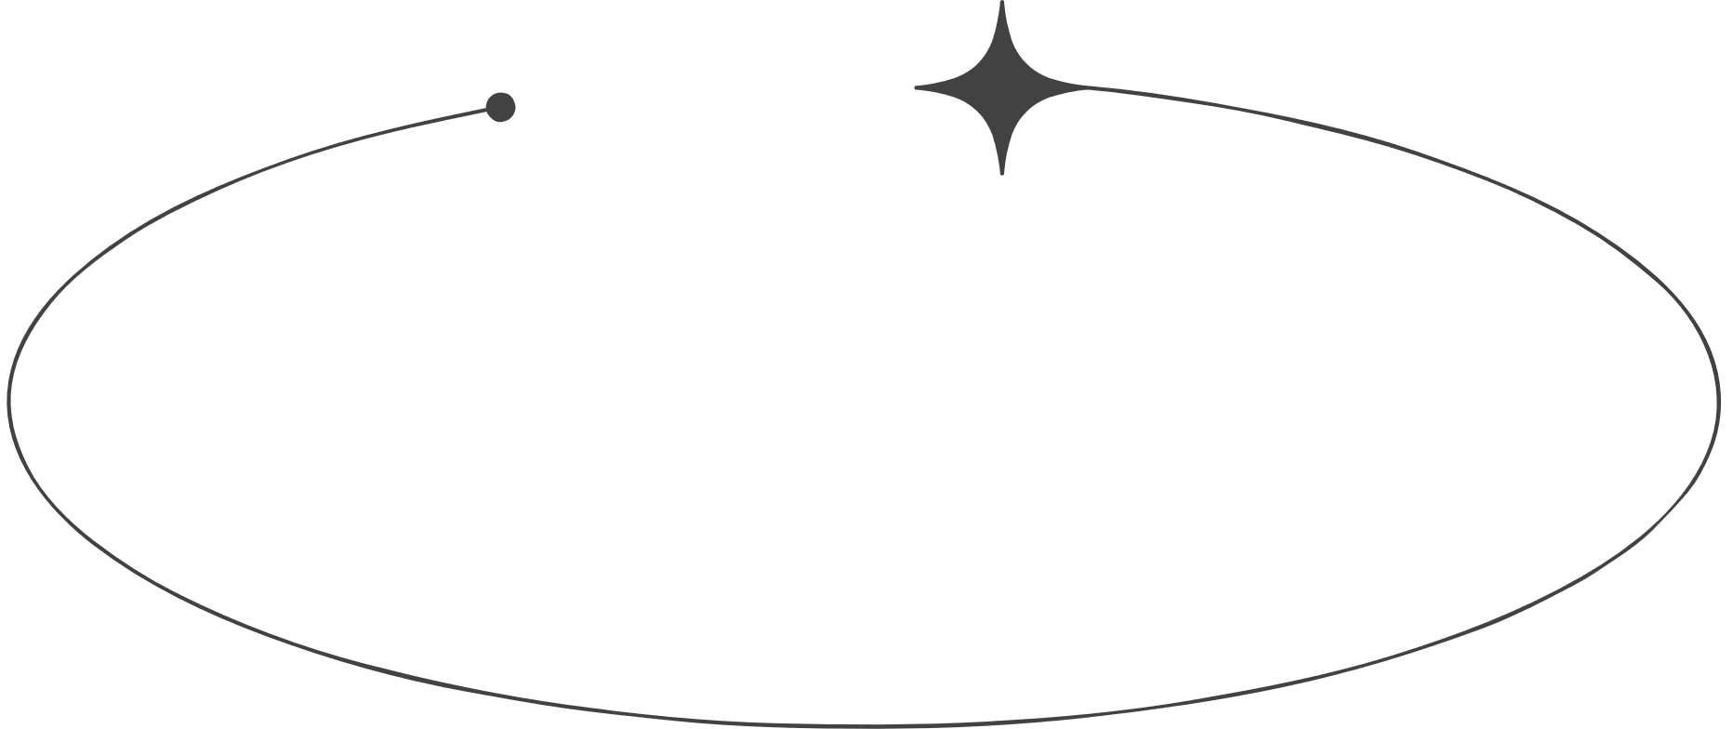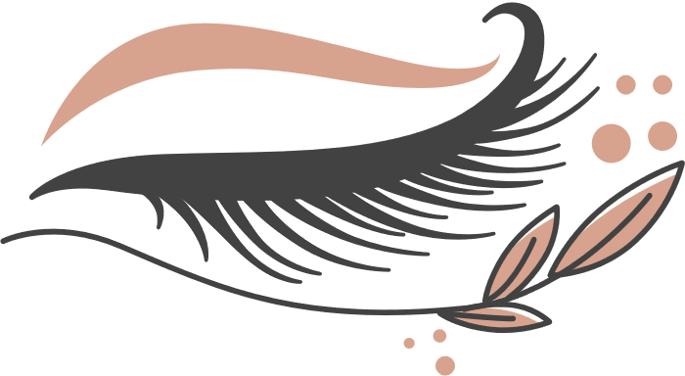

LASH

PRICE LIST

Eyelash Extensions

$40

$20

$30

$30

$15

$10

$20

Lash Lift

Master Stylist Upgrades

Lash Upgrades

Eyebrow Shaping etc.

Full Set Upgrade

Brow Lamination