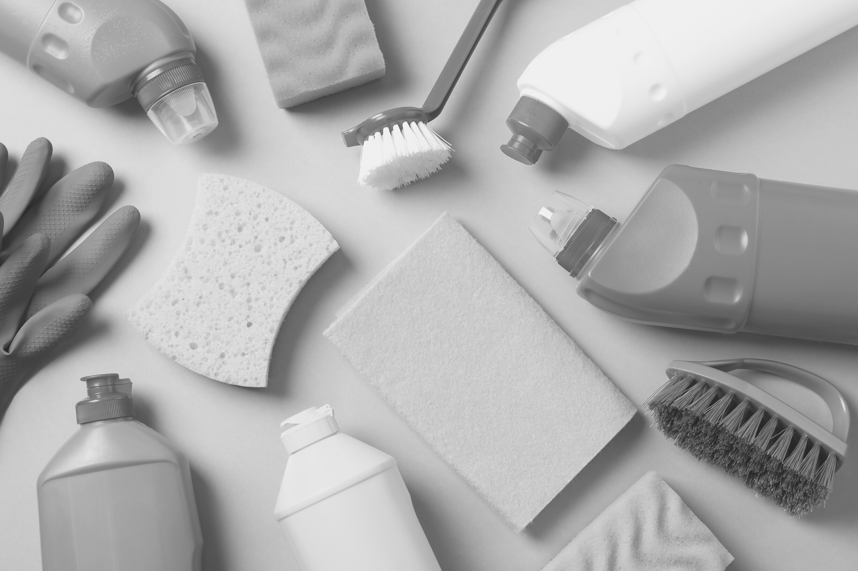

Write the slogan in here



House cleaning

services

HOUSE CLEANING

PRICE LIST

CLEANING SERVICE

Regular clean

$20/hour

Deep clean

$25/hour

Commercial clean

$30/hour

Commercial deep clean

$35/hour

Contact Us

www.templateLAB.com @templatelab hello@templateLAB.com

Contractor clean

$30/hour

Grocery service

30% of grocery bill

Window clean

Estimate required

Boat clean

Estimate required

Full service caretaker

Estimate required

Pet sitting

Estimate required

Dinner party bartending

Estimate required

Party setup and cleaning

Estimate required

PRICE

+123-456-7890