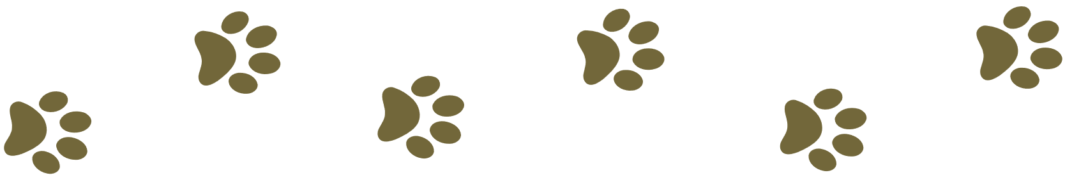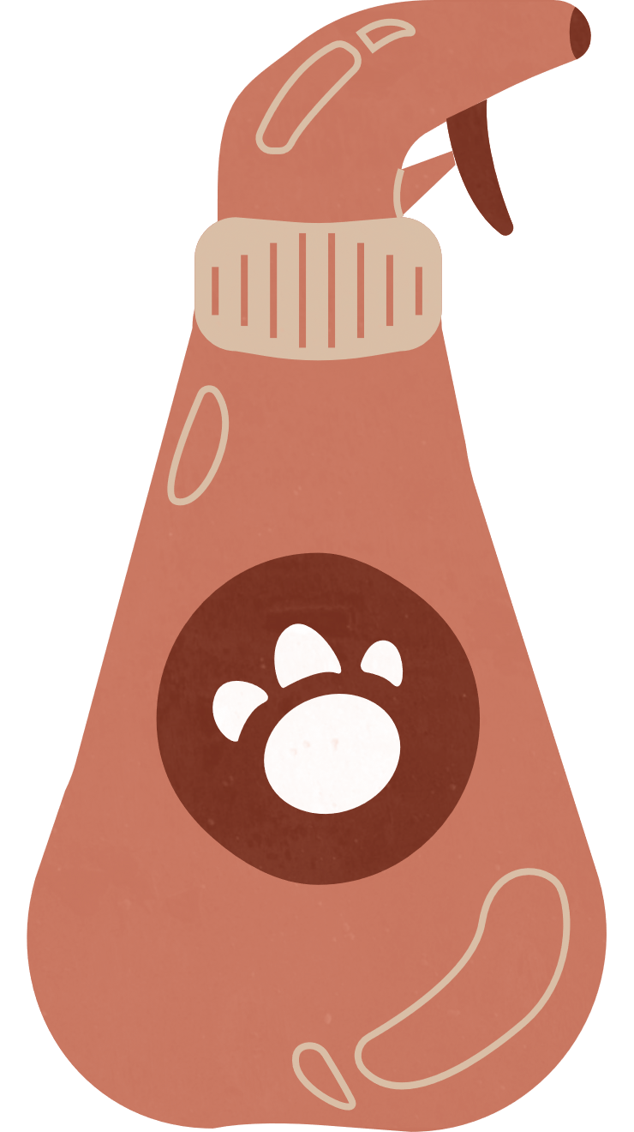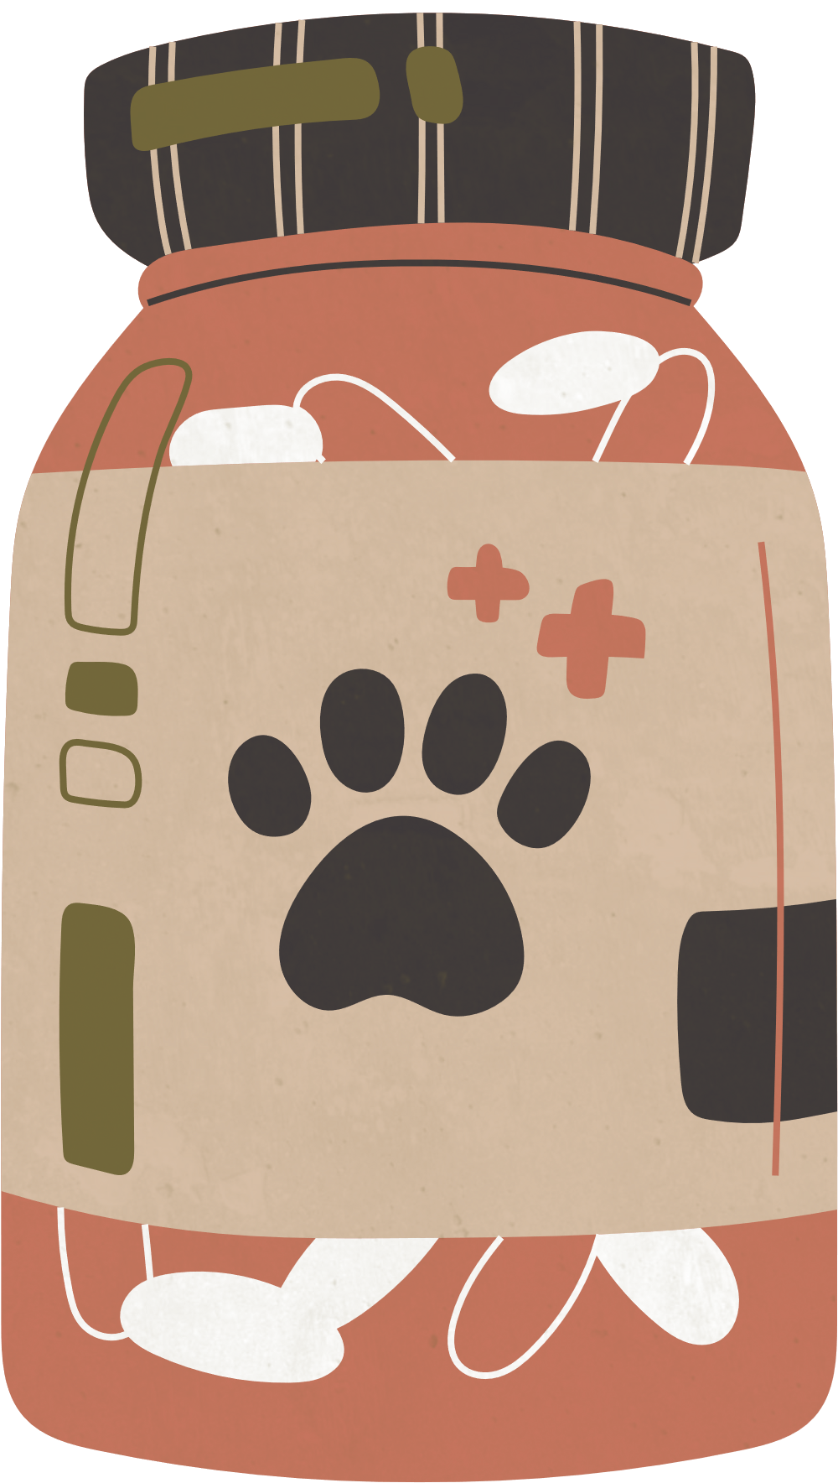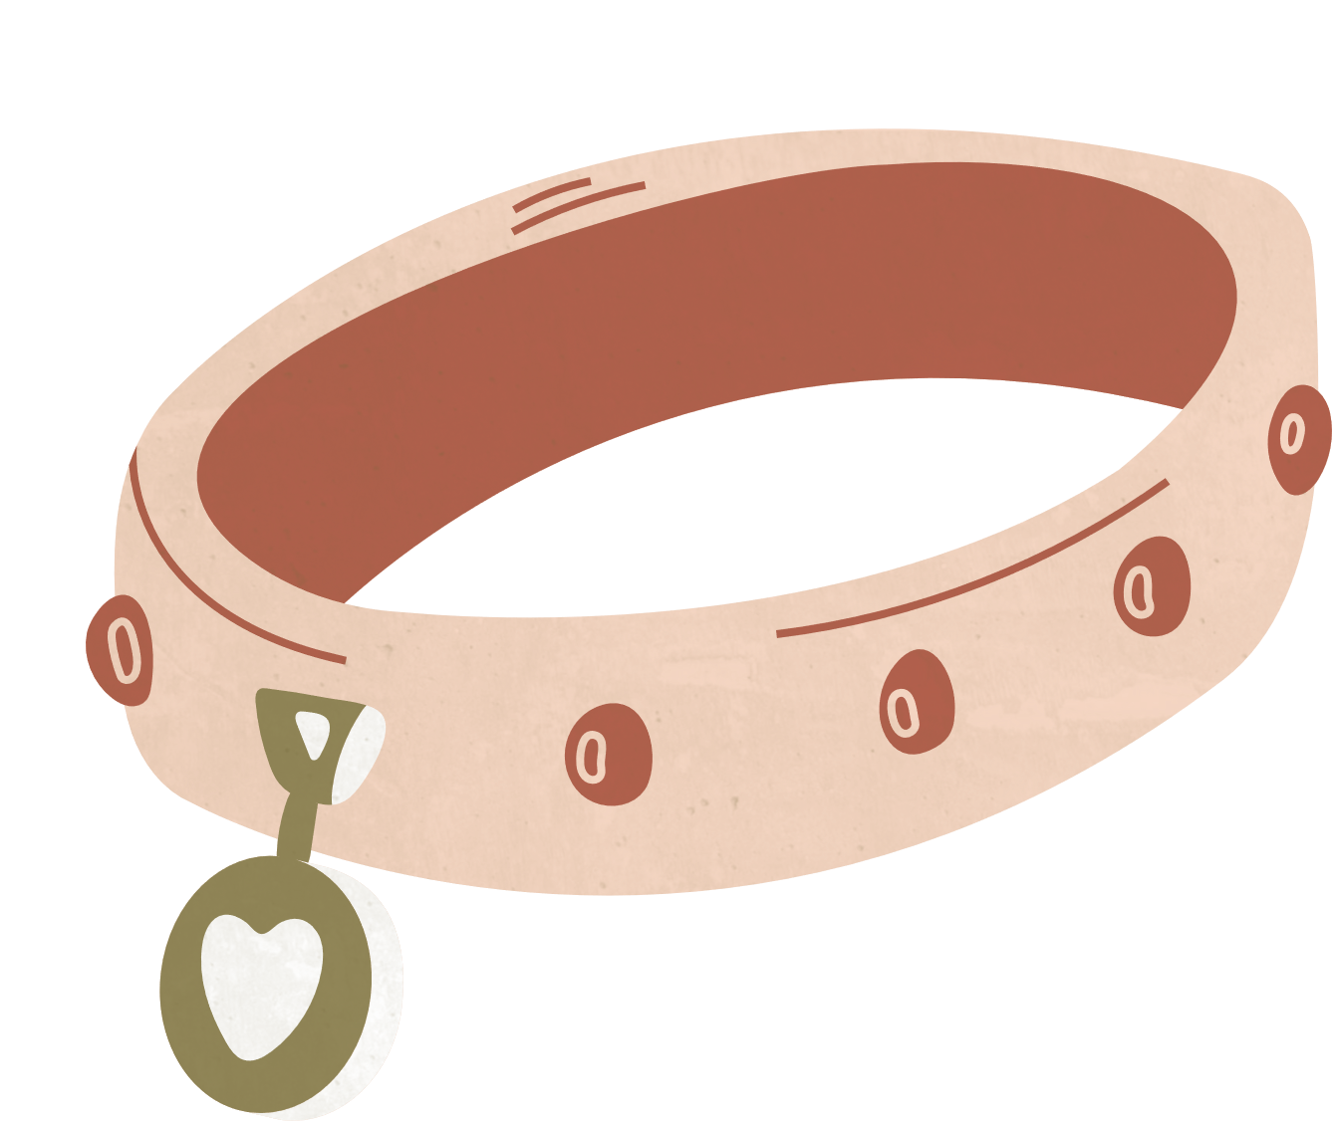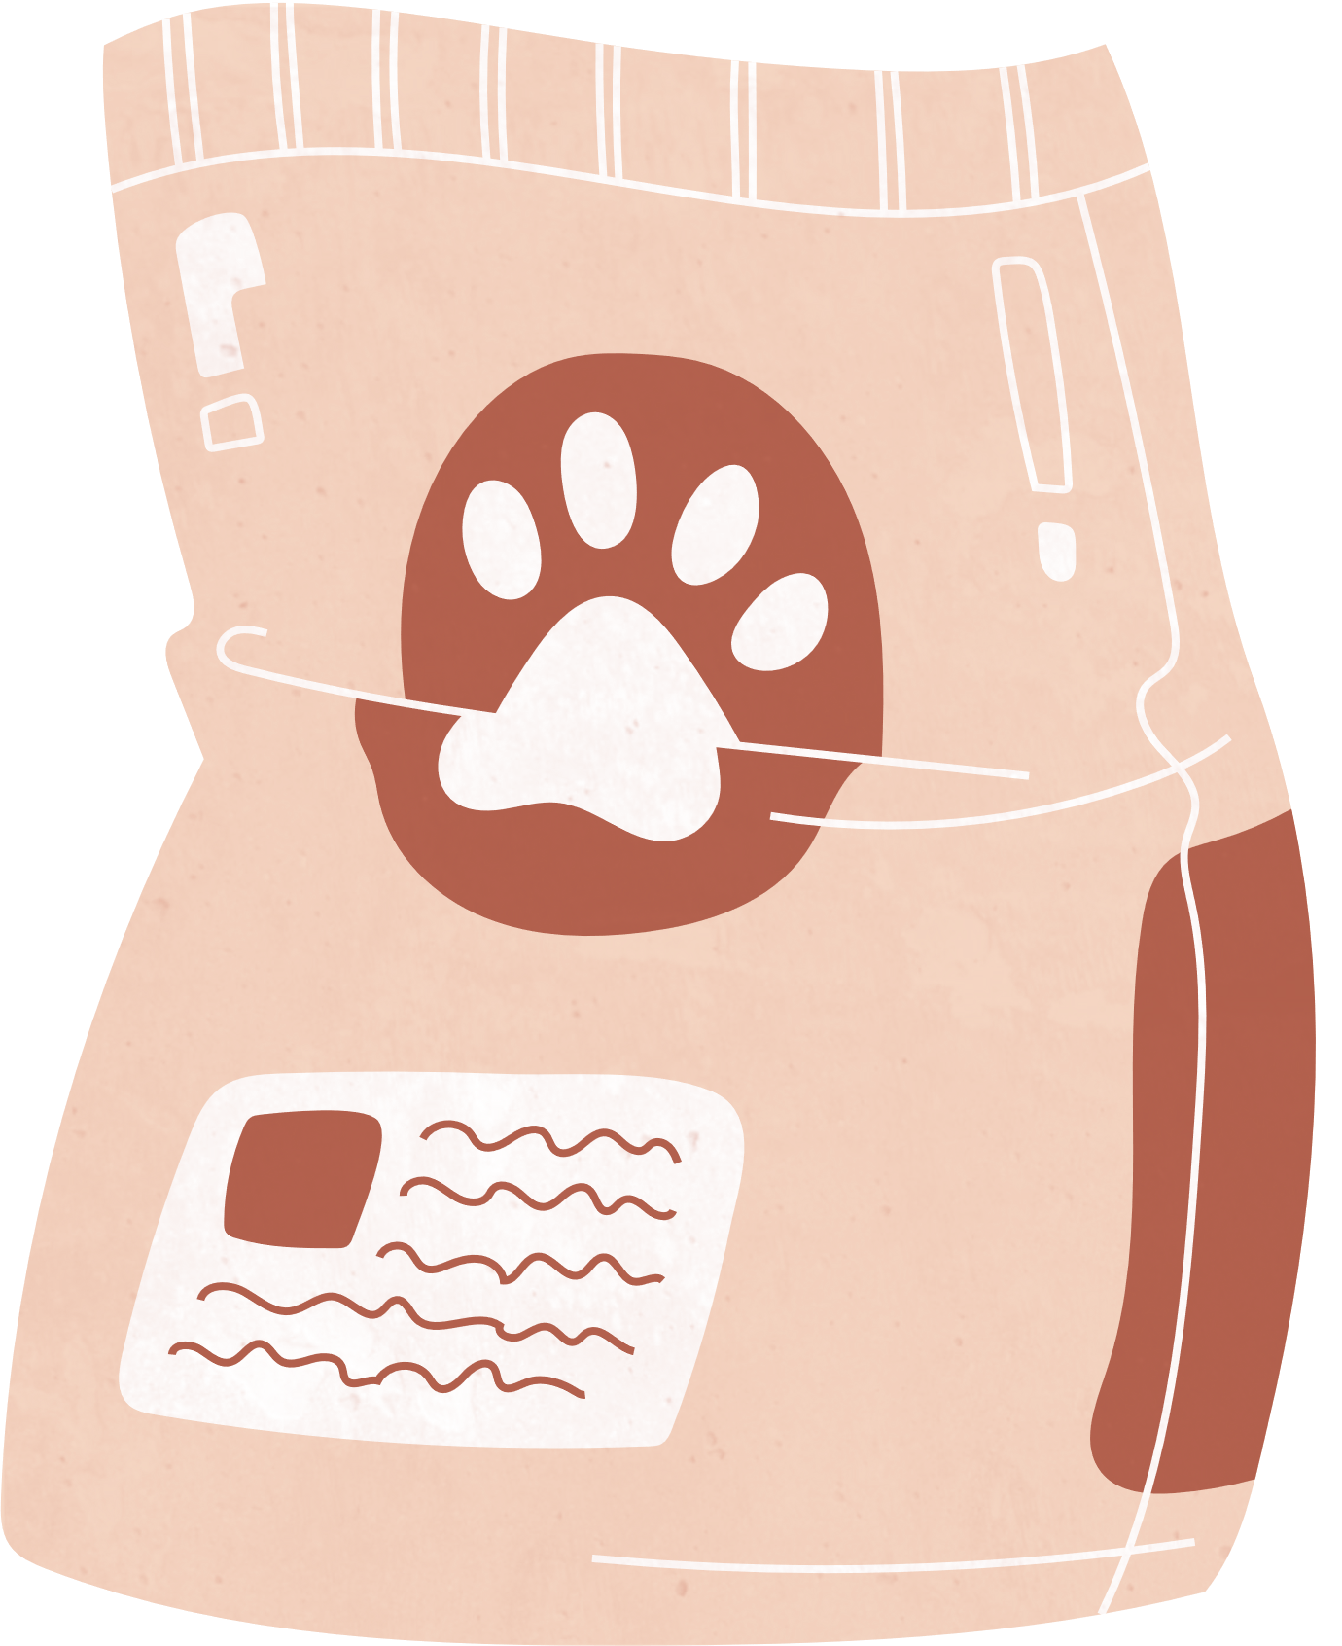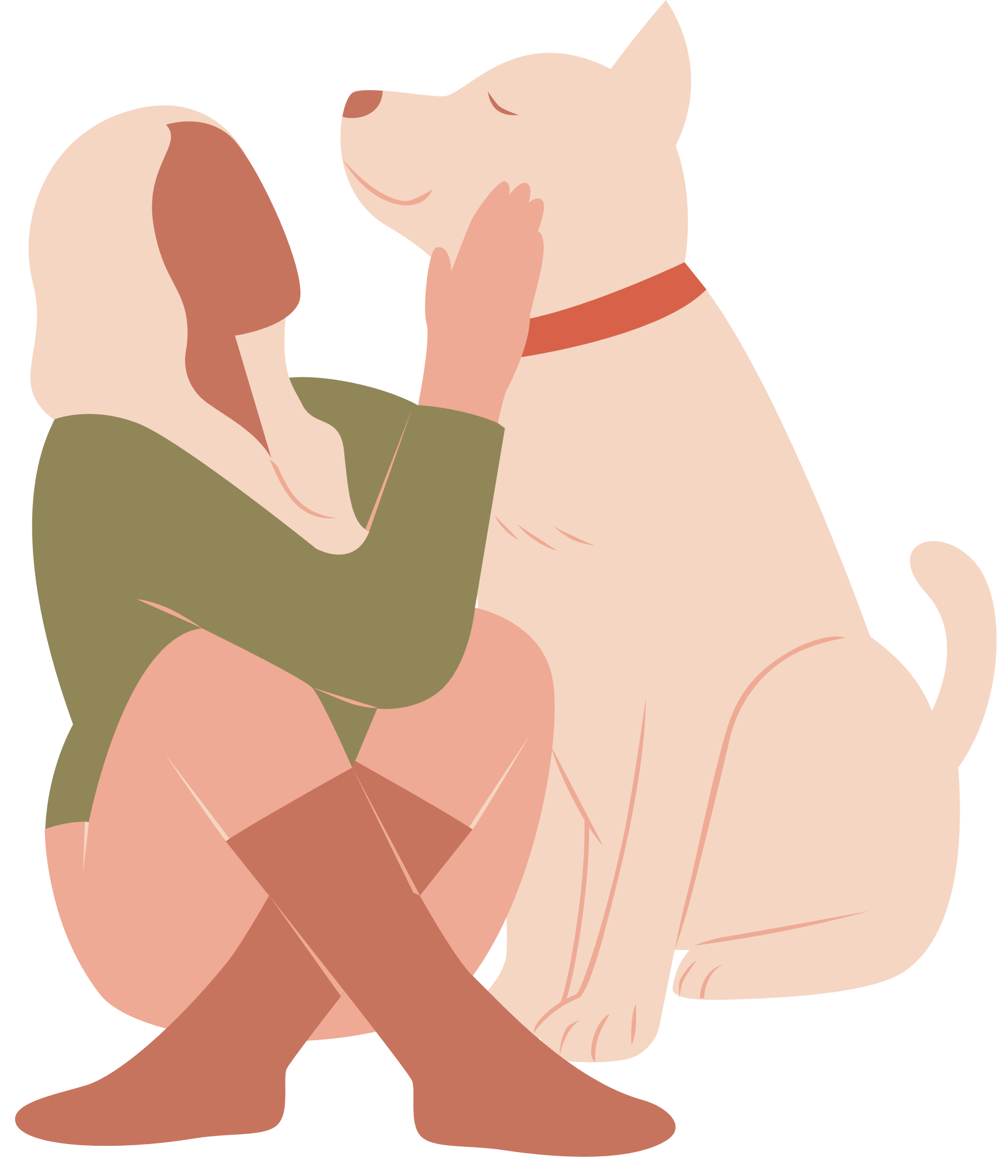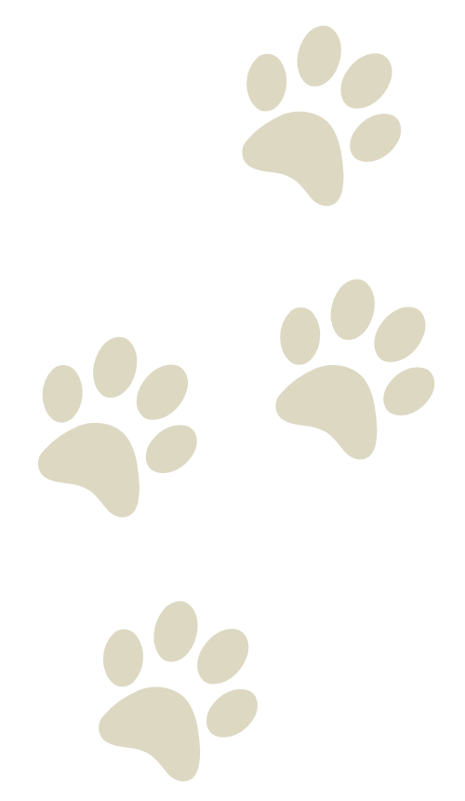

Dog Grooming

PRICE LIST

Toy

Small

Medium

Large

$7

$9

$11

$13

Toy

Small

Medium

Large

$7

$9

$11

$13

Premium Spa

Shampoo + Blowdry + Nails + Ears + Massage + Cologne + Haircut

Toy

Small

Medium

Large

$7

$9

$11

$13

Special Bath

Shampoo + Blowdry + Nails + Ears + Massage + Cologne

Basic Service

Shampoo + Blowdry + Nail + Ears

