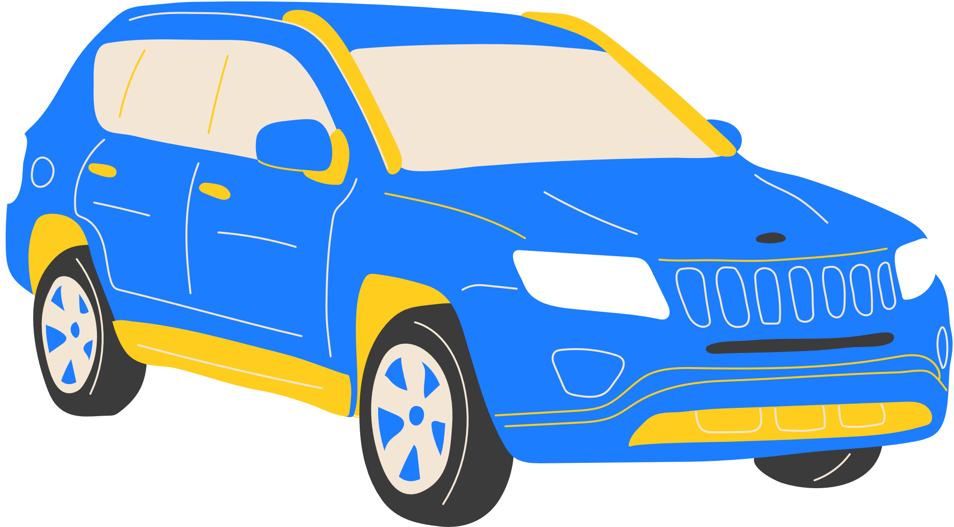

CAR WASH

$8

PACKAGE 1



PRE WASH



WASH & WAX



LEATHER DRY



TYRE SHINE

**PRICE LIST**

***WASH NOW***

123 Anywhere St., Any City

+123-456-7890

$12

PACKAGE 2



PRE WASH



WASH & WAX



LEATHER DRY



TYRE SHINE



WHEELS CLEANED

$20

PACKAGE 3



PRE WASH



WASH & WAX



LEATHER DRY



TYRE SHINE

$30

PACKAGE 2



PRE WASH



WASH & WAX



LEATHER DRY



TYRE SHINE



WHEELS CLEANED



WHEELS CLEANED



DOOR SHUTS CLEANED



INTERIOR HOOVER



RUBBISH REMOVED



INTERIOR DUST

