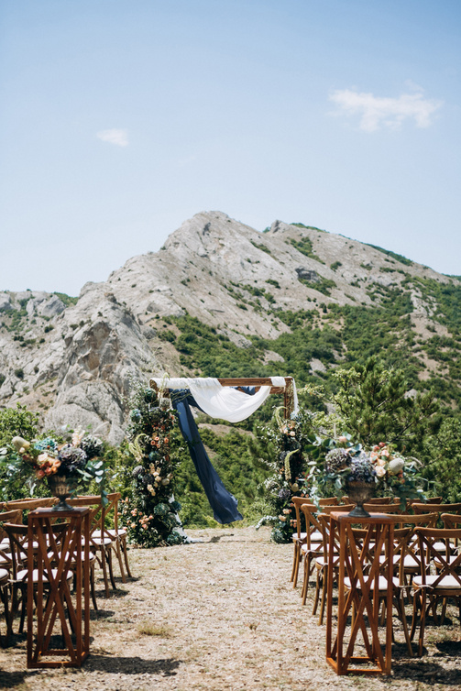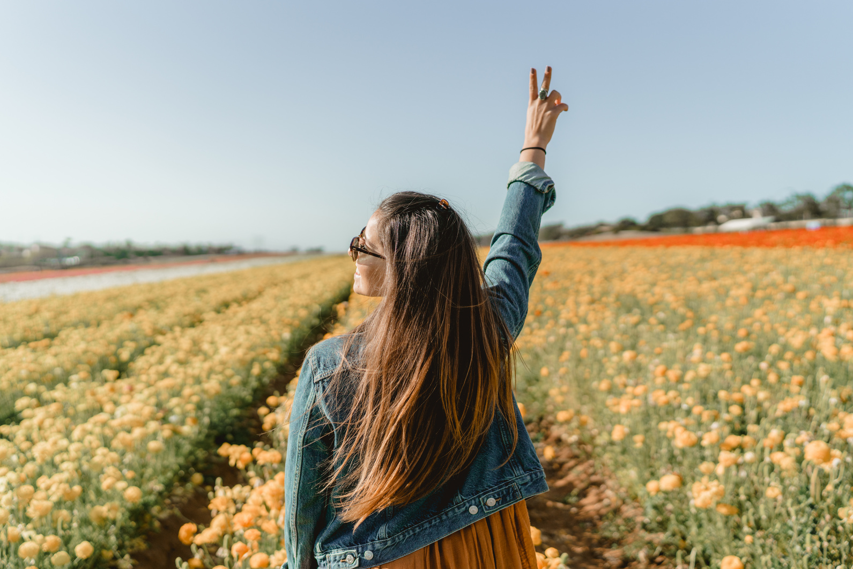

**| www.templateLAB.com | Hello@templateLAB.com | +123-456-7890 |**

beginner photography

PRICE LIST

8 hour seasons

250 edited pictures

Two locations

Photo album

Canvas prints

Online access

2 hour seasons

50 edited pictures

Two locations

Photo album

Three 5x7 prints

Online access

1 hour season

25 edited pictures

One location

Photo album

One 5x7 print

Online access

Package three

Package two

Package One

***$750***

***$450***

***$275***

CANVAS

5x7

8x10

8x20

20x30

30x50

$35

$74

$125

$250

$375

PRINTS

4x6

5x7

6x8

6x10

11x14

13x19

$12

$24

$45

$50

$57

$64

ALBUMS

10x10

12x12

14x11

$275

$300

$450