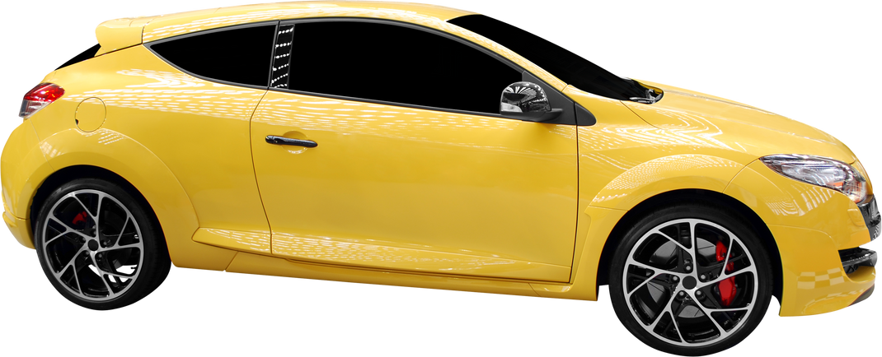

***AUTO DETAILING***

***$129***

***LIMITED PACKAGE***

* + *Complete Meticulous Hand Wash*
  + *Chamois Dry*
  + *Interior Vacuum*
  + *Clean All Flat Interior Surfaces*
  + *Wash Floor Mats*
  + *Clean & Dress All Tires*
  + *Clean Door Jams / Interior Windows*

*PRICE LIST*

***$219***

***PLATINUM PACKAGE***

* + *Clean Wheel Wells & Rims*
  + *Spray Wax*
  + *Full Engine Shampoo*

*Includes All From Limited Package Plus:*

***$69***

***SALT WASH PACKAGE***

* + *Clean Mats (Wash & Vacuum)*
  + *Remove Salt Stains*
  + *Exterior Wash*

123-456-789

www.templateLAB.com

123 Anywhere St., Any City