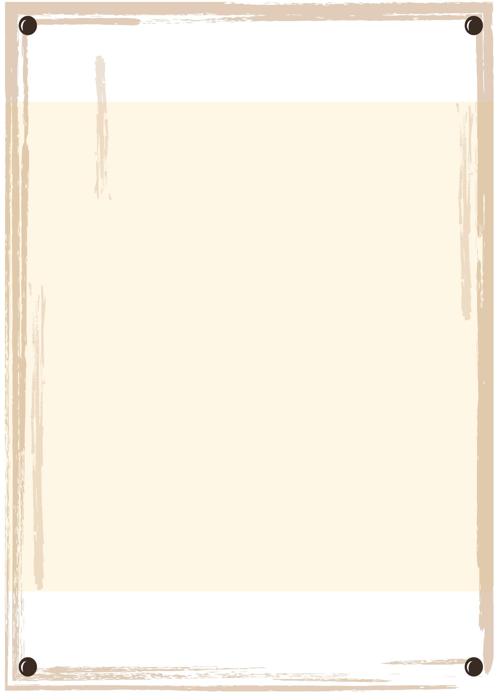

WANTED

FULL NAME

$10000

REWARD