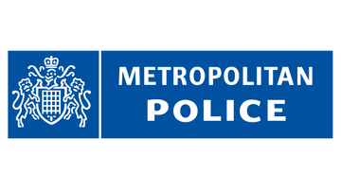

WANTED

Name: Ali Romad

Age: 28

Wanted for: Aggravated burglary

Last known location: NW10

IF YOU HAVE ANY INFORMATION CONCERNING THIS PERSON PLEASE CONTACT THE POLICE IMMEDIATELY AND HELP US TO KEEP OUR COMMUNITY SAFE

