**WANTED**

**BY THE FBI**

UNLAWFUL FLIGHT TO AVOID PROSECUTION - MURDER

FULL NAME

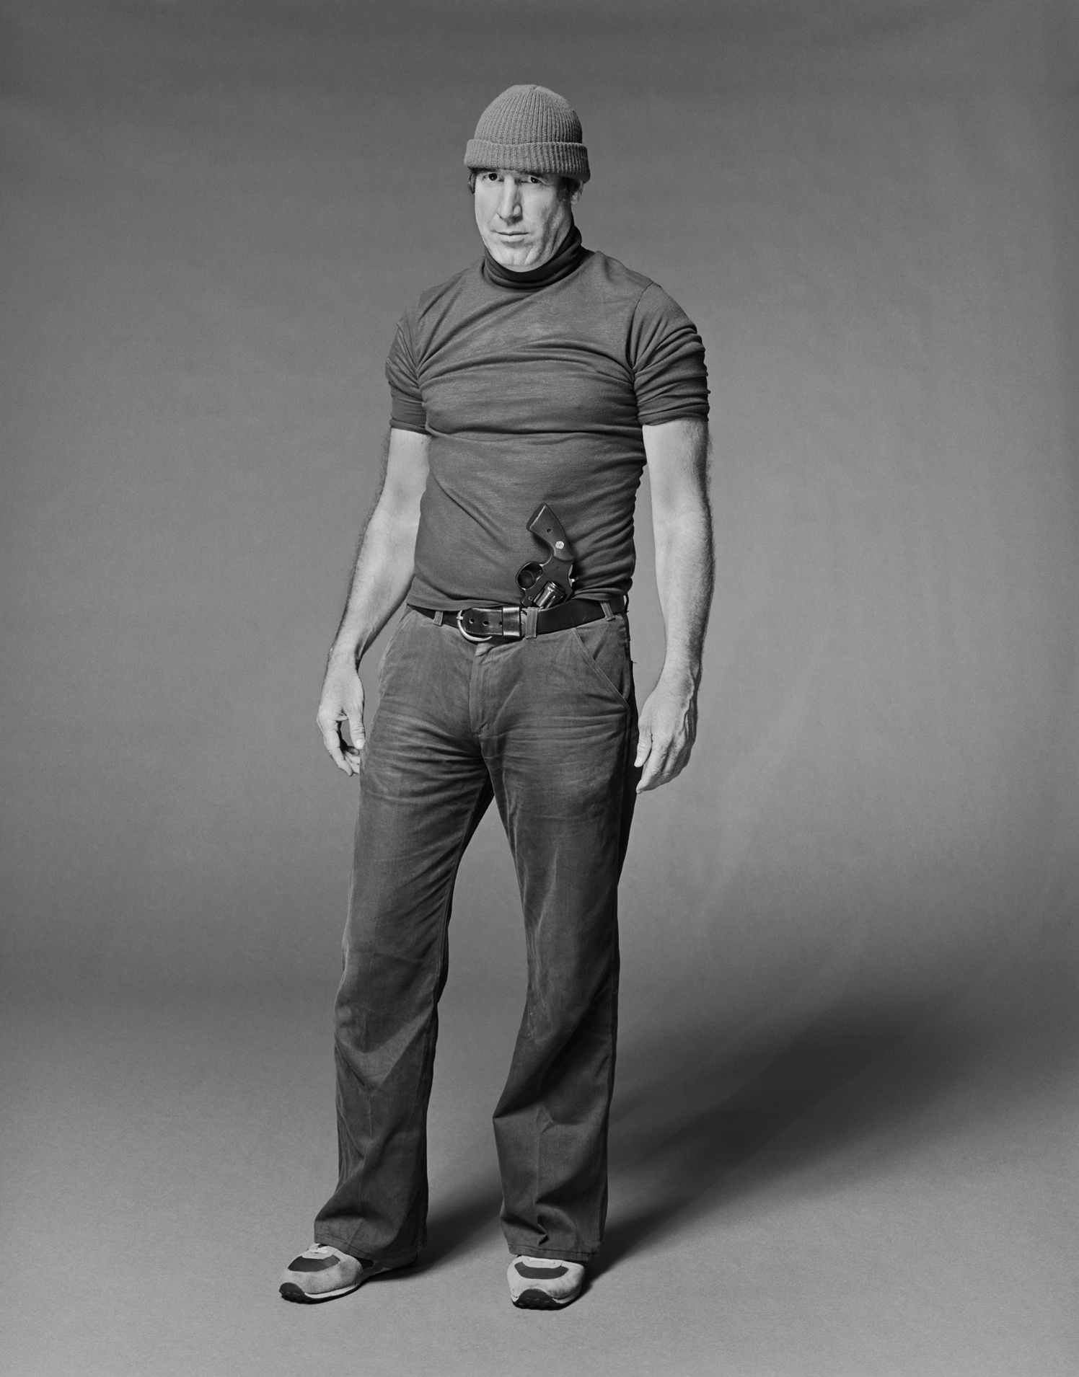

*Age:*

*Height:*

*Weight:*

*Build:*

*Hair:*

*Occupation:*

*Marks:*

*Eyes:*

*Complexion:*

*Race:*

*Nationality:*

40

5’8”

150 Pounds

Slender

Blonde

Operator

Scar on left shoulder

Blue

Tan skin

Caucasian

American

CAUTION:

Lorem Ipsum is simply dummy text of the printing and typesetting industry. Lorem Ipsum has been the industry's standard dummy text ever since the 1500s, when an unknown printer took a galley of type and scrambled it to make a type specimen book.

IF YOU HAVE ANY INFORMATION CONCERNING THIS PERSON PLEASE CONTACT YOUR LOCAL FBI OFFICE IMMEDIATELY

