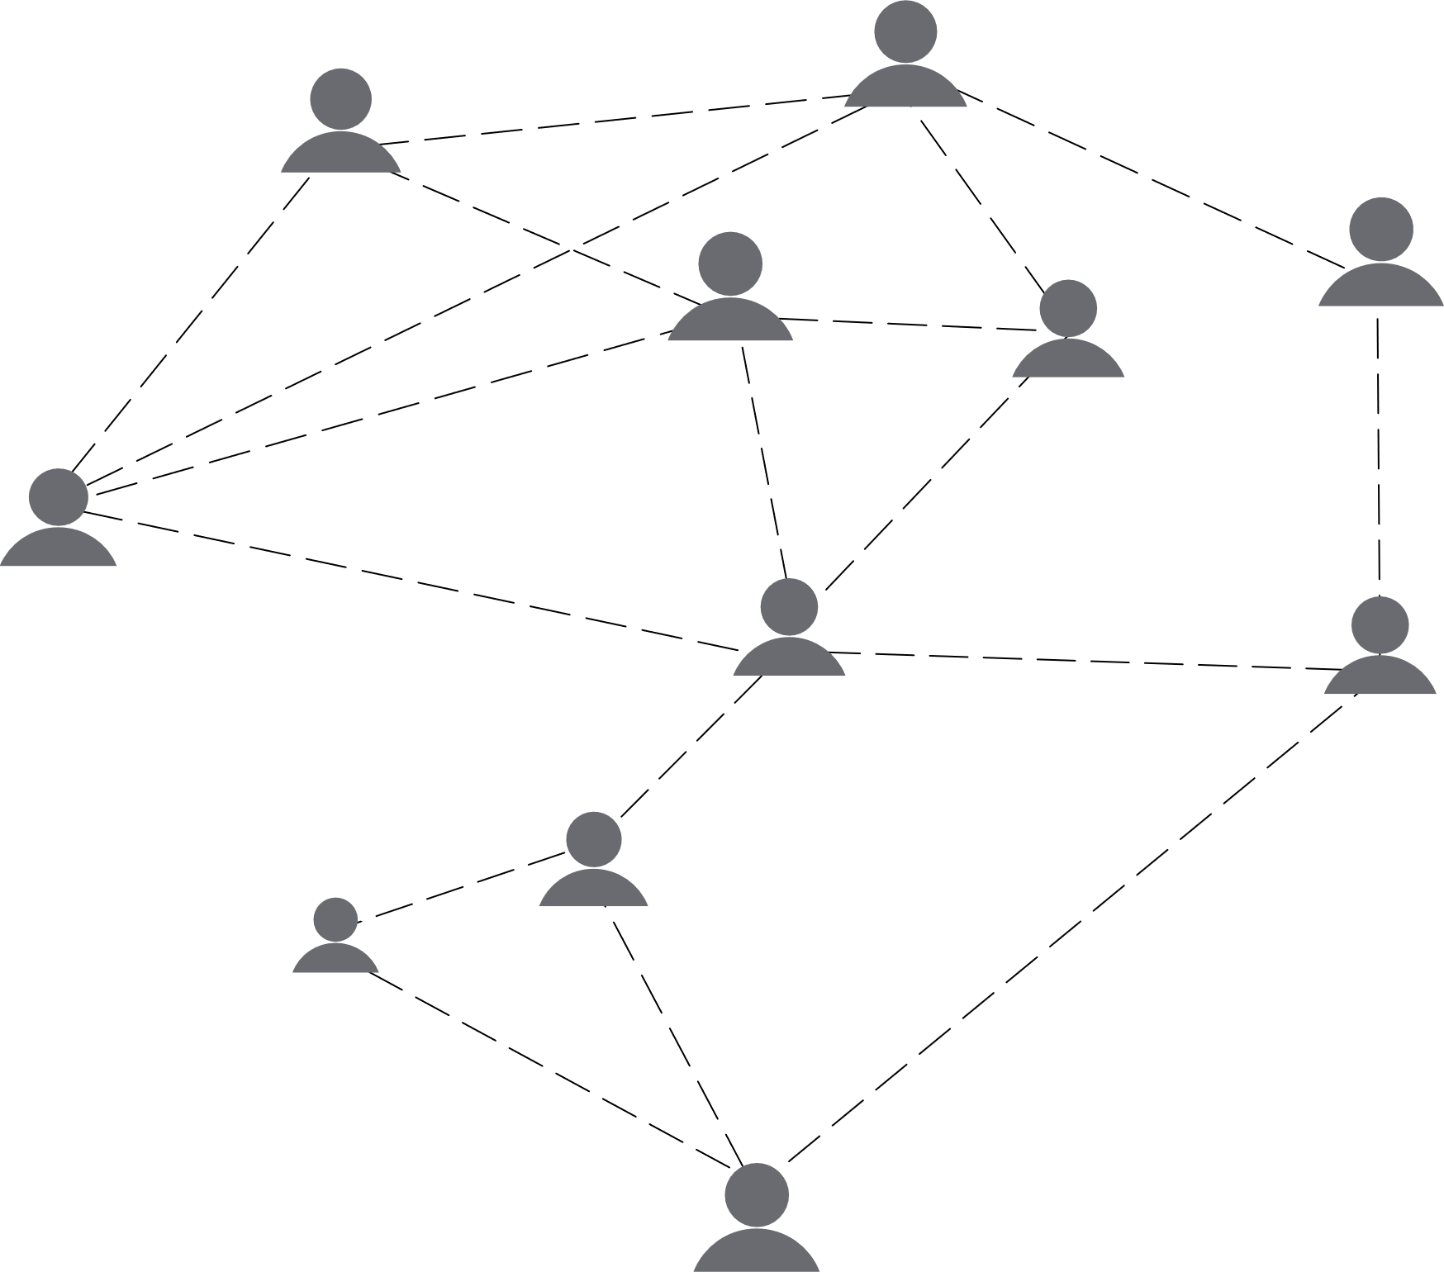

Social work genogram

YOU



FAMILY

DAD

MOM

BRO 1

SIS 1

BRO 2

Strong/ Positive relationship

Weak/Tenuous relationship

Stressful relationship

Male

Female

Queer

Community

FRIEND

MAN 1

WOMAN 1

MAN 2

MAN 3

QUEER 1

COMUNITY

WORK

CLUB 1

SOCIAL  
SERVICES

CHURCH

**Date: July 25, 2030**

**Genogram for: Carwyn Bailey**

**Prepared by: Rihanna Sykes**

**Contact: templatelab.com**