[](https://templatelab.com/)

**FAMILY**

**GENOGRAM**

Vivian Doe

1963-

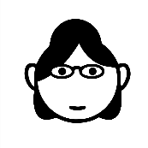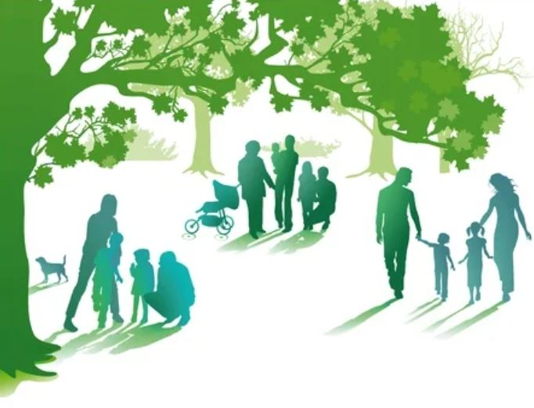

Benjamin Doe

(1922-2001)



Sarrah Doe

(1926-2006)



Eric Doe

(1957-2019)



Peter Bird

1965-



William Bird

1934-2008



Jesica Bird

(1940-2020)



Maurice Doe

1988-

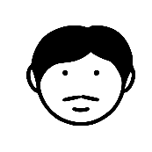

Brad Bird

1992-



Stephen Johnson

(1918-1998)



Margo Johnson

(1933-2007)



Cony Doe

1984-



Ben Doe

1987-



Jenny Bird

1988-



Belinda Nielson

(1936-2011)



Hellen Bird

1963-



Christofer Nielson

(1928-1997)



Nina Doe

1989-



John Doe

2000-



Malcolm Doe

2005-



Mag Doe

2003-



[**© TemplateLab.com**](https://templatelab.com/)