

**U SHAPED SEATING**

**CHART TEMPLATE**

A .................................

B .................................

C .................................

D .................................

E .................................

F .................................

G ................................

H .................................

I ..................................

J .................................

K .................................

L .................................

M ................................

N .................................

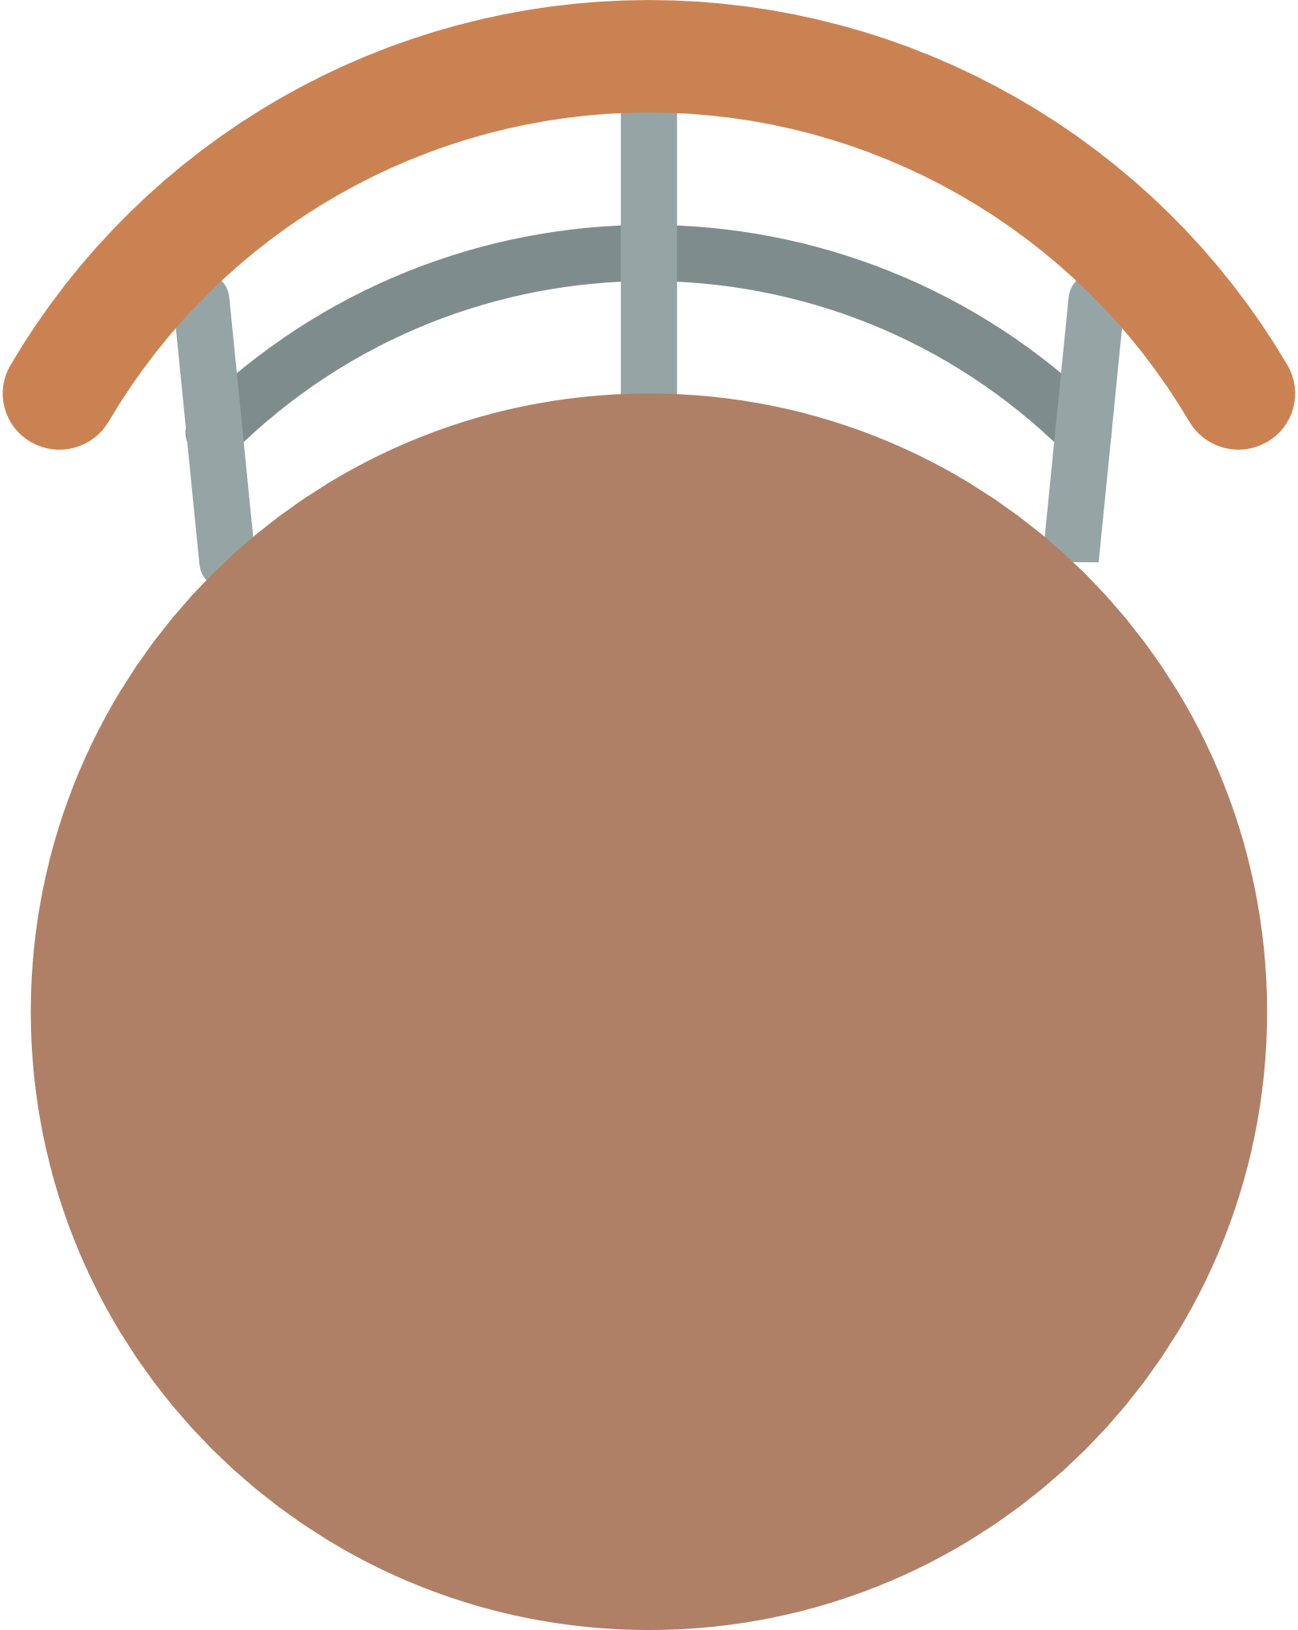

**A**



**B**



**C**



**D**



**E**



**N**



**M**



**L**



**K**



**J**



**F**



**I**



**H**



**G**