 | 01. |  |  | ROAD CONSTRUCTION
 |  |  | Gas main replacement
 |  |  | May 02 - May 28 |  | SCHEDULE
 |  |  | Gas main replacement on a portion of Gold Street by Erwing Bing. The old cast iron gas main, as well as any older services between the main and the residences, will be upgraded to plastic pipe.
 |  |  | ERWING BING & MECHANICAL TEAM
 | 02. |  |  |  | 04.
 |  |  | Replacement of water pipes |  |  |  | Seeding grass
 |  |  | Jun 05 - Jun 22 |  |  |  | Jul 12 - Jul 13
 |  |  | Replacing any water services within the City’s right-of-way that are made of older materials such as lead or cast iron. New copper piping will be installed from the water main in the street to the shut-off box. |  |  |  | Disturbed areas of the grass strip between the sidewalk and the street or on private property will be loamed and seeded.
 |  |  | WATER SERVICES DEPT |  |  |  | GRASS EXPERTS LLC
 | 03. |  |  |  | 05.
 |  |  | Roadway and sidewalks restoration |  |  |  | Missing sidewalks restoration
 |  |  | Jun 25 - Jul 10 |  |  |  | Jul 15 - Jul 30
 |  |  | Resurfacing the roadways, replacing concrete and asphalt sidewalks in any locations that have been disturbed or require replacement due to cracking or other defects, and resetting curbing where necessary. |  |  |  | A public meeting will be held to discuss plans for the final restoration of areas of missing sidewalks and berm or curbing. Notification of this meeting will be provided to residents via hand-delivered flyers.
 |  |  | M&R PAVING |  |  |  | PROJECT MANAGER
 | 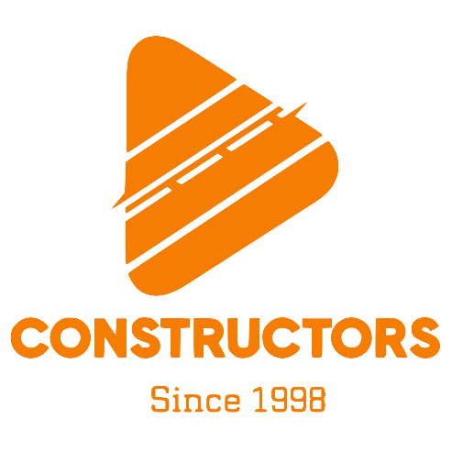 |  |  |  | 06.
 |  |  | 121 Main Drive  23422 Alabama  000-12345-6789  info@constructors.com |  |  |  | Lorem Ipsum
 |  |  |  |  |  |  | Aug 01 - Aug 25
 |  |  |  |  |  |  | Lorem ipsum dolor sit amet, consectetuer adipiscing elit. Maecenas porttitor congue massa. Fusce posuere, magna sed pulvinar ultricies, purus lectus malesuada libero, sit amet commodo magna eros quis urna. Nunc viverra imperdiet enim.
 |  |  |  |  |  |  | LOREM IPSUM COMPANY
 |  |  |  |  |  |  | © TemplateLab.com

