 |  |  | 2 |  | 3 |  | 4
 | 1
 | TEAR OUT & DEMOLITION |  | ROUGH-IN WORK |  | PROFESSIONAL INSPECTION |  | FINISHING THE WALLS
 | Clear old walls |  | Adding square footage |  | Calling the city |  | Hang drywall
 | Move old cabinetry |  | Framing |  | Scheduling appointment |  | Tape drywall
 | Deinstall fixtures |  | Moving plumbing fixtures |  | The approval |  | Finish drywall
 | Hauling debris away |  | Moving plumbing fixtures |  | The approval |  | Add a coat of primer
 |  |  | Moving plumbing fixtures |  | The approval
 | 01/04 - 04/04 |  | 05/04 - 09/04 |  | 10/04 - 14/04 |  | 15/04 - 19/04
 |  |  | 6  8 |  | 7
 | 5
 | INSTALL DOORS & WINDOWS |  | CABINETS AND PLUMBING FIXTURES |  | BRING IN NEW APPLIENCES |  | INSTALL NEW FLOORING
 | Install Doors (2pcs) |  | Install new countertops |  | Instal microwave |  | Select colors and styles
 | Install windows (3pcs) |  | Install cabinets |  | Install stove |  | Prepare the substrate
 | Check insulation |  | Install sink |  | Install refrigerator |  | Insert ceramic tiles
 | Lorem Ipsum |  | Install faucet |  | Install wine chiller |  | Lorem Ipsum
 |  |  | Position garbage bin |  | Install water cleaning system
 | 22/04 - 23/04 |  | 28/04 - 02/05 |  | 05/05 - 07/05 |  | 10/05 - 14/05
 |  |  |  |  |  |  | © TemplateLab.com
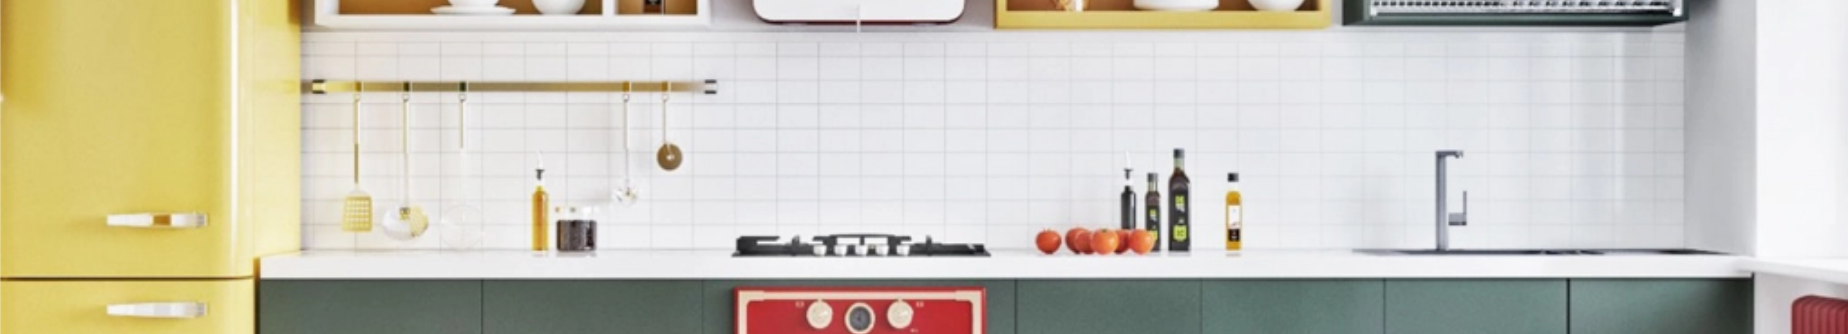
KITCHEN CONSTRUCTION SCHEDULE

