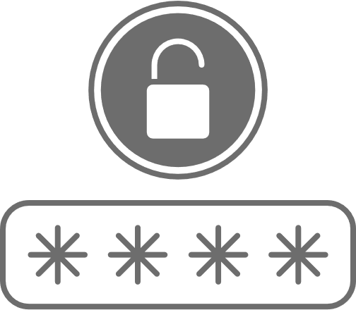

PASSWORD CARD

WEBSITE

USERNAME

PASSWORD

NOTE

WEBSITE

USERNAME

PASSWORD

NOTE

WEBSITE

USERNAME

PASSWORD

NOTE

WEBSITE

USERNAME

PASSWORD

NOTE

WEBSITE

USERNAME

PASSWORD

NOTE

WEBSITE

USERNAME

PASSWORD

NOTE

