

WEB:

USERNAME:

PASSWORD:

NOTE:

WEB:

USERNAME:

PASSWORD:

NOTE:

WEB:

USERNAME:

PASSWORD:

NOTE:

WEB:

USERNAME:

PASSWORD:

NOTE:

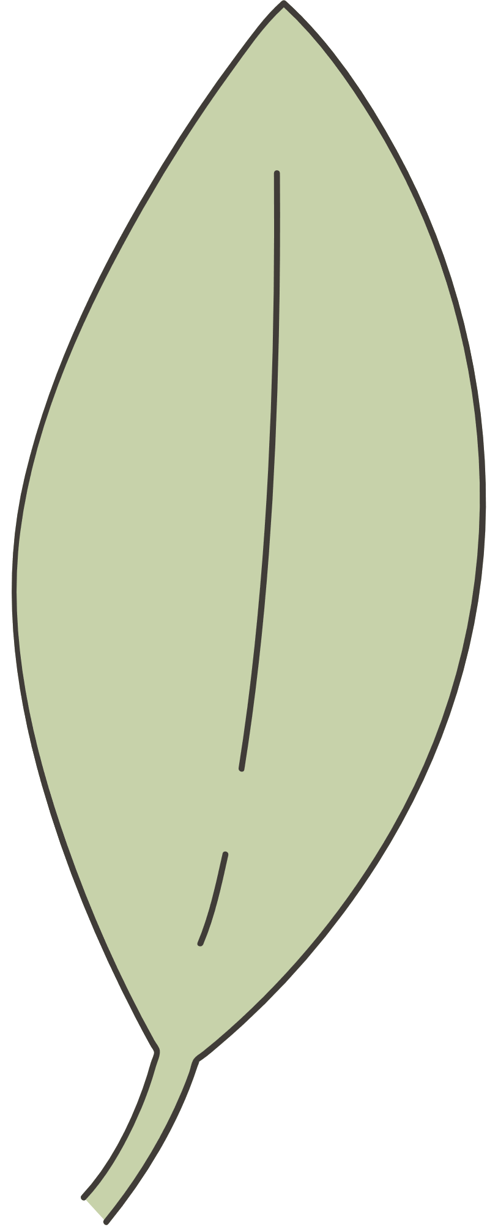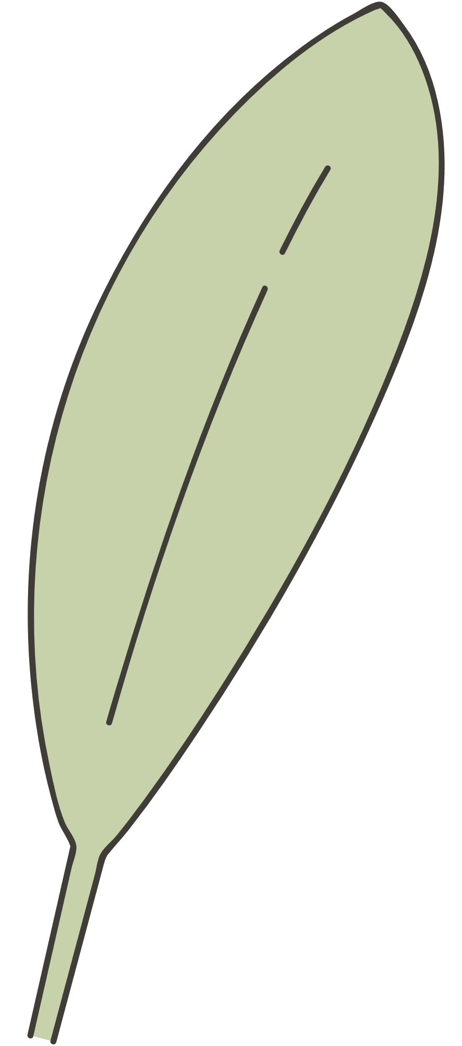

CUTE PASSWORD KEEPER

WEB:

USERNAME:

PASSWORD:

NOTE:

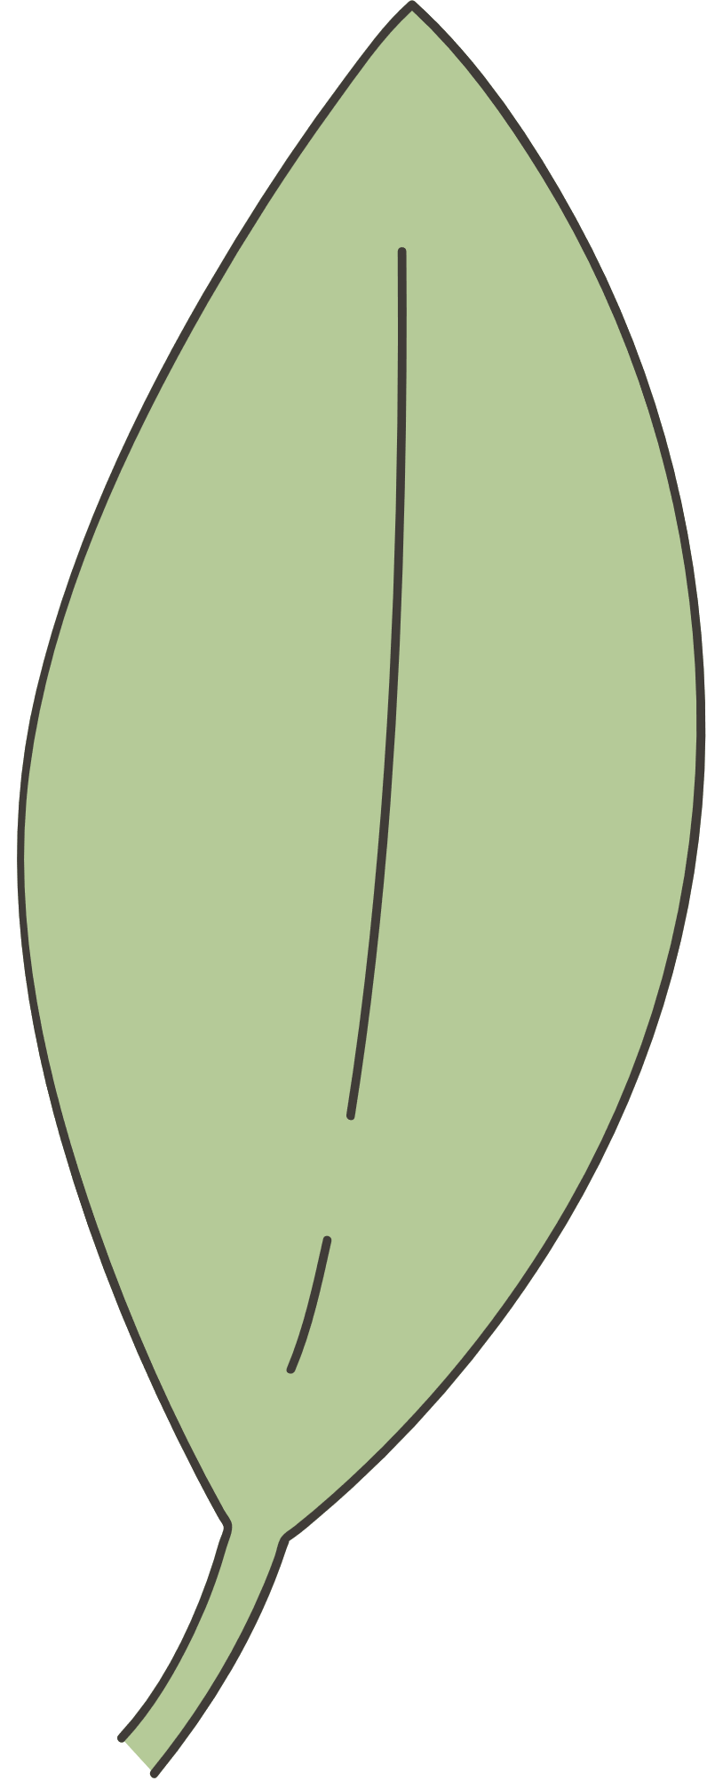

WEB:

USERNAME:

PASSWORD:

NOTE:

WEB:

USERNAME:

PASSWORD:

NOTE:

WEB:

USERNAME:

PASSWORD:

NOTE:

