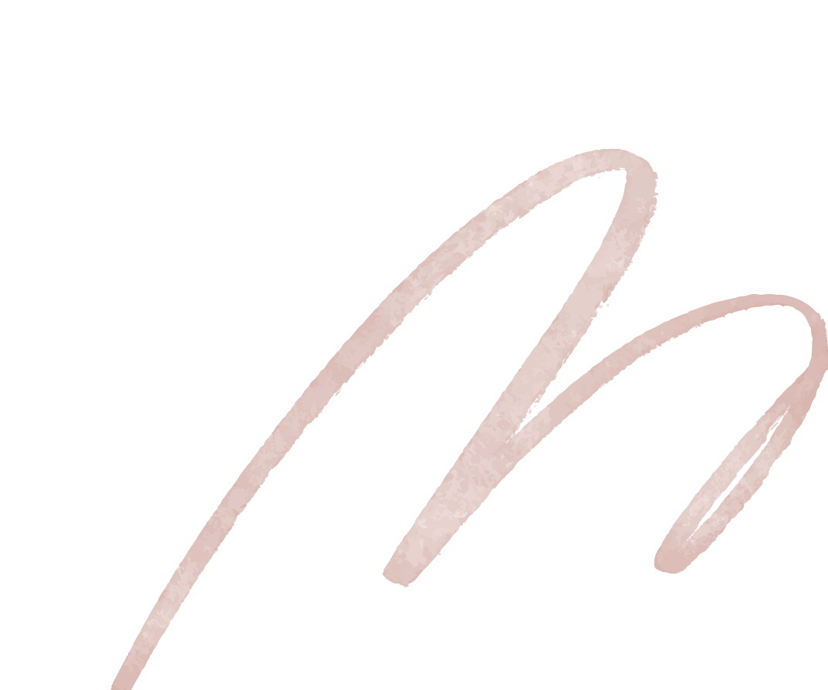

STORE NAME

10AM – 8PM

10AM – 8PM

10AM – 8PM

10AM – 8PM

10AM – 9PM

CLOSE



MONDAY

TUESDAY

WEDNESDAY

FRIDAY

SATURDAY

SUNDAY

**WE ARE OPEN**