 | QUOTATION
 | PROPERTY RENOVATION: Family House - 147 Green Street, New York
 | Bill To: |  |  | Total Due:
 | Samantha Smith |  |  | $17,325.00
 | 231 Western Avenue |  | Quotation #: | YR0251/2022
 | New York, 20909 NY |  | Date: | 05/22/2022
 | DESCRIPTION | QTY | UNIT PRICE | TOTAL
 | Exterior | 1 | $3,650.00 | $3,650.00
 | Wrap Exterior and install new vinyl siding, Install 6 new windows
 | Rough In | 1 | $2,500.00 | $2,500.00
 | Rough In HVAC, Rough In Plumbing of new full bath upstairs
 | Drywall and Trim and other interior | 1 | $6,100.00 | $6,100.00
 | Repair Drywall in living room, kitchen, and bedroom. Replace interior doors.
 | Bathroom | 2 | $800.00 | $1,600.00
 | Install new tile in 2 full bathrooms
 | Kitchen | 1 | $3,650.00 | $3,650.00
 | Install kitchen cabinets, countertops, and appliances.
 |  |  | Sub Total | $17,500.00
 |  |  | Discount | $1,750.00
 | Payment Method |  | Tax (10%) | $1,575.00
 | PayPal: paypaladdress@websitename.com | GRAND TOTAL |  | $17,325.00
 | Cards: Mastercard, Visa, and American Express
 | Terms & Conditions
 | Unless explicitly agreed prior to commencement of work, payment will be due in full upon completion of the work or services provided.
 |  |  | Account Manager
 | THANK YOU FOR YOUR BUSINESS! |  | JOHN DOE
 | YOURCOMPANY NAME |  | 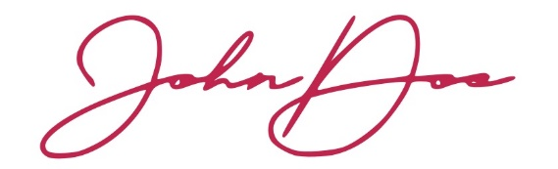
 | 241 Caster Drive, Maury 21555 CA
 | (000) 25143 9990
 | Info@yourcompanxname.com
 | yourcompanyhomeaddress.com
 |  |  | © TemplateLab.com

